**THE EFFECT OF COMMITMENT, WORK ENVIRONMENT, AND COMPENSATION ON EMPLOYEE PERFORMANCE WITH JOB SATISFACTION AS A INTERVENING VARIABEL (CASE STUDY AT PT SAI APPAREL INDUSTRIES)**

**Arina Khasbana1) Wyati Saddewisasi 2)Sujito3)Rohmini Indah Lestari4)**

Master of management, University Semarang, Indonesia

*E-mail:* [*arina.khasbana2@gmail.com*](mailto:arina.khasbana2@gmail.com)

**Abstract:**

*The level of the company's ability to produce a product from the performance quality index is one of the performance indicators. The performance quality index shows a decrease in employee performance, where performance appraisal in a company shows the profitability and sustainability of the company's operations. This study aims to analyze the effect of commitment, work environment, and compensation on employee performance with mediation of job satisfaction at PT Sai Apparel Industries. This research uses quantitative methods with stratified random sampling techniques by giving questionnaires to the entire population of two hundred employees, and one hundred and thirty- three can be processed. This research uses the Structural Equation Model-Partial Least Square (SEM-PLS) with the SmartPLS 3.2 application. The results found that commitment has no effect on job satisfaction. However, it has a positive and significant effect on employee performance. Work environment, job satisfaction, and compensation have a positive and significant effect on job satisfaction and employee performance. In addition, job satisfaction cannot mediate the relationship between commitment and compensation, but the work environment has a positive and significant effect on job satisfaction and employee performance. job satisfaction has an impact on the work environment and employee performance.*

***Keywords:*** *job satisfaction; employee performance; commitment; compensation; and work environment.*

# Introduction

The impact of the Covid-19 crisis has affected the growth of most organizations and management professionals, especially in the field of human resources (Kalogiannidis, 2021 and Baert et al., 2020). The impact of quite complex implications influences the organization's ability to operate with high strategic performance and achieve sustainable development. The two-quarter global economic recession has triggered individual challenges in working and how to manage an organization now in an unstable condition. The occurrence of imbalance creates inconsistencies so that many changes occur in various fields. The problem at PT Sai Apparel Industries is that during the 2019-2021 period, employee performance targets were still not as expected, and even tended to decline. So it can be estimated that each department produces product damage equal to 5 percent of total production.

The performance quality index which can describe the company's cognitive demands related to manufacturing tasks to optimize employee performance has become a quantitative assessment as one of the performance indicators of PT Sai Apparel Industries. *The Quality Performance Index* shows that there is a delay in production operational planning. The manufacturing process in *samples, quality control, cutting sewing* and *finishing* experienced production delays. The average change in the negative trend movement in the long term tends to decrease. A decrease in the amount of production indicates a significant decline in employee performance each year, thereby allowing for the potential for losses. Field facts that need to be considered to change gaps in work and improve employee performance can be done through applying the theory of employee performance as a company asset (Idris et al., 2020). According to Kazan & Gumus, (2013) the concept of employee performance refers to the factors of commitment, institutions, work discipline, work environment, job satisfaction, work motivation, compensation and work promotions.

Hendri, (2019) states that realizing company goals can be done by utilizing employee commitment as an alternative for developing human resources. Employees with strong commitment reflect a process to prove their seriousness in work, loyalty and positive contribution to the organization. Commitment is an attitude that shows employee attachment to the company. Luthans, (2015) defines commitment into five indicators, namely committing to core human values, clarifying and communicating the mission, ensuring social justice, creating a sense of community, and supporting employee development. Amin, (2022) explains that organizational commitment is a form of social group consisting of several individuals who have the same perception about the unity of members in a company.

Another thing that companies need to pay attention to is the impact of the work environment. Certain work environment characteristics influence the occurrence of work events that give rise to emotional reactions, such as positive and influential ( R. Fluegge -Woolf, 2014). A study by Idris et al., (2020), shows that a suitable work environment will have long-term effects, whereas an unsuitable work environment will cause employees to be stressed, not want to work, come late, and find it difficult to design an effective and efficient work system (Marlina et al., 2021; Sulaeman et al., 2021).

Idris et al., (2020) stated that the imbalance felt by employees is part of the evaluation of the sustainability of employee performance, while employee compensation is a measure of employee performance and is measured in ways that can improve employee performance which is seen as a management method for managing human resources. .

Another aspect that is no less important for improving employee performance is job satisfaction. Job satisfaction is a collection of individual employee perceptions that will influence individual employee attitudes and behavior in the workplace and help improve employee performance (Hendri, 2019). Based on the problem of decreasing employee performance, the objectives to be achieved in this research are [1] analyzing the influence of commitment on employee performance [2] analyzing the influence of the work environment on employee performance [3] analyzing the influence of compensation on employee performance [4] analyzing the influence of commitment on employee performance. job satisfaction [5] analyze the influence of the work environment on job satisfaction [6] analyze the influence of compensation on job satisfaction [7] analyze the influence of employee performance on job satisfaction [8] analyze the influence of commitment on performance mediated by job satisfaction [9] analyze the influence of the environment work on employee performance which is mediated by job satisfaction [10] analyzes the effect of compensation on employee performance which is mediated by job satisfaction.

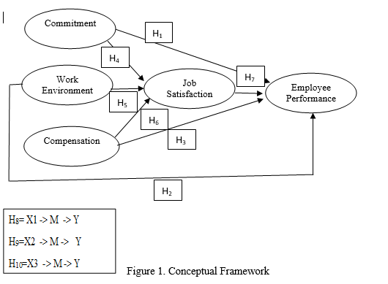

|  |  |
| --- | --- |
| Information: | |
| C.M | : Commitment ( commitment) |
| WE | : work environment |
| CP | : compensation *(compensation)* |
| E.P | employee performance *( employee performance)* |
| JS | : job satisfaction *(job satisfaction)* |

# Research Method

This research uses quantitative methods and is classified as *explanatory research.* The type of data in this research consists of primary data and secondary data. The data collection techniques used were questionnaires and documentation. This research was conducted using a survey which took samples from a population with a questionnaire as the main data collection technique. The population in the study were all employees of *the finishing department* of PT Sai Apparel Industries who were selected using probability sampling with *stratified random sampling* which was grouped according to education level. The sample size was determined using Slovin, namely a population of 200 employees with a confidence level of five percent, with a total of one hundred and thirty-three employees. The data analysis technique uses the *Partial Least Square* (PLS) approach with the SmartPLS Version 3.0 application. There are five variables involved in this research, commitment with indicators from (Lunthas, 2011; Amin, 2022) has fifteen indicators, work environment from (Sedarmayanti, 2018; Marlina et al., 2021) has eight indicators, compensation from (Simamora, 2015; Sugiono Edi et al., 2021) has four indicators, job satisfaction from (Luthans, 2002; Hendri, 2019) has five indicators, and employee performance from (Robins, 2006; Komang et al., 2019) has six indicators . Therefore, the total number of indicators is thirty-eight.

# Results and Discussion

# Results

1. Validity test

The first stage, before carrying out analysis using PLS, is to carry out a validity test. The validity test was carried out to determine the precision and accuracy of the questionnaire, with *the Rule of thumb* according to Hair et al., (2018) the factor loading value was >0.708 (re-estimated again by removing indicators that were not significant), indicating that the construct validity test was valid.

Table 1 Outer Loading *(Measurement Model)*

|  |  |  |  |  |  |
| --- | --- | --- | --- | --- | --- |
|  | Commitment | Work environment | Compensation | Job satisfaction | Performance  employee |
| X1.1 | 0.844 |  |  |  |  |
| X1.2 | 0.756 |  |  |  |  |
| X1.3 | 0.780 |  |  |  |  |
| X1.4 | 0.779 |  |  |  |  |
| X1.5 | 0.807 |  |  |  |  |
| X1.6 | 0.809 |  |  |  |  |
| X1.7 | 0.844 |  |  |  |  |
| X1.8 | 0.710 |  |  |  |  |
| X1.9 | 0.825 |  |  |  |  |
| X1.10 | 0.711 |  |  |  |  |
| X1.11 | 0.733 |  |  |  |  |
| X1.12 | 0.812 |  |  |  |  |
| X1.13 | 0.745 |  |  |  |  |
| X1.14 | 0.729 |  |  |  |  |
| X1.15 | 0.795 |  |  |  |  |
| X2.1 |  | 0.716 |  |  |  |
| X2.2 |  | 0.731 |  |  |  |
| X2.3 |  | 0.736 |  |  |  |
| X2.4 |  | 0.680 |  |  |  |
| X2.5 |  | 0.750 |  |  |  |
| X2.6 |  | 0.735 |  |  |  |
| X2.7 |  | 0.753 |  |  |  |
| X2.8 |  | 0.699 |  |  |  |
| X3.1 |  |  | 0.807 |  |  |
| X3.2 |  |  | 0.851 |  |  |
| X3.3 |  |  | 0.892 |  |  |
| X3.4 |  |  | 0.852 |  |  |
| Y2.1 |  |  |  | 0.792 |  |
| Y2.2 |  |  |  | 0.789 |  |
| Y2.3 |  |  |  | 0.721 |  |
| Y2.4 |  |  |  | 0.783 |  |
| Y2.5 |  |  |  | 0.737 |  |
| Y1.1 |  |  |  |  | 0.760 |
| Y1.2 |  |  |  |  | 0.737 |
| Y1.3 |  |  |  |  | 0.738 |
| Y1.4 |  |  |  |  | 0.854 |
| Y1.5 |  |  |  |  | 0.749 |
| Y1.6 |  |  |  |  | 0.738 |

Source: primary data processing, 2023.

Image of the first 2 external models

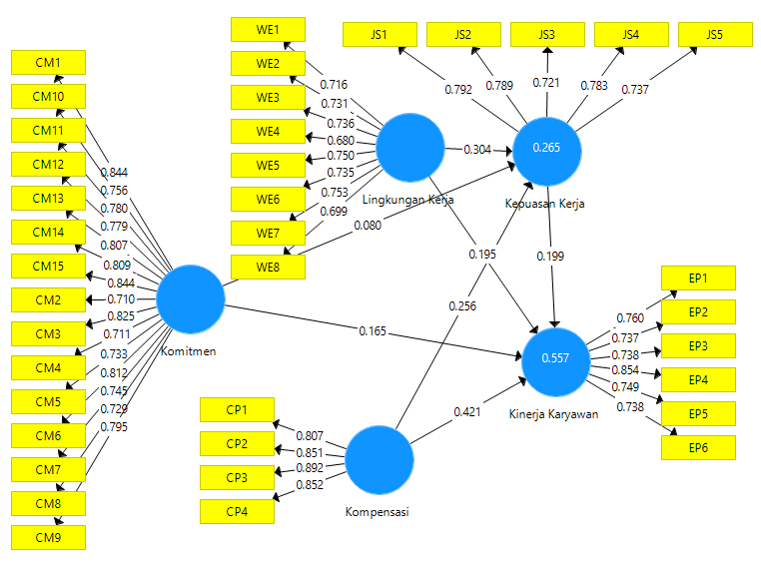

Source: data processing with PLS, 2023.

Based on Figure 1, there are 38 indicators used in this research. The first outer results show 2 indicators that are not significant, including; WE4 and WE8.

Table 2 Outer Loading *(Measurement Model)*

|  |  |  |  |  |  |
| --- | --- | --- | --- | --- | --- |
|  | Commitment | Work environment | Compensation | Job satisfaction | Performance  employee |
| X1.1 | 0.844 |  |  |  |  |
| X1.2 | 0.756 |  |  |  |  |
| X1.3 | 0.780 |  |  |  |  |
| X1.4 | 0.779 |  |  |  |  |
| X1.5 | 0.807 |  |  |  |  |
| X1.6 | 0.809 |  |  |  |  |
| X1.7 | 0.844 |  |  |  |  |
| X1.8 | 0.710 |  |  |  |  |
| X1.9 | 0.825 |  |  |  |  |
| X1.10 | 0.711 |  |  |  |  |
| X1.11 | 0.733 |  |  |  |  |
| X1.12 | 0.812 |  |  |  |  |
| X1.13 | 0.745 |  |  |  |  |
| X1.14 | 0.729 |  |  |  |  |
| X1.15 | 0.795 |  |  |  |  |
| X2.1 |  | 0.716 |  |  |  |
| X2.2 |  | 0.723 |  |  |  |
| X2.3 |  | 0.735 |  |  |  |
| X2.4 |  | - |  |  |  |
| X2.5 |  | 0.771 |  |  |  |
| X2.6 |  | 0.776 |  |  |  |
| X2.7 |  | 0.771 |  |  |  |
| X2.8 |  | - |  |  |  |
| X3.1 |  |  | 0.807 |  |  |
| X3.2 |  |  | 0.851 |  |  |
| X3.3 |  |  | 0.892 |  |  |
| X3.4 |  |  | 0.852 |  |  |
| Y2.1 |  |  |  | 0.790 |  |
| Y2.2 |  |  |  | 0.790 |  |
| Y2.3 |  |  |  | 0.719 |  |
| Y2.4 |  |  |  | 0.785 |  |
| Y2.5 |  |  |  | 0.738 |  |
| Y1.1 |  |  |  |  | 0.761 |
| Y1.2 |  |  |  |  | 0.737 |
| Y1.3 |  |  |  |  | 0.737 |
| Y1.4 |  |  |  |  | 0.854 |
| Y1.5 |  |  |  |  | 0.749 |
| Y1.6 |  |  |  |  | 0.738 |

Source: primary data processing, 2023.

Figure 3 second external model

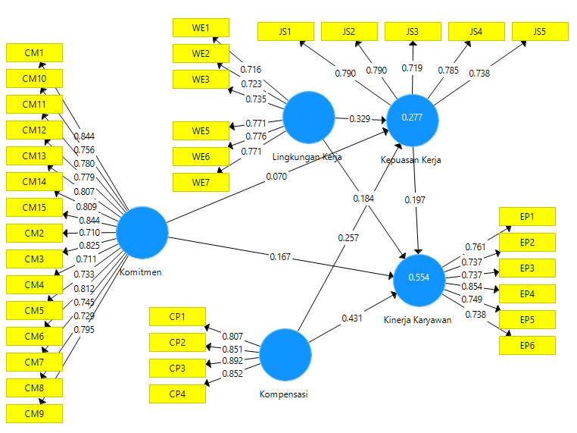

Based on Figure 3, after re-estimation was carried out again by removing indicators that were not significant, it can be seen that all indicators were declared significant with a factor loading value of >0.708 which is recommended, because it shows that the latent variable can explain 50 percent of the indicator variance, thus providing acceptable item reliability (Hair et al., 2018).

1. Reliability Test

The reliability test of the *Composite Reliability value* with *the Rule of Thumb for latent variables is declared reliable >0.7 for confirmatory* research and a value of 0.6-0.7 is still acceptable for *explonatory research*, and *the average variance extracted* (AVE) value must be >0.5 (Ghozali, 2021; Hair et al. al., 2018) shows reliability in proving the accuracy, consistency and determination of the instrument in latent variables. The results of the analysis are as follows:

Table 3 Construct Validity and Reliability Test

|  |  |  |  |  |
| --- | --- | --- | --- | --- |
|  | Cronbach's Alpha | rho_A | Composite Reliability | Average Variance Extracted (AVE) |
| Job satisfaction | 0.826 | 0.841 | 0.876 | 0.585 |
| Employee performance | 0.857 | 0.860 | 0.893 | 0.583 |
| Commitment | 0.954 | 0.960 | 0.959 | 0.608 |
| Compensation | 0.873 | 0.875 | 0.913 | 0.724 |
| Work environment | 0.845 | 0.853 | 0.885 | 0.561 |

Source: Data management with PLS, 2023.

Based on the table above, the *composite reliability output results* for all research variables are above 0.7, it can be concluded that *composite reliability* is good.

1. Evaluate the R-Square value

Analysis of the coefficient of determination (R2) is a standard of model prediction accuracy used to explain how much influence certain exogenous latent variables have on endogenous latent variables, whether they have a substantive influence. R-Square values of 0.75, 0.5, and 0.25 can be concluded that the model is strong, moderate, and weak (Ghozali, 2023).

Table 4 Construct Reliability and Validity

|  |  |  |
| --- | --- | --- |
|  | R-Square | R Square Adjusted |
| Job satisfaction | 0.277 | 0.261 |
| Employee performance | 0.554 | 0.540 |

Source: PLS data management, 2023.

Based on the coefficient of determination it can be seen that the stone geisser Q Square is 0.509. This means that the results of the analysis show that the level of diversity of the model has good feasibility, because the model is able to describe the actual conditions by 50.9%, while the remaining 49.1% is due to research instrument limitations and errors. The coefficient of determination value is quite high, so the model is suitable for interpretation.

1. Hypothesis Test Results

Hypothesis testing in PLS analysis is the value contained in *the output result for inner weight, estimate for part coefficients* , which is testing the significance of the path coefficient value in the model. The bootstrap resampling method was used to minimize data non-normality. The significance value used is *the t-value* 1.96 ( *significance level* = 5%) (Ghozali, 2021)

Table 5 Hypothesis Testing of Part Coefficient (Mean STDEV, P-Value

|  |  |  |  |  |  |  |  |  |  |  |
| --- | --- | --- | --- | --- | --- | --- | --- | --- | --- | --- |
|  | Original Sample (O) | | Sample Mean (M) | | Standard Deviation (STDEV) | | T Statistics (|O/STDEV|) | | P Values | |
| Satisfaction - > Employee Performance | | 0.197 | | 0.200 | | 0.081 | | 2,444 | | 0.015 | |
| Commitment -> Job Satisfaction | | 0.070 | | 0.073 | | 0.096 | | 0.733 | | 0.464 | |
| Commitment -> Employee Performance | | 0.167 | | 0.172 | | 0.074 | | 2,262 | | 0.024 | |
| Compensation -> Job Satisfaction | | 0.257 | | 0.257 | | 0.085 | | 3,005 | | 0.003 | |
| Compensation -> Employee Performance | | 0.431 | | 0.422 | | 0.091 | | 4,710 | | 0,000 | |
| Work environment  -> Job Satisfaction | | 0.329 | | 0.342 | | 0.080 | | 4,099 | | 0,000 | |
| Work environment  -> Employee Performance | | 0.184 | | 0.183 | | 0.081 | | 2,274 | | 0.023 | |

Source: data management with PLS, 2023.

Measuring the intervening role was carried out by testing the hypothesis through a Parth diagram resulting from Bootstrapping to prove the ability of the job satisfaction variable to be an intervening variable for the latent variables of commitment, work environment and compensation on employee performance. The results of *the Specific Indirect Effect* calculation are as follows:

Table 6. Specific Indirect Effect

|  |  |  |  |  |  |
| --- | --- | --- | --- | --- | --- |
|  | Original Sample (O) | Sample Mean (M) | Standard Deviation (STDEV) | T Statistics (|O/STDEV|) | P Values |
| Commitment -> Job Satisfaction - > Employee Performance | 0.014 | 0.016 | 0.023 | 0.599 | 0.550 |
| Compensation -> Job Satisfaction - > Employee Performance | 0.051 | 0.052 | 0.029 | 1,752 | 0.080 |
| Work Environment - > Job Satisfaction -> Employee Performance | 0.065 | 0.068 | 0.031 | 2,083 | 0.038 |

Source: data management with PLS, 2023.

# Discussion

1. The research results show that commitment has a positive and significant effect on employee performance (H1 is accepted). These results support research findings (Hendri 2019; Isse et al., 2018) which explain that employees who have commitment can reflect strengths that show loyalty, carry out solid coordination between individual values and goals and support organizational goals and even put in more effort. work that can improve employee performance. Another perspective from the exchange-based theory *(side bet theory)* or side bet from Backer (1960) explains that commitment can be measured from a person's job role or position regardless of the stressful conditions faced. So it can be interpreted that organizational commitment is the employee's psychological sympathy and dedication to achieving the performance expected by the company. However, this research is not in line with Amin (2022) who explains that commitment has no effect on employee performance.
2. work environment has a positive and significant effect on performance (H2 is accepted). This finding is in line with research (Meregawa & Suwandana, 2020; Idris et al., 2020; Komang et al., 2018 and EkaWati et al., 2021) which reveals that a comfortable work environment can motivate employees to work by utilizing the level of job satisfaction by the best. Another perspective from social exchange theory *(Social Exchange Theory)* used to explain a person's work behavior (Cropanzano & Mitchell, 2005) states that someone who provides other people with valuable and useful resources feels obliged to return something comparable that will appear. Management is expected to be able to encourage initiative and creativity that creates employee enthusiasm to unite in the organization to achieve goals through the work environment so that it has a positive impact on employee performance. In contrast to Riyadi's empirical research, (2019) did not find a significant effect of improving the work environment. The work environment does not affect employee performance because the work environment provided by the organization does not meet employee needs.
3. Compensation has a positive and significant effect on employee performance (H3 is accepted). The research results are supported by (Kadhias Akabar, 2022; Komang et al, 2018; and Sugiono Edi et al., 2021) stating that adequate compensation is highly correlated with social competence, with good enough competence it can provide peace of mind and determination for related employees. by fulfilling life's needs so that employees concentrate more on providing the best performance for the company. The perspective in terms of motivators and *hygiene* shows that indirectly, employees feel satisfaction from several factors, including compensation, so that the level of satisfaction and dissatisfaction depends on what employees feel about the applicable company policies in accordance with the two-factor theory (Herzberg, 1959). This statement is not in line with research (Hutahayan 2021; Idris et al., 2020) which states that employee performance levels are not affected by the size of compensation.
4. Commitment has no significant effect on job satisfaction. The research results show that commitment has a positive and insignificant effect (H4 is rejected). In line with Muhammadin's research, (2022) stated that employee commitment is higher but has not been able to contribute to employee job satisfaction. Therefore, companies must clarify organizational goals and policies to foster employee commitment.
5. The work environment has a positive and significant effect on job satisfaction. The research results show that the work environment has a positive and significant effect (H5 is accepted). In line with research conducted by (Komang et al., 2018; Idris, 2020; and Wahiddi et al., 2021) it is stated that the work environment must support work activities, because it has been proven that the work environment triggers employees to feel job satisfaction by working more effectively and efficient to achieve organizational goals with what is done in the work.
6. compensation has a positive and significant effect on job satisfaction. The research results show that compensation has a positive and significant effect (H6 is accepted). Agree with research (Komang et al., 2018; Sugiono Edi et al., 2021; and Muhammadin, 2022) which states that the higher the compensation received, the more significant it will be to increase job satisfaction. Especially in providing fair incentives to employees.
7. Job satisfaction has a significant effect on employee performance. The research results show that job satisfaction has a significant effect (H7 is accepted). in line with research (Hendri, 2019, Isse et al., 2018, Amin, 2022, Idris, 2019, Riyadi, 2019, and Hutahayan, 2021) stating that the more satisfied employees are with their work, the better the employee's performance. so companies must consider the suitability of salaries, incentives, allowances and supporting work facilities to create a work environment that meets employee satisfaction and performance. Job satisfaction is an important element for implementing human resource management and organizational behavior.
8. Commitment has no significant effect on employee performance which is mediated by job satisfaction. *(Direct-Only Non-Mediation)* (H8 rejected)*.* In agreement with research by Arifin et al., (2022) which states that the higher organizational commitment , the satisfaction will increase so that it will have an impact on employee performance and vice versa. However, research findings reveal the level of employee commitment. Most of them depend on the company to meet their living needs. However, it is not in line with job satisfaction, indicating that the salary received is not able to meet life's needs, which has a negative impact on employee performance.
9. The work environment has a positive and significant effect on employee performance through job satisfaction playing a full role in mediating the influence of the work environment on employee performance *(full mediation)* (H9 accepted) *.* work is in line with studies (Ekawati et al., 2021; Indris 2020) which reveal that a good work environment has an indirect effect on improving employee performance through job satisfaction.
10. Compensation has an insignificant effect on employee performance through job satisfaction and cannot mediate the effect of commitment on employee performance *(Direct-Only Non-Mediation)* (H10 is rejected)*.* agree with studies (Indris, 2020 and Hutahayan, 2021) stating that the size of the compensation level cannot affect performance, this is because some employees consider that providing compensation by the company is an obligation and necessity for what employees give to the company.

# Conclusion

Based on the results and discussion, the conclusion in this research is that improving employee performance at PT Sai Apparel Industries in the finishing sector can be done by optimizing commitment, work environment and compensation. Increasing commitment can be supported by an emotional approach towards employees to grow employees' organizational commitment to remain committed to work. Creating a conducive work environment that has an impact on the integrity of employees who collaborate so that employees will not neglect that what is required of a job is responsibility. The compensation given by the company is considered not to be balanced with the workload which must be considered with aspects of feasibility and fairness.

# Recommendation

Implementation of commitment must be the totality of employees in carrying out every work activity. So companies need to pay attention to the work environment and compensation as its potential. Creating a stronger commitment to employees can provide job satisfaction and improve employee performance. The limitations of this research are that research using a questionnaire allows the answers given by respondents not to lead to the actual situation and the use of a limited sample so that the ability to generalize and validate the results is very limited.

Further research is recommended to use several similar companies so that they can explain a broader understanding, increase the number of respondent samples, with the hope that the greater the number of samples the higher the level of data accuracy, add other variables that influence employee performance besides the variables used in this research, so that the results are more measurable and more perfect. So that it can produce new research models by increasing the number of research references that support the topic being researched.

# Reference

Amin, Muh. S. (2022). Organizational Commitment, Competence on Job Satisfaction and Lecturer Performance: Social Learning Theory Approach. *Golden Ratio of Human Resource Management*, *2*(1), 40–56. <https://doi.org/10.52970/grhrm.v2i1.156>

Arifin, Sarangi.., Hermansyur, M., & Sunaryo, ). (2022). *Pengaruh Komitmen Organisasi Terhadap Kinerja Karyawan Melalui Kepuasan Kerja Sebagai Variabel Intervening Pada Pt. Graha Mandiri Barata Medan*.

Baert, S., Lippens, L., Moens, E., Sterkens, P., & Weytjens, J. (2020). *How Do We Think the COVID-19 Crisis Will Affect Our Careers (If Any Remain)?* [www.iza.org](http://www.iza.org)

Becker, HS (1960). Catatan tentang konsep komitmen. Jurnal Sosiologi Amerika, 66(1), 32-40.

Cropanzano, R., & Mitchell, M. S. (2005). Social exchange theory: An Interdisciplinary review. *Journal of Management,* 31(6), 874-900. https:doi.org/10.1177/0149206305279602

EkaWati, V. D., Aima, M. H., & Hazrati, I. L. (2021). The Influence of Organizational Culture and Work Environment on Employee Performance with Job Satisfaction as Mediation (Case Study on West Jakarta Mayor’s Office Employees). *European Journal of Business and Management Research*, *6*(4), 383–387. https://doi.org/10.24018/ejbmr.2021.6.4.1043

Fluegge-Woolf, E. R. (2014). Play hard, work hard: Fun at work and job performance. *Management Research Review*, *37*(8), 682–705. https://doi.org/10.1108/MRR-11-2012-0252

Ghozali, Imam. 2021. *Partial least squares konsep, teknik dan aplikasi menggunakan program SmartPLS 3.2.9 untuk penelitian empiris*. Semarang: Badan Penerbit Universitas Diponegoro.

Hair, J. F., Risher, J. J., Sarstedt, M., & Ringle, C. M. (2019). When to use and how to report the results of PLS-SEM. In *European Business Review* (Vol. 31, Issue 1, pp. 2–24). Emerald Group Publishing Ltd. <https://doi.org/10.1108/EBR-11-2018-0203>

Hendri, M. I. (2019). The mediation effect of job satisfaction and organizational commitment on the organizational learning effect of the employee performance. *International Journal of Productivity and Performance Management*, *68*(7), 1208–1234. <https://doi.org/10.1108/IJPPM-05-2018-0174>

Herzberg, 1959. The Motivation to Work. New York: John Willey and Sons.

Hutahayan, B. (2021). The Role of Compensation as a Determinant of Employee Performance and Employee Job Satisfaction: A Study in PT Bank Rakyat Indonesia (Persero) Tbk. *Journal of Information and Knowledge Management*, *20*(4). <https://doi.org/10.1142/S0219649221500490>

Idris, Adi, K. R., Soetjipto, B. E., & Supriyanto, A. S. (2020). The mediating role of job satisfaction on compensation, work environment, and employee performance: Evidence from Indonesia. *Entrepreneurship and Sustainability Issues*, *8*(2), 735–750. <https://doi.org/10.9770/jesi.2020.8.2(44)>

Isse, Hasan, H.,Abdirahman. (2018). The relationship between job satisfaction, worklife balance and organizational commitment on employee performance. *Academic Journal of Economic Studies*, <http://hdl.handle.net/11159/2489>

Kalogiannidis, S. (2021). The Impact of COVID-19 on Human Resource Management Practices and Future Marketing. *International Journal of Industrial Marketing*, *6*(1), 43. <https://doi.org/10.5296/ijim.v6i1.17994>

Luthans, Fred. 2002. Organizational Behavior: 7th Edition. New York: McGraw-  
Hill Inc

Luthans, Fred. 2011. Perilaku organisasi. Yogayakarta : Andi.

Luthans. Fred. 2015. Perilaku Organisasi. Yogyakarta: Andi.

Kandhias Akbar, Y., & Kandhias Akbar, Yunata. (2022). Analysis Of The Influence Of Organizational Commitment, Motivation And Compensation On Employee Performance. *Central Asia And The Caucasus*, *23*(1), 2022. <https://doi.org/10.37178/ca-c.23.1.112>

Kazan, H., & Gumus, S. (2013). Measurement of employees' performance: A state bank application. International Review of Management and Business Research, 2(2), 429-441.

Komang, I., Permadi, O., Landra, N., Gusti, I., Eka, A., Kusuma, T., & Sudja, I. N. (2018). The Impact Of Compensation And Work Environment Towards Job Satisfaction To Affect The Employee Performances. In *International Journal of Management and Commerce Innovations* (Vol. 6). www.researchpublish.com

Meregawa, N. F., & Suwandana, G. M. (2020). Work Environmental Analysis of Employee Performance With Reward As Mediation Variables (Case Study On Bay Beach Resort & Spa Jimbaran. In *American Journal of Humanities and Social Sciences Research* (Issue 8). www.ajhssr.com

Muhammadin, A. (2022). Pengaruh Komitmen Organisasi, Budaya Organisasi Dan Kompensasi Terhadap Kepuasan Kerja Sebagai Variabel Intervening Terhadap Kinerja Pada Kantor Dinas Koperasi Dan Ukm Kota Makassar. *Movere Journal*, *4*(1), 1–10. <http://ojs.stie-tdn.ac.id/index.php/mv>

N. Marlina., Yusuf, Hendra, R. E., Sibarani, J., Lubis, S., & Sutanto, A. T. (2021). The Effect Of The Working Environment And Incentives On Employee Performance With Job Satisfaction As Variables Moderating In The Management Agency Regional Finance Of Langsa City. *South East Asia Journal of Contemporary Business, Economics and Law*, *24*.

Riyadi, S. (2019). The Influence Of Job Satisfaction, Work Environment, Individual Characteristics And Compensation Toward Job Stress And Employee Performance. *International Review Of Management And Marketing*, *9*(3), 93–99. <Https://Doi.Org/10.32479/Irmm.6920>

Robbins, P. Stephen. 2006. Perilaku Organisasi. Edisi Sepuluh. Diterjemahkan oleh: Drs. Benyamin Molan. Erlangga, Jakarta.

Sedarmayanti. 2018. Sumber Daya Manusia dan Produktivitas Kerja.  
Bandung: CV.Mandar Maju.

Simamora Henry. 2006. Manajemen Sumber Daya Manusia. Yogyakarta: SIE YKPN

Sugiono Edi, Darmaji, & Efendi Suryono. (2021). kompentensi terhadap kinerja melalui kepuasan kerjaa. *Jurnal Manajemen Dan Bisnis Indonesia* , *07*, 132–149. unmuhjember.ac.id

Sulaeman, M., Metris, D., Rusliana, I., Teknologi dan Bisnis Muhammadiyah Purbalingga, I., & Sunan Gunung Djati, U. (2021). *The Importance Of Education, Competence, Work Environment, Work Discipline, And Compensation In Improving Employee Performance*. <https://ejournal.unperba.ac.id/index.php/pijeb>

Wahyudi, K., Ruslan, M., Campaniga Kecamatan Camba, K., & Maros, K. (2021). Pengaruh Komitmen Organisasi Dan Lingkungan Kerja Terhadap Kinerja Pegawai Melalui Kepuasan Kerja Pada Kantor Pemerintah Kecamatan Camba Kabupaten Maros The Influence of Organizational Commitment and Working Environment on Employee Performance through Work Satisfaction in Government Office of Camba District Maros Regency. In *Idn. J. of Business and Management* (Vol. 3, Issue 2). https://postgraduate.universitasbosowa.ac.id/index.php/jbm

**#Note:**

Journal volume in header adjusts.