**ANALYSIS IMPLEMENTATION STRATEGY DIGITAL MARKETING IN ERA SOCIETY 5.0 FOR PRODUCEN TOFU MEATBALL MAS ARTA**

**Arta Prawira Dinata1,Siti Istikhoroh2, Untung Lasiyono3**

Master of Management Student at Universitas PGRI Adi Buana Surabaya1

Master of Management Lecturer at Universitas PGRI Adi Buana Surabaya2,3

Email : [artaprawir@gmail.com](mailto:artaprawir@gmail.com), [Istikhoroh_Siti@unipa.ac.id](mailto:Istikhoroh_Siti@unipa.ac.id), [untunglasiyono@unipa.ac.id](mailto:untunglasiyono@unipa.ac.id)

**Abstrak :** In era society 5.0 the development of technology and information is growing very quickly and developing increasingly rapidly. Companies that can compete in the era society 5.0 are companies maximizing the benefits of information technology developments, especially in the product marketing process, digital marketing strategy is one of the most effective strategies. and efficient to carry out the product marketing process. This research aims to determine the implementation of digital marketing strategies in the era of society 5.0 in Mas Arta meatball tofu producers. The research method used is a qualitative method with an interpretive paradigm which aims to gain insight into the digital marketing strategy implemented by the Mas Arta meatball tofu producer in the era of society 5.0. The results of this research are the iImplementation of Digital Marketing Strategy in the Society 5.0 Era at the Mas Arta Bakso Tofu Producer for its consumers referring to the digital marketing marketing mix. There are several components in the digital marketing marketing mix, namely; Product, price, distribution, promotion, so that these components run well, the Mas Arta meatball tofu producer takes an integrated digital marketing approach. This approach is used to answer the implementation of digital marketing strategies in the era of society 5.0 for the Mas Arta meatball tofu producer: Using advertising/ads on the applied platform, Carrying out live/introducing products directly through the social media used, Utilizing content creators as the originator of product marketing..

**Keyword:** *Digital marketing strategy, Society 5.0, meatball tofu producer, implementation, content analysis.*

1. **INTRODUCING**

In the era of society 5.0, the development of technology and information is growing very quickly, the development of information technology is growing very rapidly, various kinds of business activities from MSMEs and macro equivalents are taking advantage of this development in their businesses (Khanafi, 2023). The development of information technology has changed the world of marketing in recent years. The increasing number of internet users can certainly be an opportunity for business owners to be able to use it as a sales prospect (Setiawan et al., 2023). The benefit of internet technology is that humans can do various things, such as socializing and communicating with other humans at close or long distances. Apart from that, you can use it to read articles, get the information you need, and even do online shopping. This technological change means that humans can carry out activities at home or outside the home, because marketing communications that were initially carried out conventionally can now be carried out using internet marketing. Marketing activities that utilize sophisticated digital technology are often called digital marketing. Digital marketing consists of interactive and integrated marketing that facilitates interaction between producers, market intermediaries and potential consumers (Purwana et al., 2017).

To maintain a competitive advantage in the modern digital economy, businesses need to improve their strategic management approach. In addition to the creation of new products or services, it is important to consider the company's operations, connections with clients, and ongoing creation of added value when formulating innovative strategies [(Afrizal, dkk, 2024)](https://jurnal.unipasby.ac.id/index.php/jamanis/article/view/8913/5515)

Digital marketing has many advantages compared to conventional marketing strategies (door to door), including in measuring the success of a company (Nursatyo & Rosliani, 2018). Digital marketing can provide benefits for business actors in monitoring and providing all the needs and desires of potential consumers. On the other hand, potential consumers can search for and obtain product information just by browsing cyberspace, thus making the search process easier (Irfani et al., 2020).

businesses need to monitor current trends and adapt their marketing strategies to these changes [(Afrizal, 2024)](https://journal.ipm2kpe.or.id/index.php/INTECOM/article/download/10465/6549/). Digital marketing is the main key in determining the success of a business. This is because implementing digital marketing can help business actors track customer activity in real time and new products released via the internet can have a wide reach and involvement. So that business actors can understand customer needs accurately (Kaur, 2017).

Business actors should be able to utilize digital media as one of their product marketing efforts, so that customers can become more familiar with the products produced by these business actors. Business actors who have online access, are involved in social media, and develop their e-commerce capabilities, this will enable business actors to gain significant profits. However, many business actors still have not implemented marketing strategies through digital marketing, due to a lack of knowledge and role in using digital media for marketing strategies (Naimah et al., 2020).

Mas Arta Bakso Tofu Producer, which was founded in 2018, is one of the meatball tofu producers in Surabaya. Has also implemented digital marketing strategies. Digital marketing has now been recognized as a necessity, because digital marketing strategies can connect various market segments in various cities, both nationally and internationally. Since 2021, Mas Arta Bakso Tofu Producer has begun to focus on online marketing to reach the furthest markets.

**Digital Marketing**

Digital marketing is a marketing activity using digitalization in the form of websites, social media and e-mail which aims to increase the number of customers (Chaffey & Ellis-Chadwick, 2019). Digital marketing is a marketing activity using digitalization in the form of websites, social media and e-mail which aims to increase the number of customer Digital marketing itself is one of the marketing media that is currently in great demand by business people, both micro and macro businesses, to attract customers who are interested in offering goods or services. Businesses are now starting to abandon old marketing methods (conventional) and switch to new methods (online), namely digital marketing (Sukmasetya et al., 2020).

Digital marketing is also known as company activities to create and inform product value to customers (Muljono, 2018). With digital marketing, it can improve marketing strategies and become a very appropriate choice for millennials and generation z (Afrilia, 2018).

The importance of digital marketing in the business world, the more people who know about your business, the faster your business will get transactions. Digital marketing has an important role in reaching wider market segments through more practical methods compared to conventional methods (Sari et al., 2023a).

**Digital Marketing Strategy**

Digital marketing is the use of technology based on digitalization to market business products online. The following are several digital marketing strategies that can be implemented:   
1. Optimasi Mesin Pencari (SEO)

Efforts to increase site rankings in search engine search results. To be able to achieve top rankings, you must understand how search engines work. Media that can be used include websites, blogs, and infographics (Lukito et al., 2014). The following are the efforts used if you have on-page SEO:

a). Keyword research includes keywords that consumers often use to enter content on websites (Komalasari et al., 2021).

b). Content Marketing, contains content that is needed more by customers. The more it is needed, food will definitely be sought (Rahman, 2019).

c). Focusing on access speed, the Google website will place content that opens faster at the beginning of the results page (Ahmad et al., 2022).

d). Sub Header Correct, using keywords in the sub header will increase ranking in search engines (Achmady, 2016)

e). Internal links, inserting links into website content makes the discussion more concise (Sari et al., 2023a)

**SOCIAL MEDIA**

Social media is a medium whose function is to socialize with each other and is done online which allows people to interact without being limited by space and time. Selling products using social media to attract buyers by providing information related to the products offered to consumers (Habibi, 2018).

Marketing activities for a product or service that uses social media as a promotional medium for a product or service is the meaning of social media marketing. Social media marketing is used to introduce products or services to the public (Geralda & Kasih, 2020). Each social media has its own function and use which can be profitable in carrying out promotions. Social media is very important in the era of society 5.0 to carry out digital marketing activities where consumers can communicate with business people. In the era of society 5.0, various platforms are very influential for digital marketing methods. For example: a). TikTok, b). Shopee, c). Tokopedia, d) Instagram, e). Facebook. All of these publishers are very influential and very profitable for business people in the era of society 5.0 (Sari et al., 2023b).

1. **RESEARCH METHODS**

This research uses a qualitative approach with an interpretive paradigm which aims to gain insight into the digital marketing strategies implemented by Mas Arta meatball tofu producers in the era of society 5.0 (Somantri, 2005). This method used is descriptive. The subjects in this research are individuals who are owners and employees of the Mas Arta meatball tofu producer. Researchers will conduct interviews with sources, namely: a). Owner of Mas Arta meatball tofu producer, b). Marketing supervisor The data collection method uses interviews (interview) in depth which is carried out directly in the field (Rahardjo, 2011). Data analysis was carried out using data analysis techniques developed by (Creswell, 2021) as follows: a). compiling and preparing the data to be analyzed, b). read all the data that has been written to find meaning of the research findings, c). carry out programming on the data to sort the data, d). use programming results to combine by category, e). make reportsfrom programming results and categories, f). interpreting qualitative research findings data.

1. **RESULTS AND DISCUSSION**

**Overview Produsen Tofu Meatball Mas Arta**

Producen tahu bakso mas arta r is an industry that produces various kinds of meatball tofu and meatballs, which was first established by Mas Arta, located on JL. Lidah Harapan XXIX Block AE/10, Lidah Wetan sub-district, Lakarsantri sub-district, Surabaya city. Before establishing this business, Mas Arta was an employee at a stateowned bank who at that time also had additional work, namely being a meatball tofu entrepreneur. As time went by and many people liked Mas Arta's meatball tofu, people also asked Mas Arta to actively produce this meatball tofu. Because he didn't have enough time to work effectively with selling, Mas Arta chose to develop the meatball tofu. Mas Arta's meatball tofu producer was finally founded by Mas Arta in 2018.

The tofu meatball producing industry was initially established only by the community itself without any employees. The production and marketing processes are carried out in-house. Marketing is carried out conventionally, namely doingdoor to doorin private/state company offices, in schools, and also retailers close to home in the Tongue Wetan area of Surabaya city. As sales of meatball tofu grow, the business develops by recruiting employees according to their respective positions, namely; production positions, marketing spv positions, marketing, and also sales so that work can be carried out effectively and efficiently.

Produsen tofu meatball mas arta are growing, business competition is becoming more competitive, and technological developments are very rapid, Mas Arta meatball tofu producers are making production in frozen packaging, where Mas Arta hopes that these products will get a wider market segment up to the national level. There are many permits that must be taken care of by producers of Mas Arta meatball tofu, such as; Business Permit (NIB), PIRT, and also Halal Certification from the government of the Republic of Indonesia. For sales using frozen packaging, Mas Arta must complete the permits that have been determined by the government of the Republic of Indonesia.

The marketing strategy used by the Mas Arta meatball tofu producer uses a digital marketing strategy that is currently competitive in the era of society 5.0. Many e-commerce platforms and digital content are used by mas arta, such as Tokopedia, Shopee, TikTok, Instagram, WhatsApp and Facebook

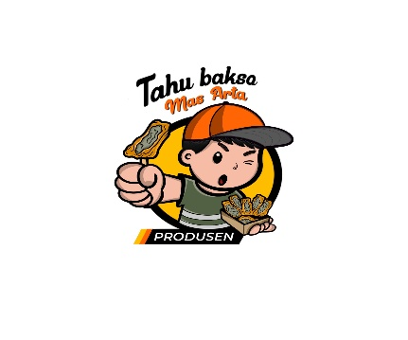**Figure 1. Logo Produsen Tofu Meatball Mas Arta**

**License Letter Produsen Tofu Meatball Mas Arta**

To carry out sales in a wide market segment conventionally and online, the producer of Mas Arta meatball tofu has obtained several permits such as NIB, PIRT, and Halal Certification. Mas Arta meatball tofu producers can compete in the era of society 5.0.

**Gambar 2. Surat izin berusaha, PIRT, Halal**

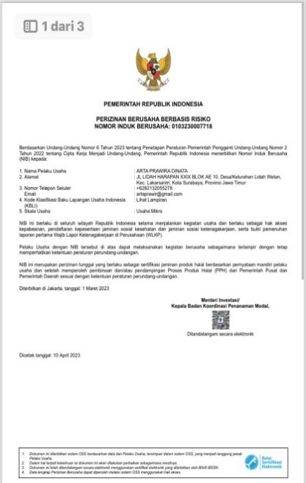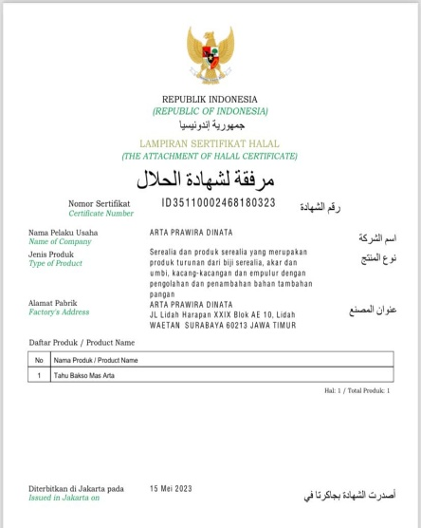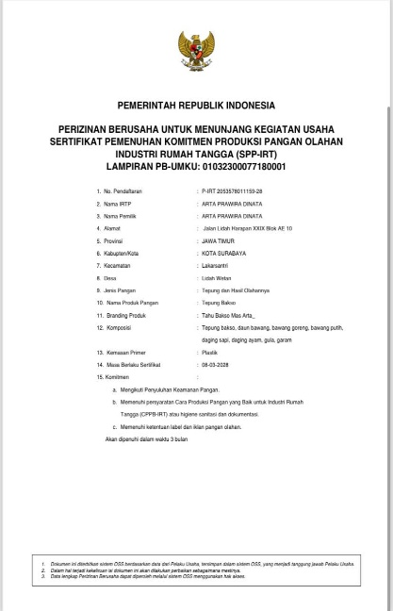

Business License number; 0103230007718

PIRT letter number; P-IRT 2053578011159-28

Halal Certification Letter number; ID35110002468180323

The unique thing about the Mas Arta Tofu Meatball Producer is that it has many different flavors, such as; original, mushroom, spicy, quail and cheese. The flavor variants in the Mas Arta meatball tofu producer's menu itself are input from consumers. Regarding the Mas Arta meatball tofu producer's product, it also has an interesting form of tofu combined with quite a few beef and chicken meatballs. Proportions according to consumer wishes. Because of the attractive variants and sizes, consumers are more interested and really like it because it is unique and interesting with the combination of meatball tofu and its variations. Currently, mushrooms and quail are the favorite variants that consumers are usually interested in.

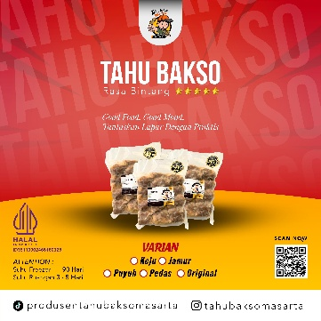**Figure 3. (Instagram source Produsen Tofu Meatball Mas Arta)**

Prices set start from Rp. 15,000- Rp. 32,000 price is the price per portion that has been determined. To know, original meatballs containing 9 pieces are priced at IDR 15,000, and those containing 15 are priced at IDR. 27,000, for flavors ranging from mushroom, spicy and cheese per pack containing 9 at a price of 20,000, and containing 15 for 32,000. price of mushrooms per portion containing 9 pieces Rp. 22,000, up to 15 contents at Rp. 34,000.

In the marketing process itself, meatball tofu producers sell offline and online. In this case, meatball tofu producers have 3 ways of interaction, namely;

a). Consumers can come to the production site at the address, JL. Lidah Harapan XXIX Block AE/10, Lidah Wetan sub-district, Lakarsantri sub-district, Surabaya city.

b). Consumers can order via the GoJek or Grab application, which consumers feel is too far away or haven't had time to stop by the outlet, the GoJek and Grab applications make it very easy for consumers to enjoy products from the Mas Arta meatball tofu producer.

**Figure 4. (Application source Gojek&Grab)**

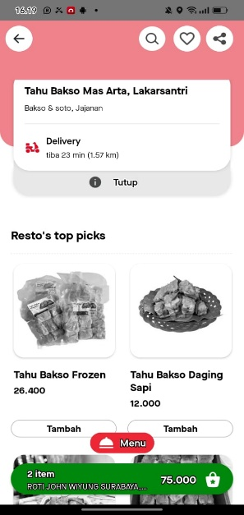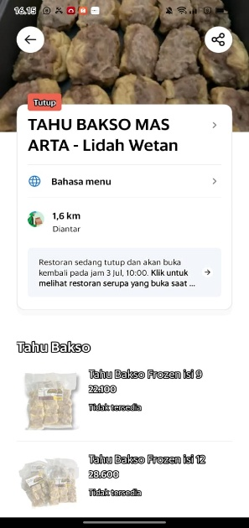

c). Orders can be made via the Shopee and Tokopedia e-commerce applications, for consumers who feel the reach is very far, more than 20km from the production site to the consumer's location.

**Figure 5. (Source Shopee & Tokopedia)**

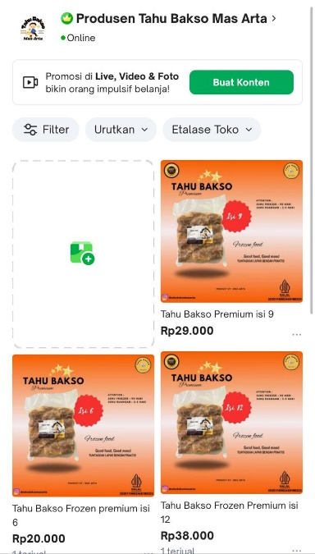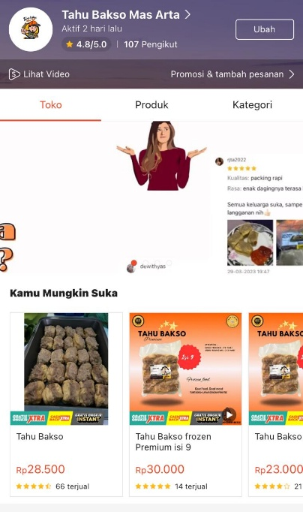

The process of in-depth interviews and observations was carried out on informants, namely, Mas Arta as owner, Hafiz as SPV Marketing. In this era of society 5.0, actors must be able to compete in technological developments, especially in the marketing process. Online marketing utilizes social media, chat platforms, partnerships with marketplaces, and the use of other platforms, making it easier for business actors to attract consumers and interact directly.

Produsen tahu bakso mas arta use social media to provide information and communicate with consumers. The social media that are often used are Instagram and TikTok. This platform is quite effective in informing consumers about the Mas Arta meatball tofu producer's products directly with consumers. The chat platforms used are WhatsApp, Instagram/Tiktok.

Produsen tahu bakso mas arta also partner with marketplaces to sell their products. That is; Gofood, Grabfood, Shopee, Tokopedia, Facebook. This partnership is also carried out in accordance with consumer needs and the ease of ordering delivery via the application.

**Digital Marketing Implementation Strategy**

In carrying out business marketing, the Mas Arta meatball tofu producer makes various efforts to introduce its products so that they are better known to consumers, both old and new. In this case, there is a need for effective and efficient communication to support the marketing process and introduceprodusen tahu bakso mas arta products through social media such as the Mas Arta exposure**.**

“… in the past it was just an offerdoor to doorto several offices, schools, friend relations, etc. Then I asked friends, especially friends, to offer if they wanted to order, I would open the PO system (pre order) which can be ordered via WhatsApp, as well as consumers in office premises. Not only that, I also think that in this day and age, everything can be accessed online. So here I also decided to sell meatball tofu online, at that time, it was just Instagram and WhatsApp status.

The journey produsen tofu meatball mas arta process is not only through direct marketing which is carried out starting from the owner's friendship process with his friends and neighbors, but the owner also uses social media as one of his marketing strategies.

“…I think social media itself in the era of society 5.0 is very important for us to pursue, because we now live in an era of increasingly sophisticated technological development. So we have to be able to compete in the current era.

The opinion of the owner of Mas Arta's meatball tofu in the era of society 5.0 was when asked how he could focus on marketing while Mas Arta had already carried out production and then in the process of finishing the meatball tofu product itself, he had used up quite a lot of human energy

“…it's like this, sir, at first I felt it wasn't very effective, because I myself had spent a lot of energy in the production department, then I moved on to marketing, which I felt wasn't optimal, so I came up with the idea of creating my own marketing division where I could later focus on production, and the marketing division can focus on its position.

Currently, have you got human resources in the marketing field?

“…yes, I have got 5 human resources consisting of SPV Marketing, then 4 are direct sales. You can directly interview SPV Marketing, or their subordinates.

SPV Marketing's opinion, to what extent has Hafiz done marketing to sell Mas Arta's meatball tofu products?

“…of course in offline and online marketing, bro, for offline I am assisted by 4 direct sales whose job is to market products face to face (door to door), if I go online myself, I manage it by utilizing social media as digital marketing.

SPV Marketin's opinion, how to use digital marketing strategies so that sales of the Mas Arta meatball tofu producer's products increase significantly.

“…of course, while I have been working here for almost 6 years, I have used social media platforms and e-commerce platforms as marketplaces. For social media platforms I use TikTok and also Instagram. Meanwhile, my marketplace platform uses Facebook, Shopee, and Tokopedia. I think it's quite significant, sir, the graph that I found from 2018-2024 is continuously increasing.

**Figure 6. (Source Tiktok dan Instagram)**

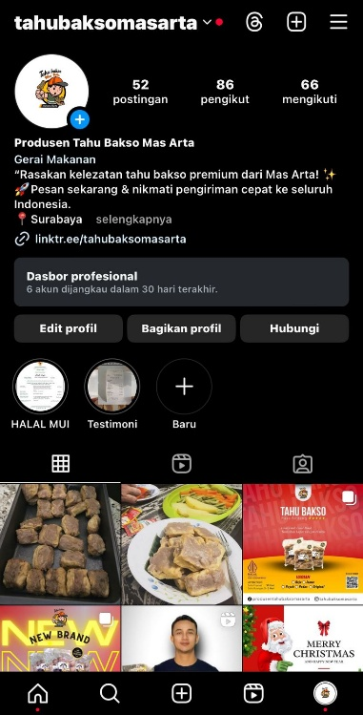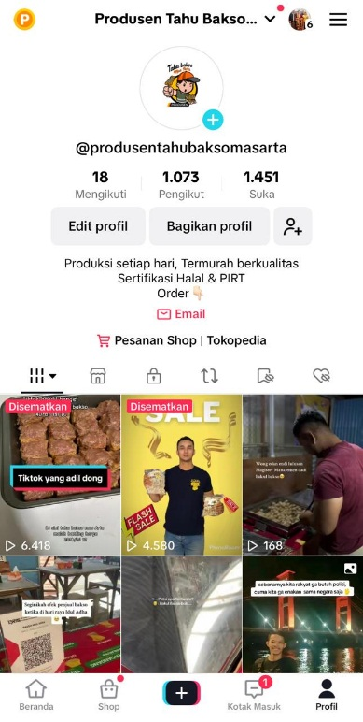

From promotions via social media TikTok and Instagram, the Mas Arta meatball tofu producer has 1,073 followers on TikTok, and 86 people on Instagram. TikTok content promoted by the marketing division can reach 6,478 viewers.

Sales from the marketplace via the Shopee, Facebook and Tokopedia applications can also be reached within a 20km radius from the production site and the furthest in Banten Province. Digital marketing strategies are continuously being developed by Producen tofu meatball mas arta is very significant in helping sales at the national level, not only in the city of Surabaya but also outside the province.

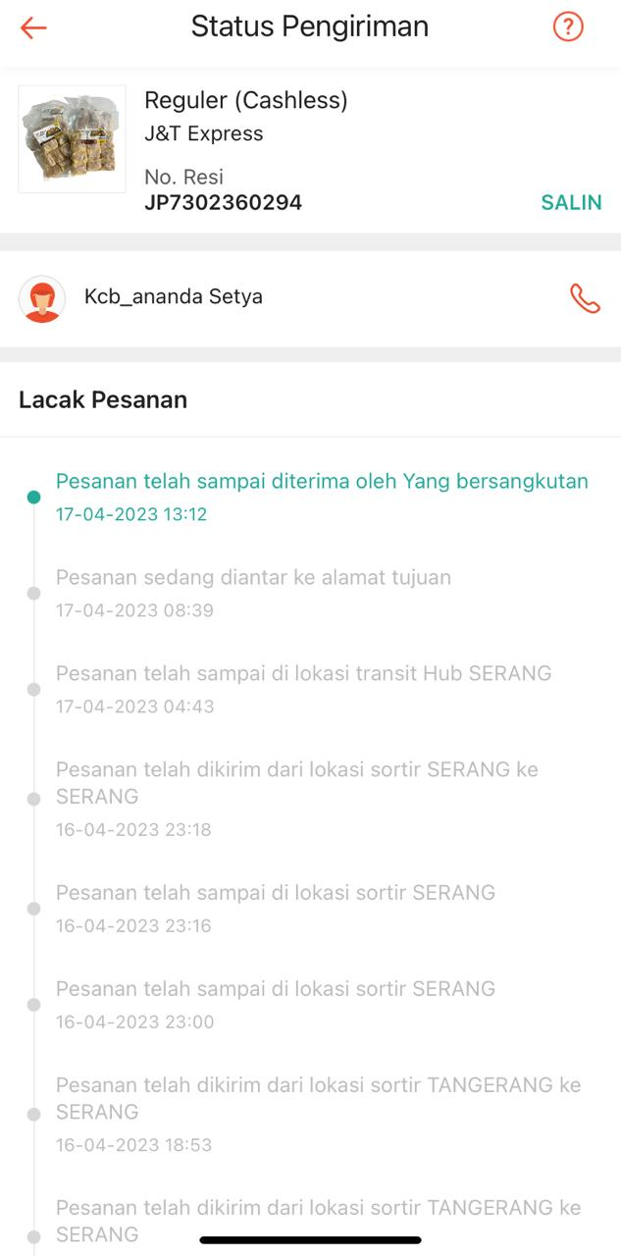**Figure 7. (Source Shopee)**

1. **CONCLUSION**

In this section, from the research that has been carried out and the analysis that has been discussed as above, it can be concluded that "Implementation of digital marketing strategies in the era of society 5.0 for Mas Arta meatball tofu producers" to answer this research, namely;

Implementation of Digital Marketing Strategy in the Era of Society 5.0 at Tofu Bakso Producer Mas Arta refers to consumers as referring to the digital marketing marketing mix. There are several components in the digital marketing marketing mix, namely; Product, price, distribution, promotion, so that these components run well, the Mas Arta meatball tofu producer takes an integrated digital marketing approach. This approach is used to answer the implementation of digital marketing strategies in the era of society 5.0 for Mas Arta meatball tofu producers: 1). Using advertising/ads on the application platform, 2). Carrying out live/introducing products directly through the social media used, 3). Utilizing content creators as product marketing triggers

**Reference**

Achmady, S. (2016). Optimasi Website Untuk Meningkatkan Posisi Index Pada Halaman Google. *CESS (Journal of Computer Engineering, System and Science)*, *1*(1), 30–34.

Afrilia, A. M. (2018). Personal Branding Remaja di Era Digital. *Mediator: Jurnal Komunikasi*, *11*(1), 20–30.

[Afrizal, 2024, MENINGKATKAN MINAT PEMBELI MENGGUNAKAN STRATEGI AFILIASI PADA PEMASARAN DIGITAL,Journal of Information Technology and Computer Science (INTECOMS)](https://journal.ipm2kpe.or.id/index.php/INTECOM/article/download/10465/6549/)

Ahmad, I., Kom, S., Kom, M., Djajasinga, I. N. D., Astuti, S. D., Annisa Sanny, S., Cahyadi, N., S ST, M., Rullyana Puspitaningrum Mamengko, S. P., & Reza, V. (2022). *Digital Marketing (Concept, Strategy, and Implementation)*. Cendikia Mulia Mandiri.

Chaffey, D., & Ellis-Chadwick, F. (2019). *Digital marketing*. Pearson uk.

Creswell, J. W. (2021). *A concise introduction to mixed methods research*. SAGE publications.

Geralda, M., & Kasih, J. (2020). *Implementasi Digital Marketing pada Sosial Media dan Website Bimbel Media Bandung*. *2*.

Habibi, M. (2018). *OPTIMALISASI DAKWAH MELALUI MEDIA SOSIAL DI ERA MILENIAL*. *12*.

Irfani, H., Yeni, F., & Wahyuni, R. (2020). Pemanfaatan digital marketing sebagai strategi pemasaran pada UKM dalam menghadapi era industri 4.0. *JCES (Journal of Character Education Society)*, *3*(3), 651–659.

Kaur, G. (2017). The importance of digital marketing in the tourism industry. *International Journal of Research-Granthaalayah*, *5*(6), 72–77.

Khanafi, A. (2023). *ANALISIS IMPLEMENTASI STRATEGI PEMASARAN DIGITAL PADA BISNIS FASHION*. *1*(1), 216–226.

Komalasari, D., Pebrianggara, A., & Oetarjo, M. (2021). Buku Ajar Digital Marketing. *Umsida Press*, 1–83.

Lukito, R. B., Lukito, C., & Arifin, D. (2014). Penerapan Teknik SEO (Search Engine Optimization) Pada Website Dalam Strategi Pemasaran Melalui Internet. *ComTech: Computer, Mathematics and Engineering Applications*, *5*(2), 1050–1058.

Muljono, R. K. (2018). *Digital Marketing Concept*. Gramedia Pustaka Utama.

Naimah, R. J., Wardhana, M. W., Haryanto, R., & Pebrianto, A. (2020). Penerapan digital marketing sebagai strategi pemasaran UMKM. *Jurnal IMPACT: Implementation and Action*, *2*(2), 119–130.

Nisak, Z. (2013). Analisis SWOT untuk menentukan strategi kompetitif. *Jurnal Ekbis*, *9*(2), 468–476.

Nursatyo, N., & Rosliani, D. (2018). Strategi Komunikasi Pemasaran Digital Situs Pembanding Harga Telunjuk. Com. *Expose: Jurnal Ilmu Komunikasi*, *1*(2), 46–67.

Purwana, D., Rahmi, R., & Aditya, S. (2017). Pemanfaatan digital marketing bagi usaha mikro, kecil, dan menengah (UMKM) di Kelurahan Malaka Sari, Duren Sawit. *Jurnal Pemberdayaan Masyarakat Madani (JPMM)*, *1*(1), 1–17.

Rahardjo, M. (2011). *Metode pengumpulan data penelitian kualitatif*.

Rahman, T. (2019). *Pengaruh content marketing terhadap keputusan pembelian dengan minat beli sebagai variabel intervening: Studi pada konsumen Caffe Go-Kopi di Kota Malang*.

Sari, O. H., Rukmana, A. Y., Munizu, M., Novel, N. J. A., Salam, M. F., Hakim, R. M. A., Sukmadewi, R., & Purbasari, R. (2023a). *DIGITAL MARKETING: Optimalisasi Strategi Pemasaran Digital*. PT. Sonpedia Publishing Indonesia.

Sari, O. H., Rukmana, A. Y., Munizu, M., Novel, N. J. A., Salam, M. F., Hakim, R. M. A., Sukmadewi, R., & Purbasari, R. (2023b). *DIGITAL MARKETING: Optimalisasi Strategi Pemasaran Digital*. PT. Sonpedia Publishing Indonesia.

Setiawan, Z., Jauhar, N., Putera, D. A., Santosa, A. D., Fenanlampir, K., Sembel, H. F., Harto, B., Roza, T. A., Dermawan, A. A., & Rukmana, A. Y. (2023). Kewirausahaan Digital. *Global Eksekutif Teknologi*.

Somantri, G. R. (2005). MEMAHAMI METODE KUALITATIF. *Makara Human Behavior Studies in Asia*, *9*(2), 57. https://doi.org/10.7454/mssh.v9i2.122

Sukmasetya, P., Haryanto, T., Sadewi, F. A., Maulida, R. B. G., Aliudin, H. S., & Sugiarto, B. (2020). Pemanfaatan Digital Marketing sebagai Media Pemasaran Global untuk Meningkatkan Penjualan Produksi pada Home Industry. *Community Empowerment*, *5*(2), 28–35.