SriNawatmi-Nov2024
by Kristiawan Nugroho
Submission date: 05-Nov-2024 03:01PM (UTC+0700)
Submission ID: 2509100768
File name: korupsi_dan_kemiskinan_2.docx (28.83K)
Word count: 4033
Character count: 23098


34
1
12
27
1
1
48
42
1
13
10
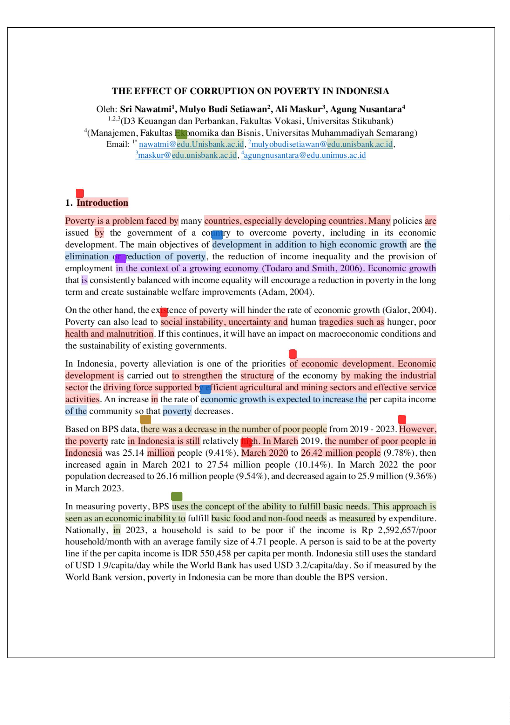

14
18
26
6
45
43
30
2
25
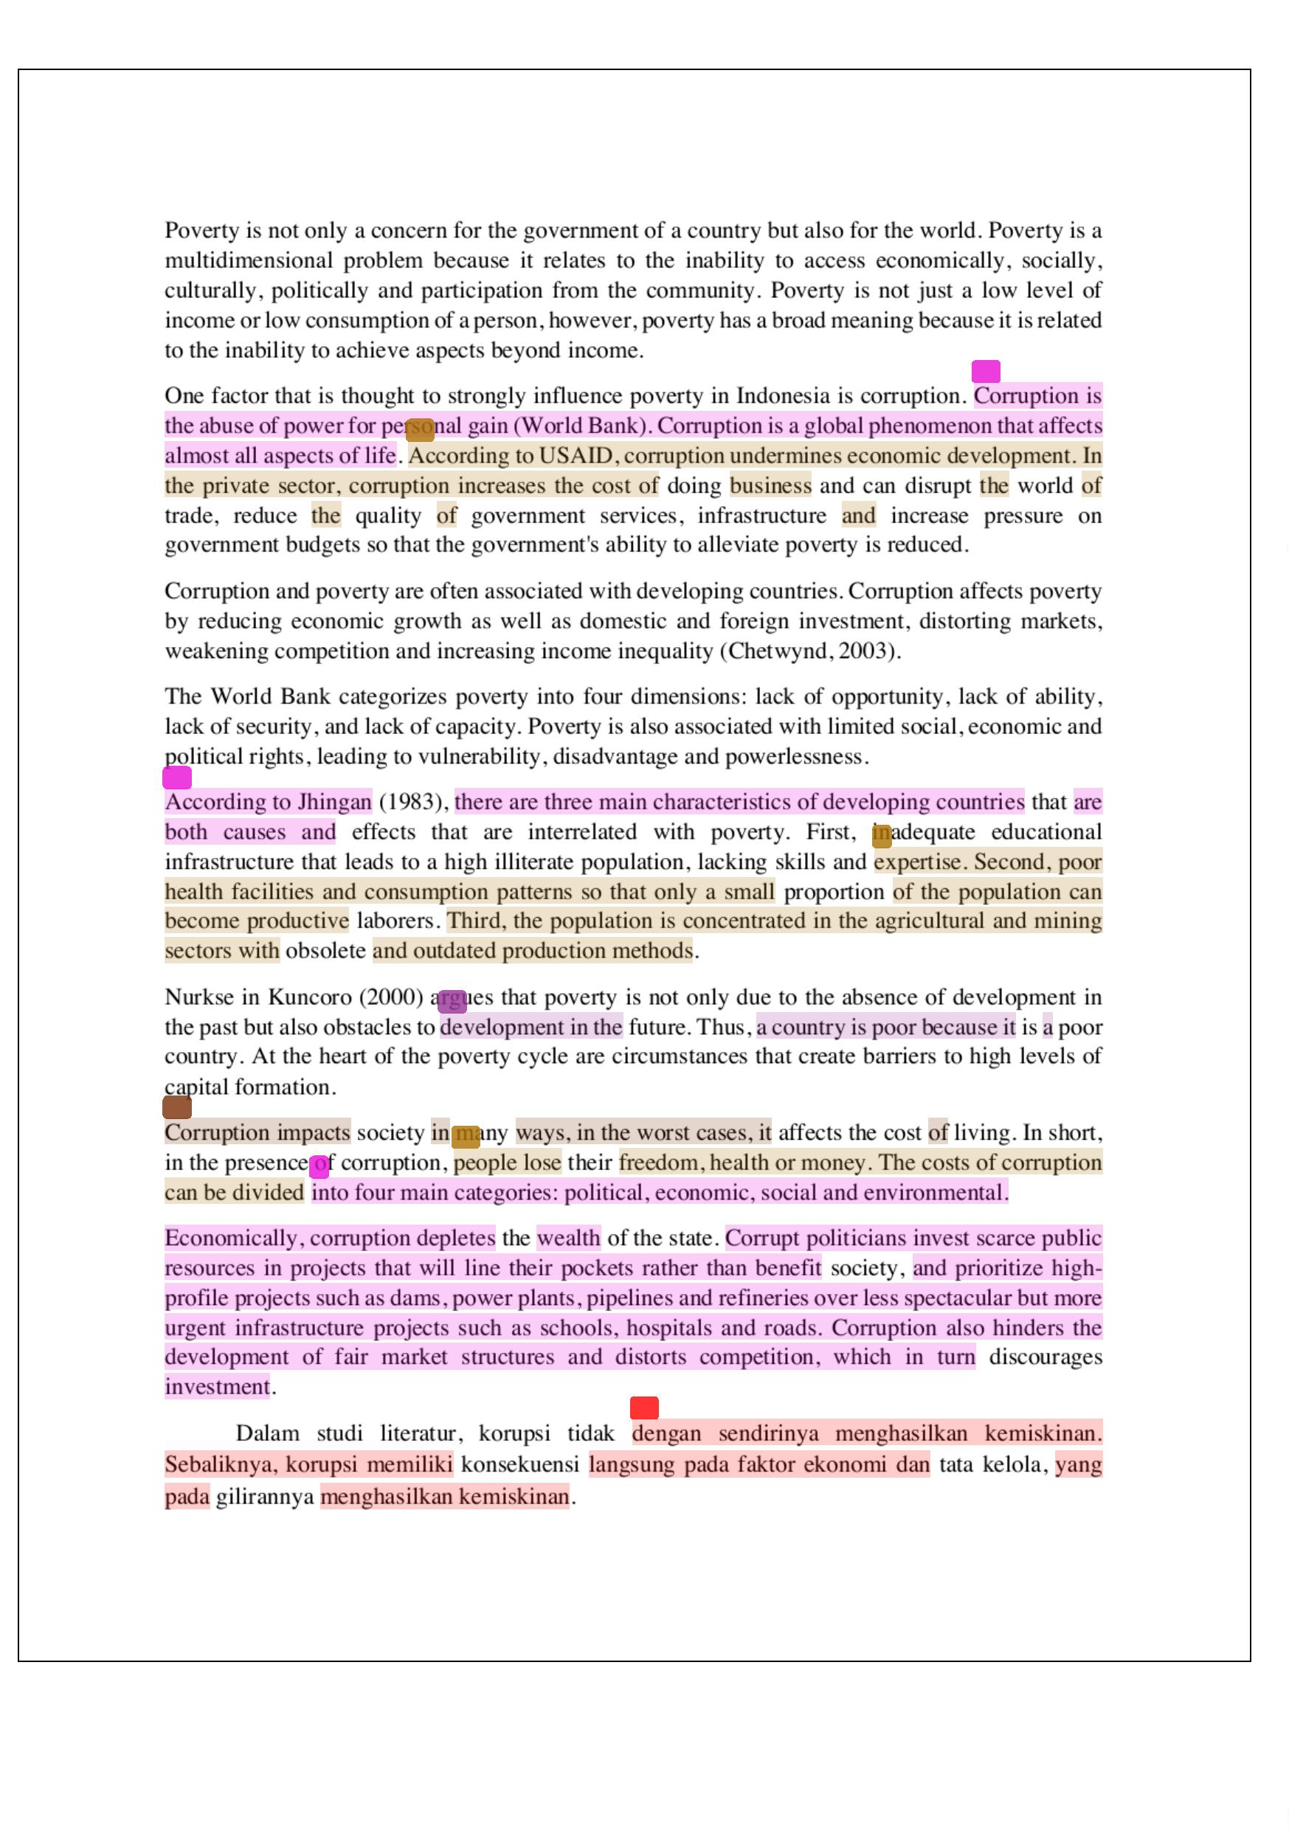

4
37
8
32
3
61
40
38
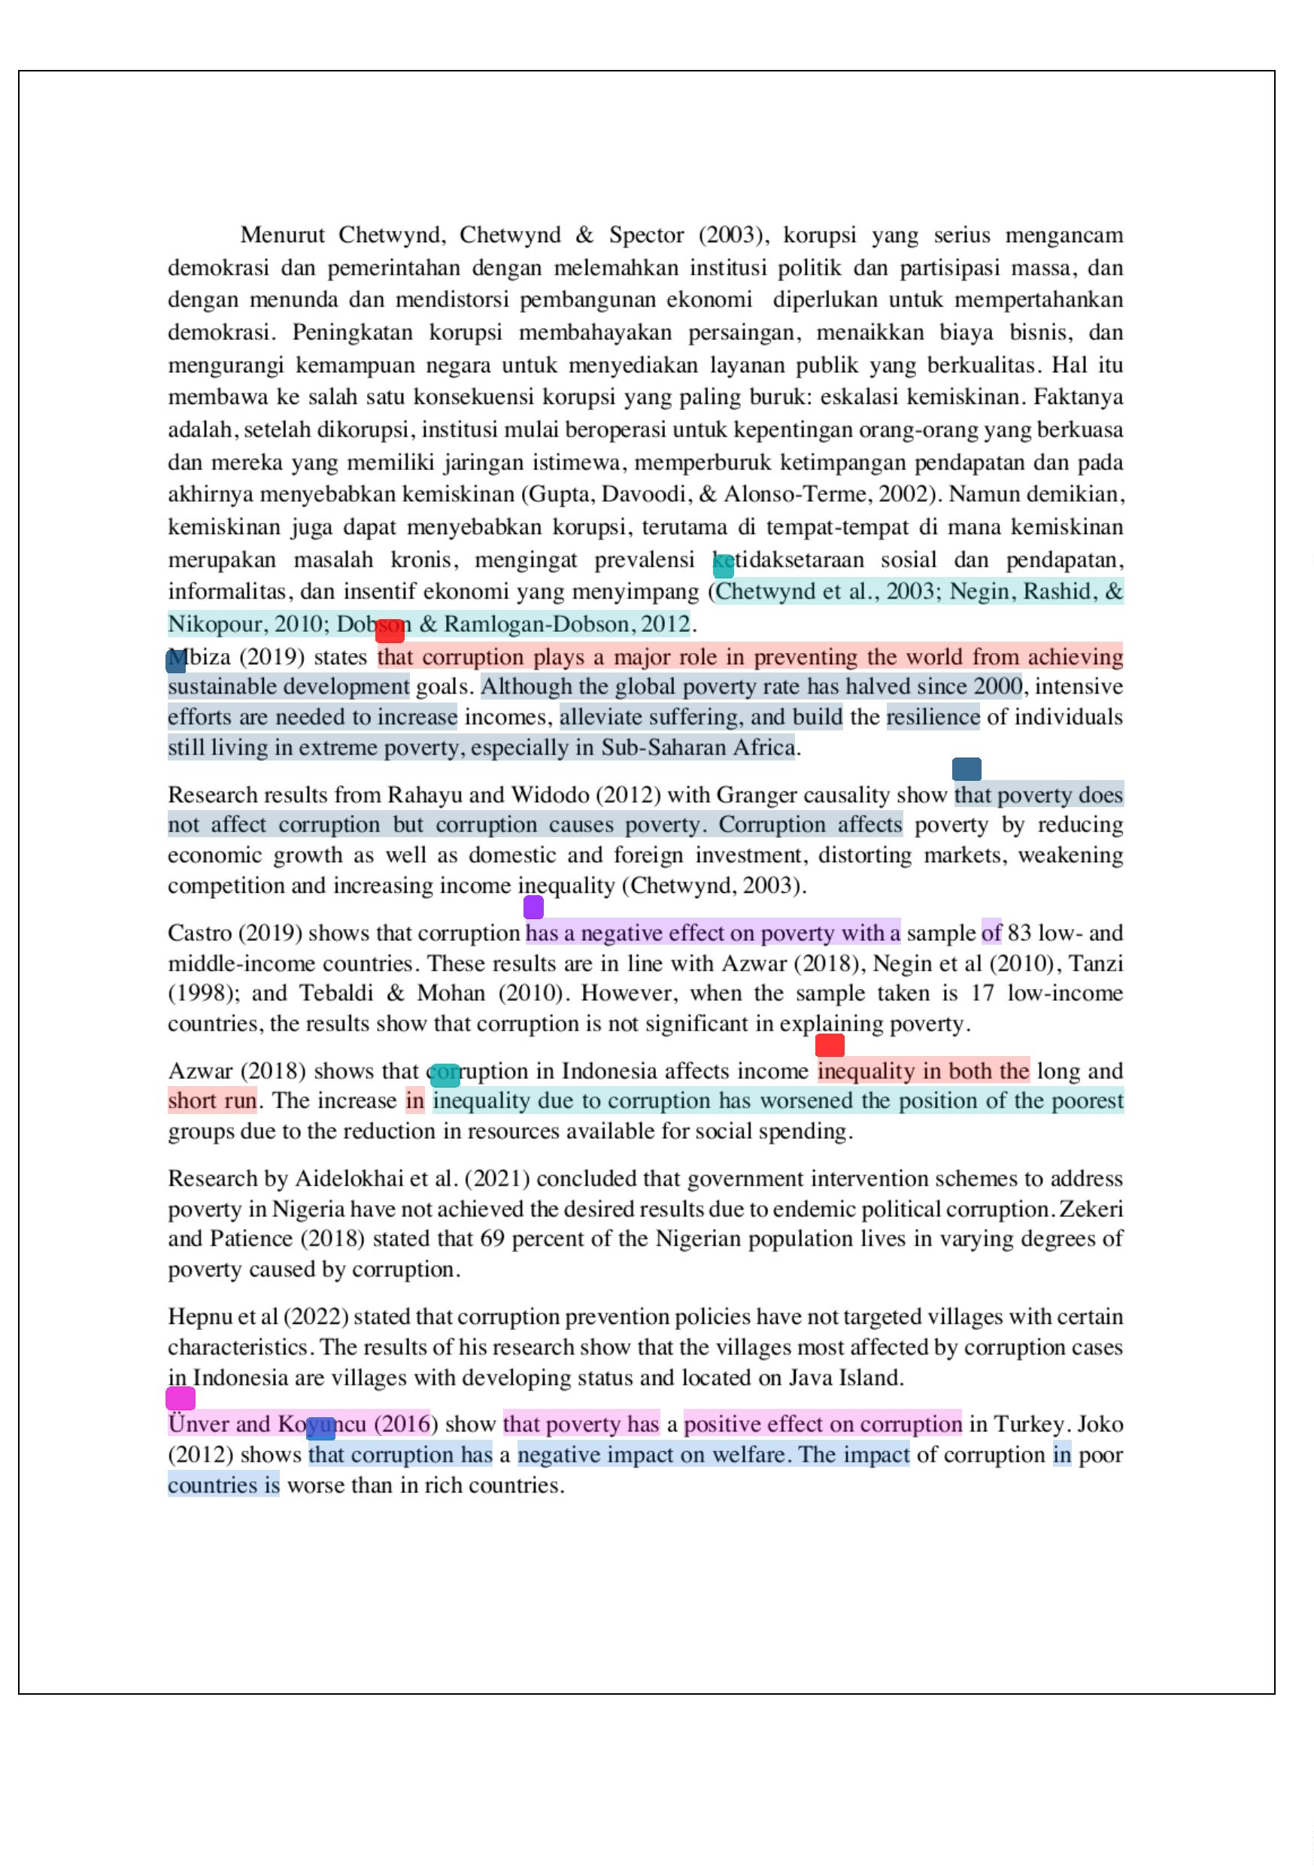

46
33
11
4
4
39
52
35
57
63
16
54
56
31
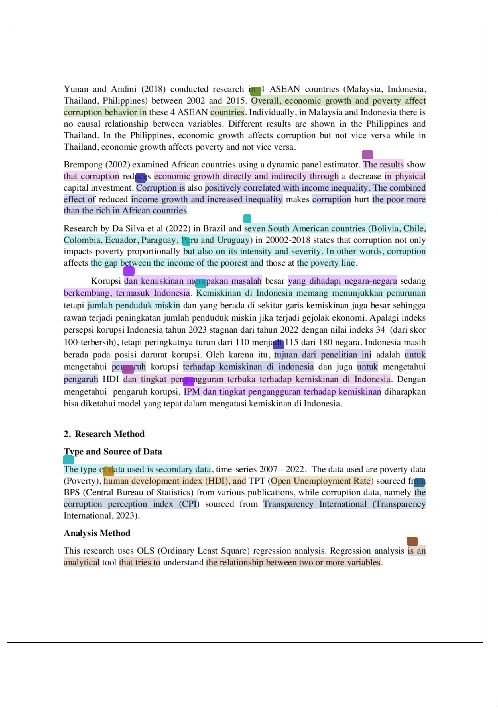

21
19
5
9
6
1
24
41
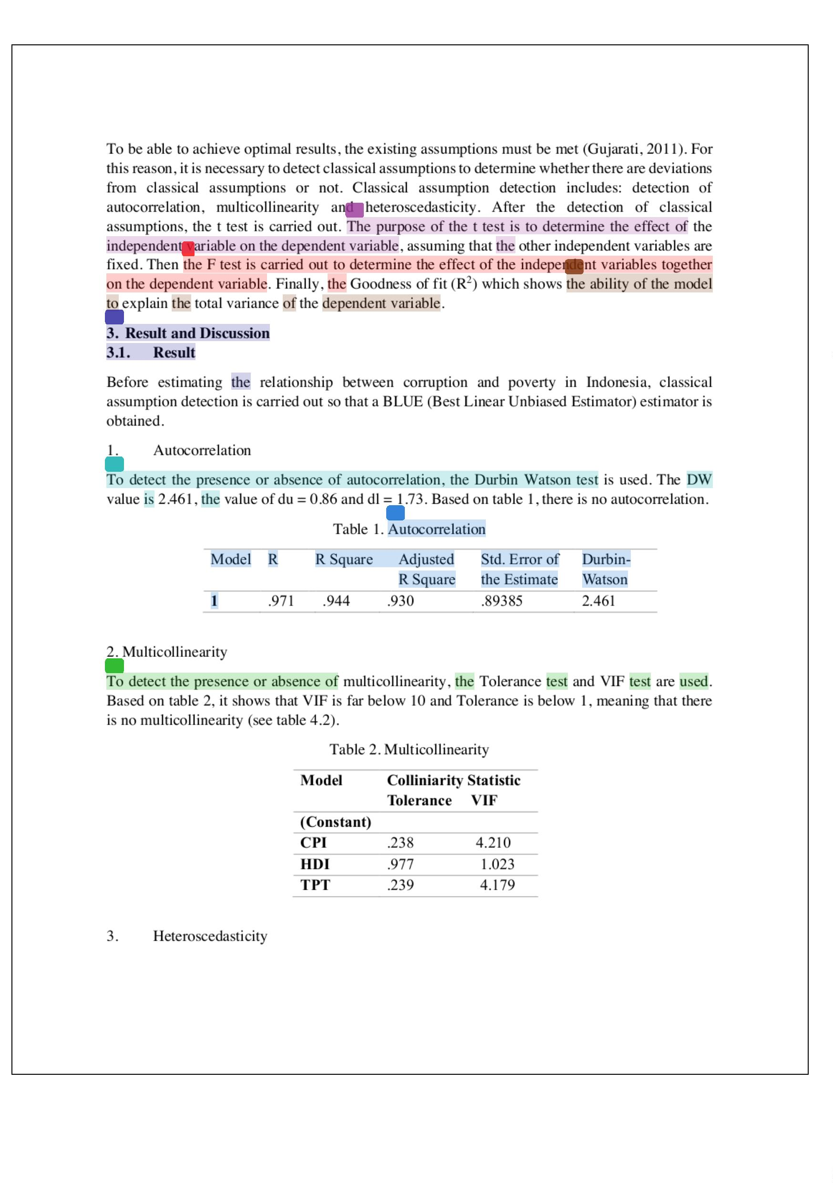

50
29
53
28
22
49
12
13
15
55
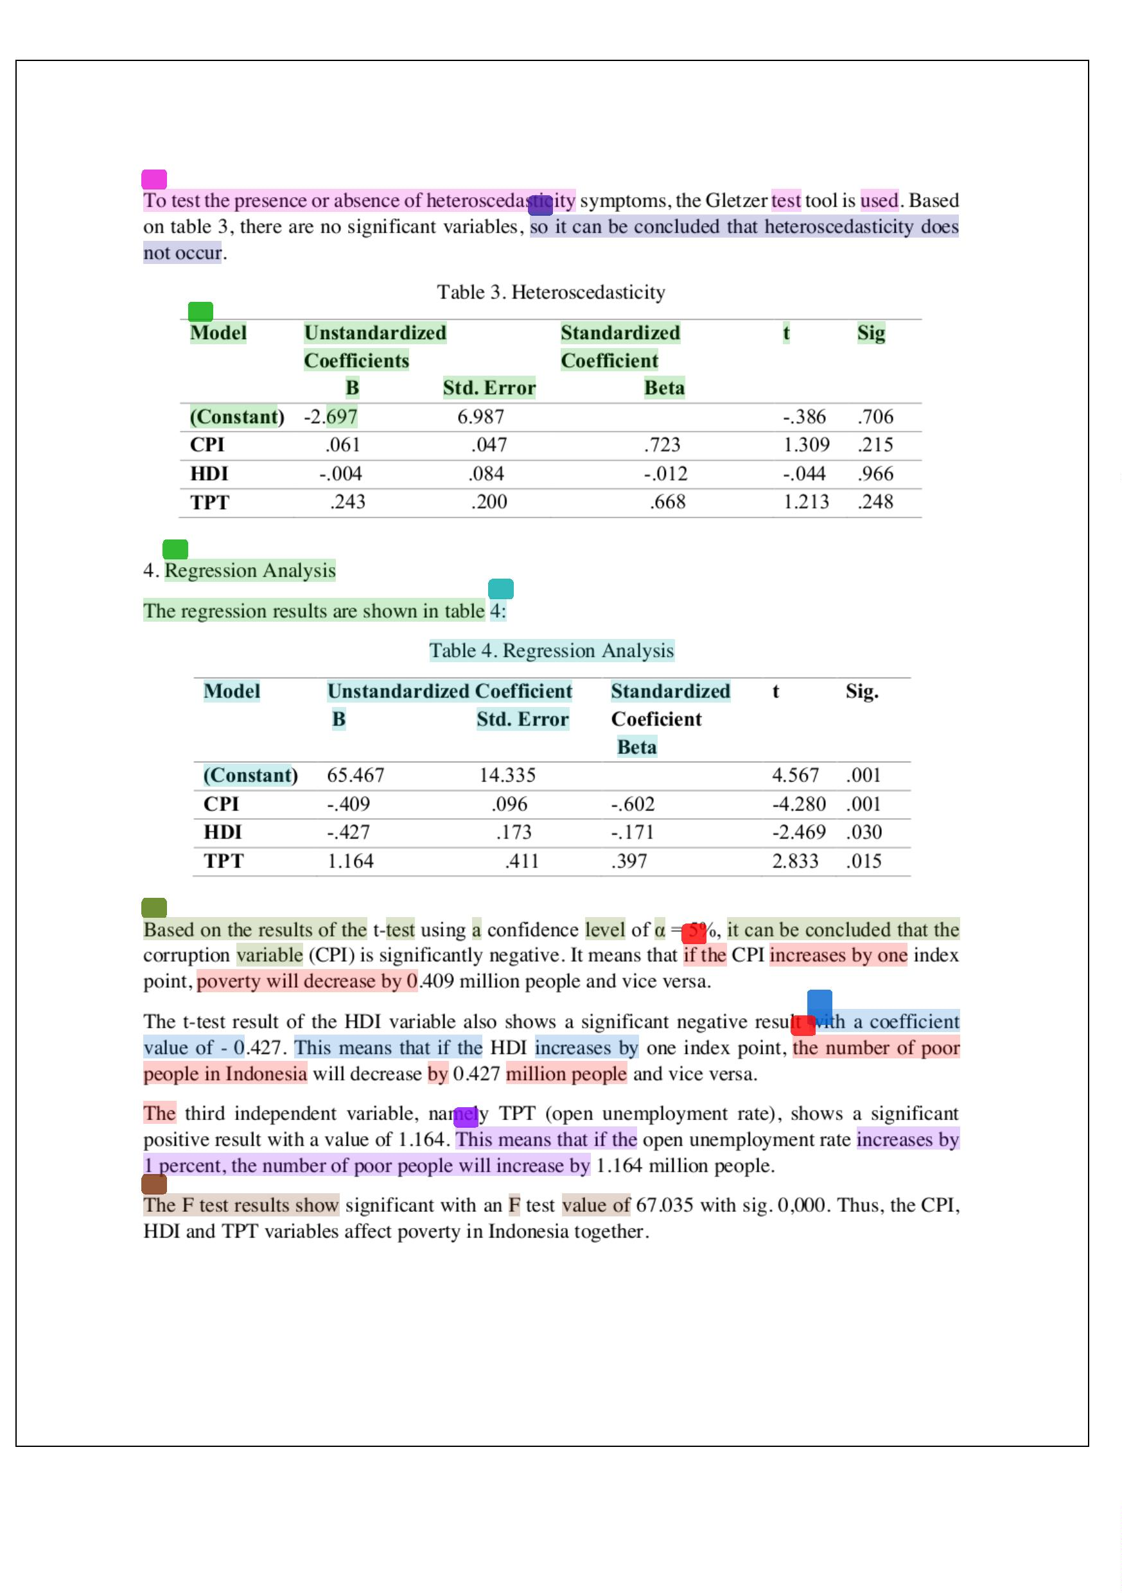

17
23
5
51
20
7
7
60
5
13
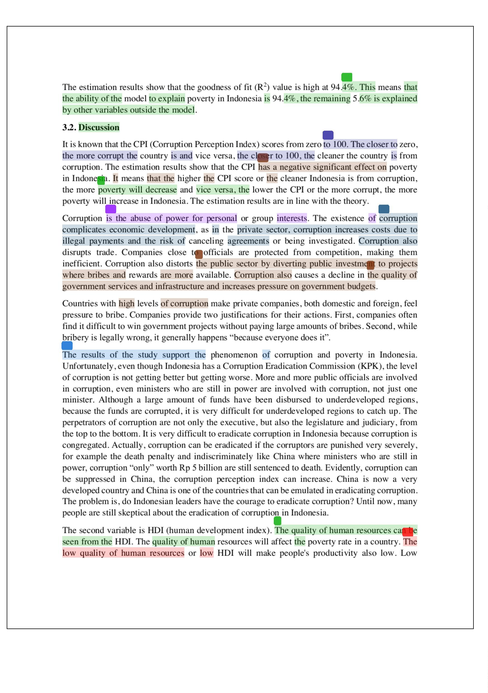

9
44
5
9
62
5
15
58
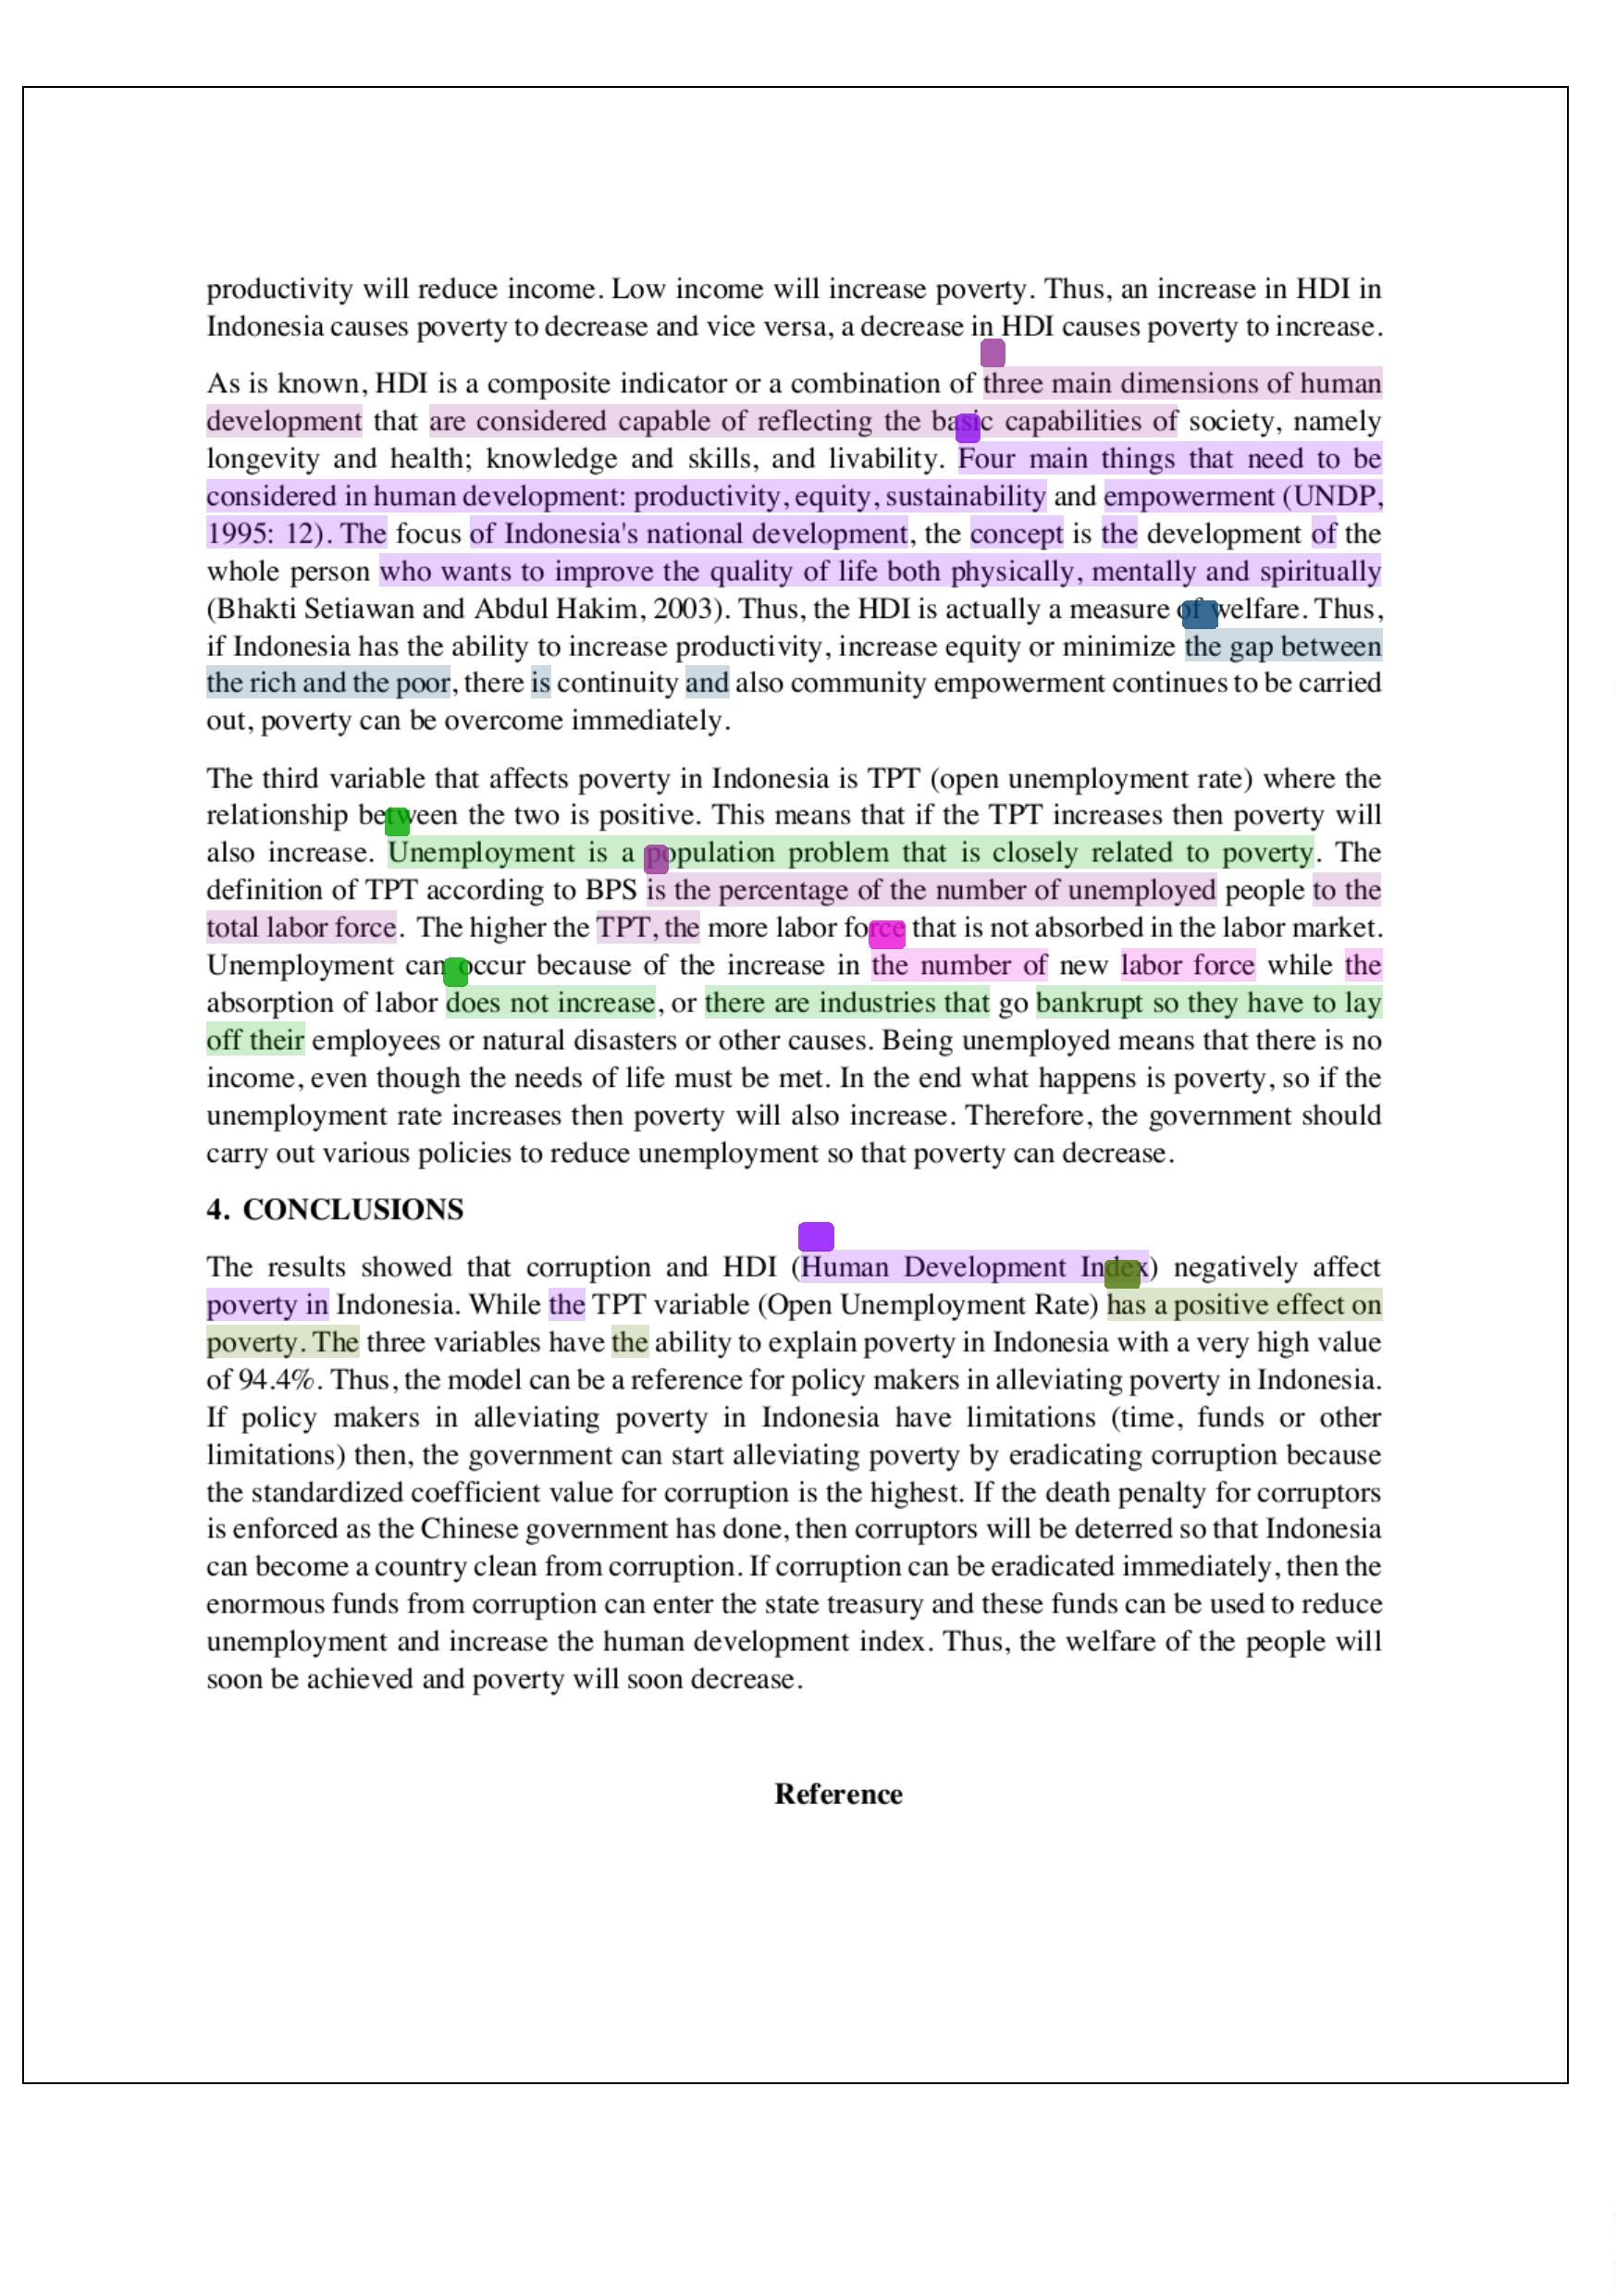

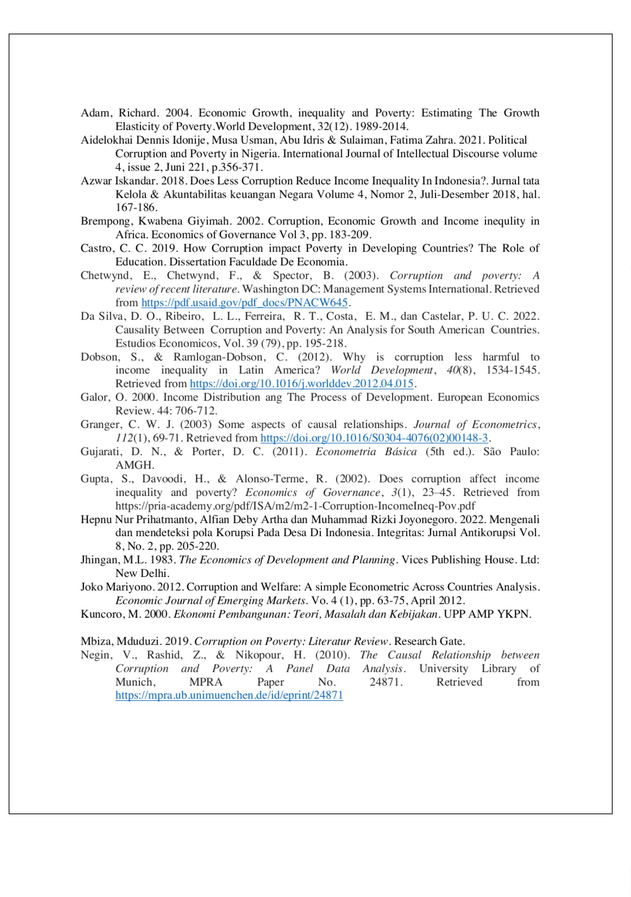

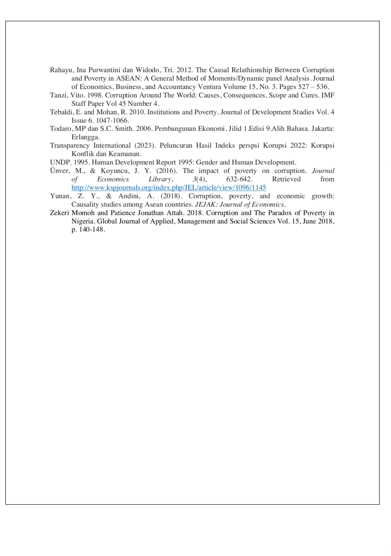

SriNawatmi-Nov2024
ORIGIN
3
ALITY R
EPORT
%
27%
19%
13%
SIMILARITY INDEX
INTERNET SOURCES
PUBLICATIONS
STUDENT PAPERS
PRIMARY SOURCES
3
%
%
%
%
%
www.atlantis-press.com
1
2
3
4
5
Internet Source
2
1
1
1
ena.lp.edu.ua:8080
Internet Source
dergipark.org.tr
Internet Source
repositorio.ufc.br
Internet Source
Rifda Nabila. "The eﬀect of macroeconomic
variables on the poverty rate in Indonesia",
Journal of Economics Research and Policy
Studies, 2021
Publication
1
1
1
%
%
%
jurnal.harianregional.com
6
7
8
Internet Source
Submitted to Deakin University
Student Paper
Submitted to Royal Holloway and Bedford
New College
Student Paper
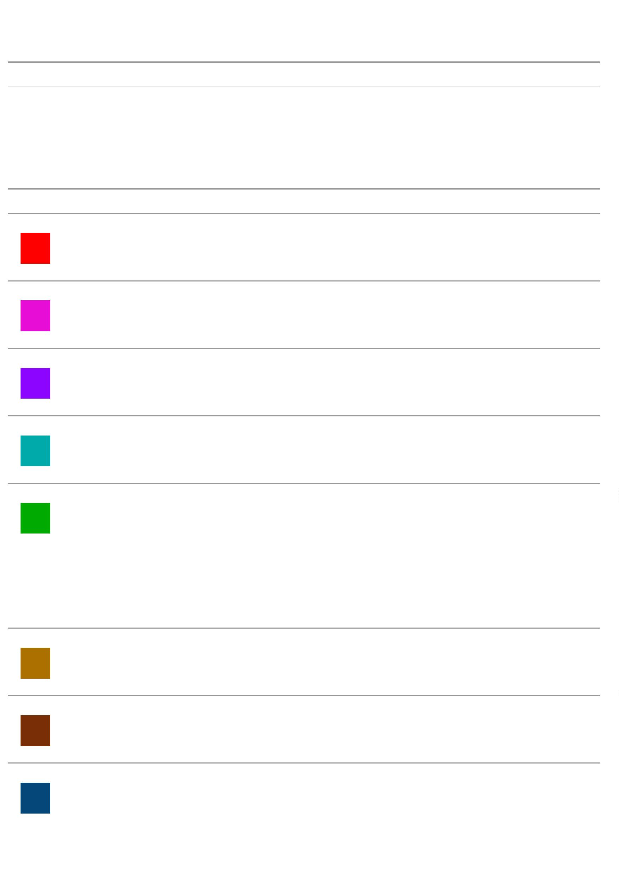

1
1
1
1
1
%
%
%
%
%
ojs3.unpatti.ac.id
9
Internet Source
Submitted to Università Carlo Cattaneo - LIUC
1
0
1
2
3
Student Paper
Submitted to SUNY, New Paltz
1
1
1
Student Paper
jurnal.untagsmg.ac.id
Internet Source
Resti Wahyuni. "K-MEANS CLUSTERING FOR
GROUPING INDONESIA UNDERDEVELOPED
REGIONS IN 2020 BASED ON POVERTY
INDICATORS", Parameter: Journal of
Statistics, 2021
Publication
1
%
Submitted to Asia Paciﬁc University College of
14
Technology and Innovation (UCTI)
Student Paper
1
1
1
1
%
%
%
%
ojs.unimal.ac.id
15
16
17
18
Internet Source
repository.uinjkt.ac.id
Internet Source
www.iiste.org
Internet Source
link.springer.com
Internet Source
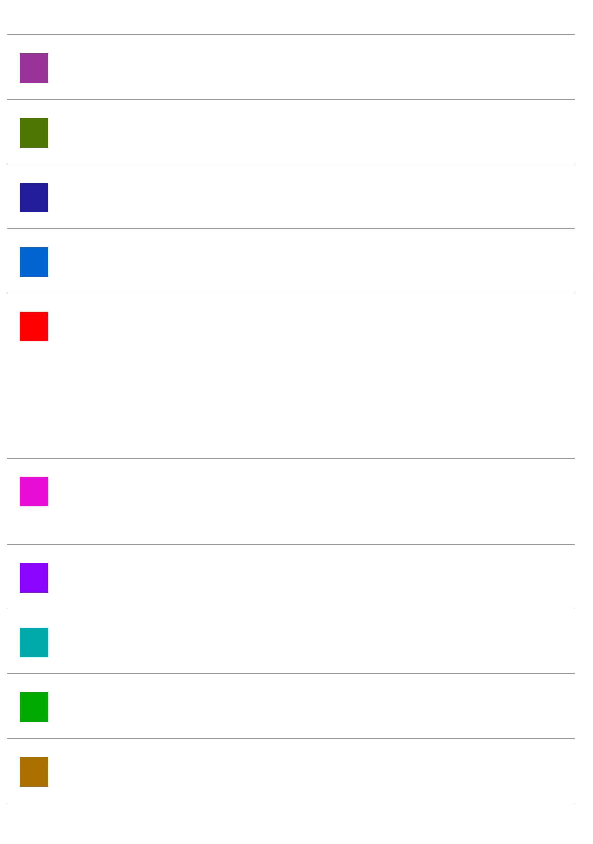

1
1
1
%
%
%
eprints.uny.ac.id
1
9
Internet Source
pdfs.semanticscholar.org
20
21
22
Internet Source
eprints.umm.ac.id
Internet Source
<1%
Anik Djuraidah, Hartinah Djalihu, Agus
Mohamad Soleh. "Mixed Geographically and
Temporally Weighted Autoregressive to
Modeling the Levels of Poverty Population in
Java in 2012-2018", Journal of Physics:
Conference Series, 2021
Publication
<1%
<1%
<1%
<1%
<1%
<1%
Submitted to Bryant College
23
24
25
26
27
28
Student Paper
Submitted to University of Sarajevo
Student Paper
Submitted to iGroup
Student Paper
ojs.unud.ac.id
Internet Source
repository.ut.ac.id
Internet Source
www.davidpublisher.com
Internet Source
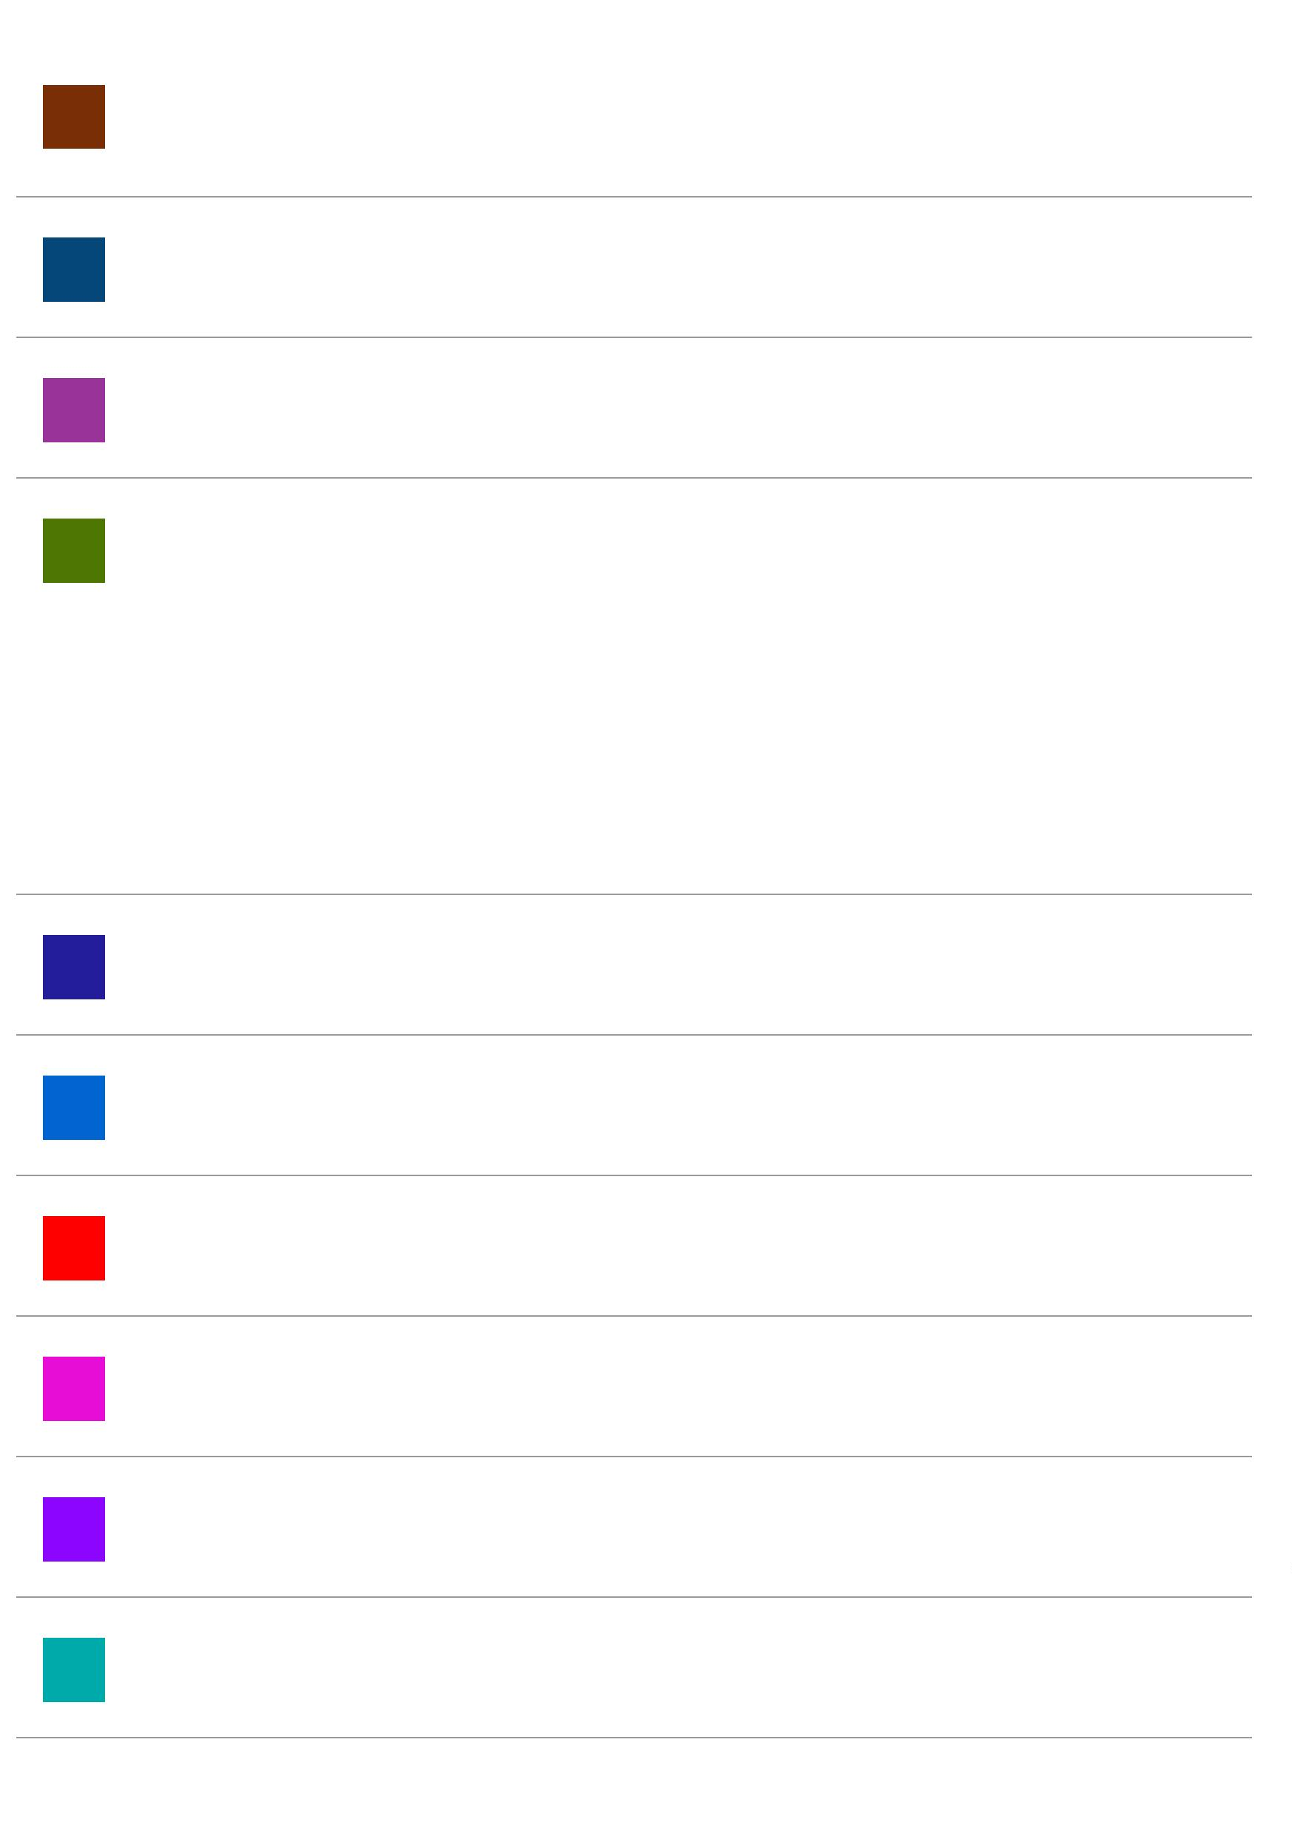

<1%
<1%
<1%
<1%
core.ac.uk
29
30
31
32
33
Internet Source
eudl.eu
Internet Source
jurnal.stie-aas.ac.id
Internet Source
Submitted to Far Eastern University
Student Paper
Submitted to Higher Education Commission <1%
Pakistan
Student Paper
Sri Mulyani, Purwatiningtyas Purwatiningtyas, <1%
34
Yunus Anis. "ANALISA DAN DESAIN KONTEN
INSTAGRAM YANG MENARIK DAN
BERDAMPAK POSITIF PADA INTERAKSI
PENGGUNA", Rabit : Jurnal Teknologi dan
Sistem Informasi Univrab, 2024
Publication
Submitted to Universitas Negeri Surabaya <1%
35
The State University of Surabaya
Student Paper
<1%
<1%
jurnal.uii.ac.id
3
6
7
Internet Source
www.slideshare.net
3
Internet Source
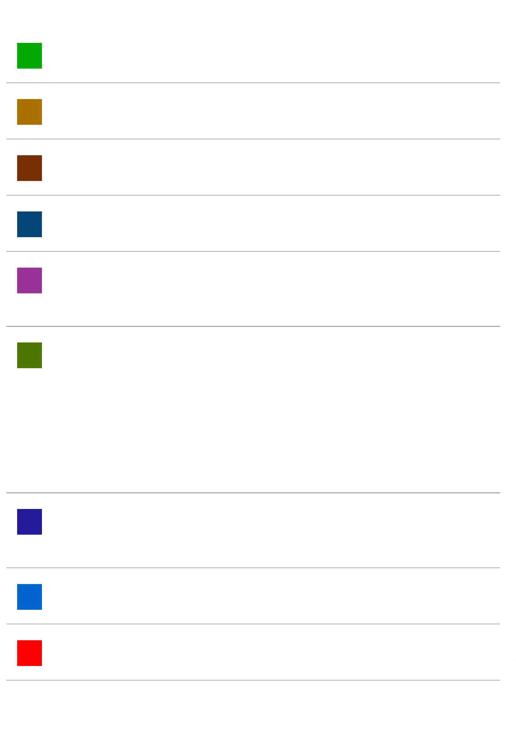

<1%
A. Enisan Akinlo. "Corruption and Misery
3
8
9
Index in Nigeria: Is There a Link?", Journal of
Interdisciplinary Economics, 2022
Publication
Zuhrotul Maghﬁroh, Andhatu Achsa, Khairul <1%
3
Ikhwan. "The Eﬀect of Attitude, Subjective
Norms, and Achievement Needs on
Entrepreneurship Intention (Study on
Management S1 Students for the 2018
Beginning)", International Journal of
Marketing & Human Resource Research, 2022
Publication
<1%
<1%
<1%
jurnal.bpk.go.id
40
41
42
Internet Source
kipdf.com
Internet Source
L O Mardiyana, H M Ani. "The eﬀect of
education and unemployment on poverty in
East Java Province, 2011-2016", IOP
Conference Series: Earth and Environmental
Science, 2019
Publication
<1%
<1%
behorizon.org
4
3
4
Internet Source
discovery.ucl.ac.uk
4
Internet Source
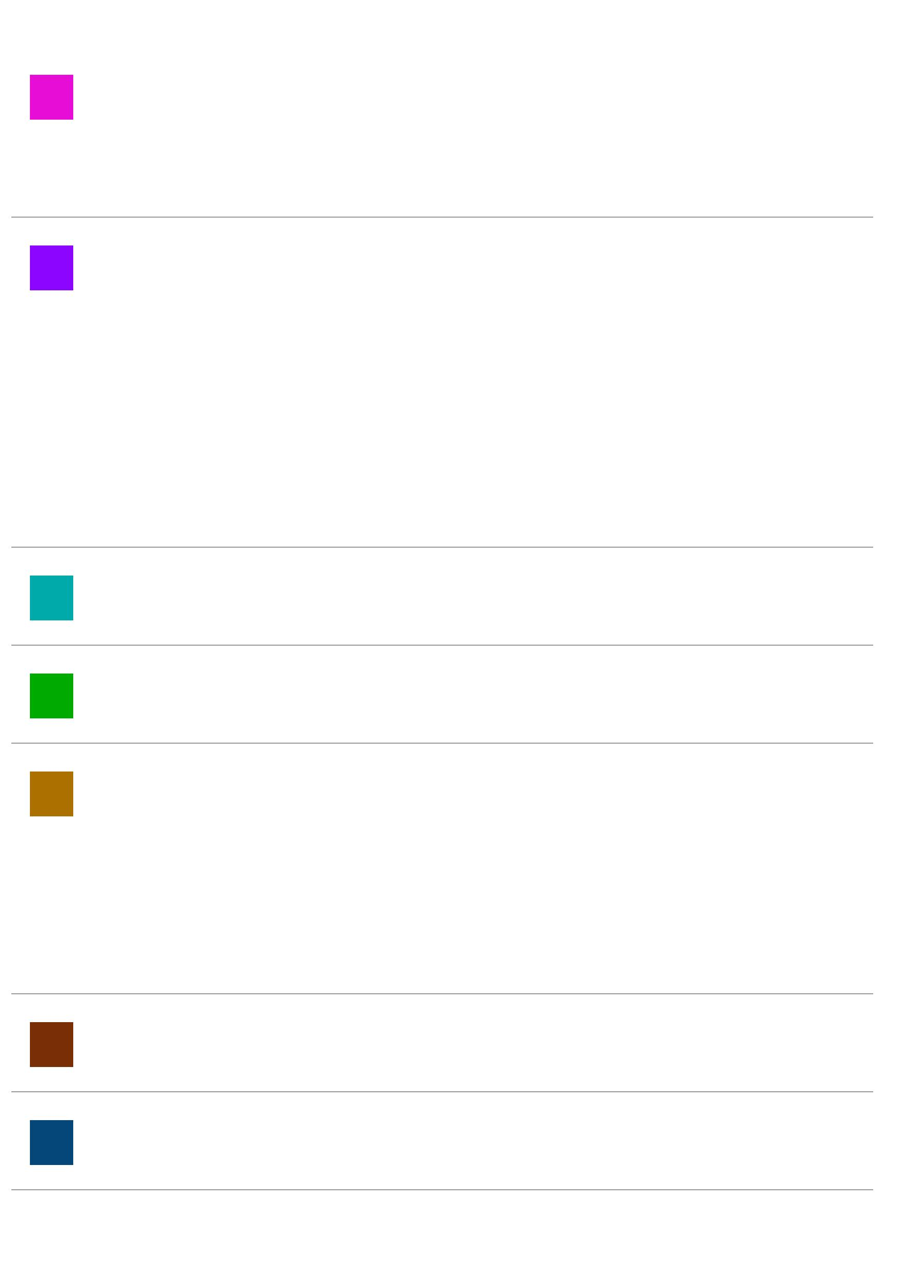

<1%
<1%
<1%
<1%
<1%
<1%
elibrary.tucl.edu.np
45
46
47
48
49
50
51
Internet Source
journal.unnes.ac.id
Internet Source
jurnal.ibik.ac.id
Internet Source
mpra.ub.uni-muenchen.de
Internet Source
repository.unja.ac.id
Internet Source
www.bircu-journal.com
Internet Source
Dirk Tänzler, Konstadinos Maras, Angelos <1%
Giannakopoulos. "The Social Construction of
Corruption in Europe", Routledge, 2016
Publication
<1%
<1%
eprints.unisbank.ac.id
52
53
54
Internet Source
ojs.bbwpublisher.com
Internet Source
Eka Purwanda. "The Inﬂuence of the Human <1%
and Economic Index Development
Components on the Unemployment Rate in
Indonesia", ijd-demos, 2022
Publication
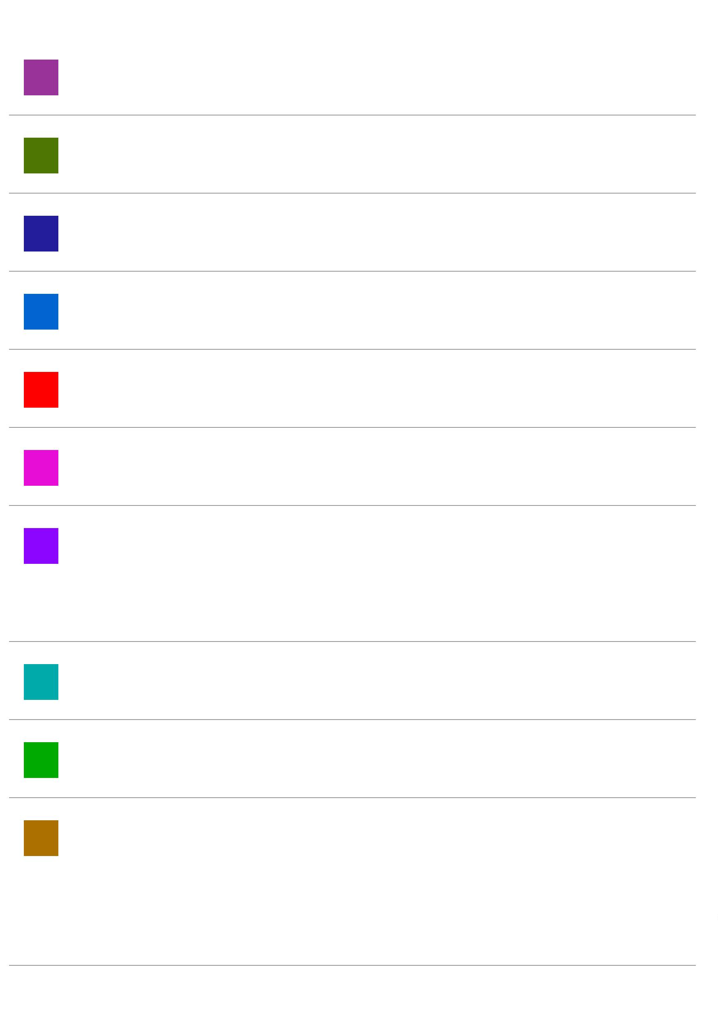

<1%
Fauziah Olga Kusuma, Ermi Tety, Susy
Edwina. "Faktor-Faktor yang Mempengaruhi
Permintaan Sayuran Hidroponik di Kota
5
5
6
Pekanbaru", Jurnal Ilmiah Sosio-Ekonomika
Bisnis, 2023
Publication
Margot I. Witvliet, Anton E. Kunst, Onyebuchi <1%
5
A. Arah, Karien Stronks. "Sick regimes and
sick people: a multilevel investigation of the
population health consequences of perceived
national corruption", Tropical Medicine &
International Health, 2013
Publication
<1%
<1%
<1%
<1%
<1%
repository.fe.unj.ac.id
57
58
59
60
61
Internet Source
repository.uin-malang.ac.id
Internet Source
world.journal.or.id
Internet Source
www.ctrs-stik-mtsij.ac.id
Internet Source
Obadiah Gimba, Mehdi Seraj, Huseyin
Ozdeser. "What drives income inequality in
sub‐Saharan Africa and its sub‐regions? An
examination of long‐run and short‐run
eﬀects", African Development Review, 2021
Publication
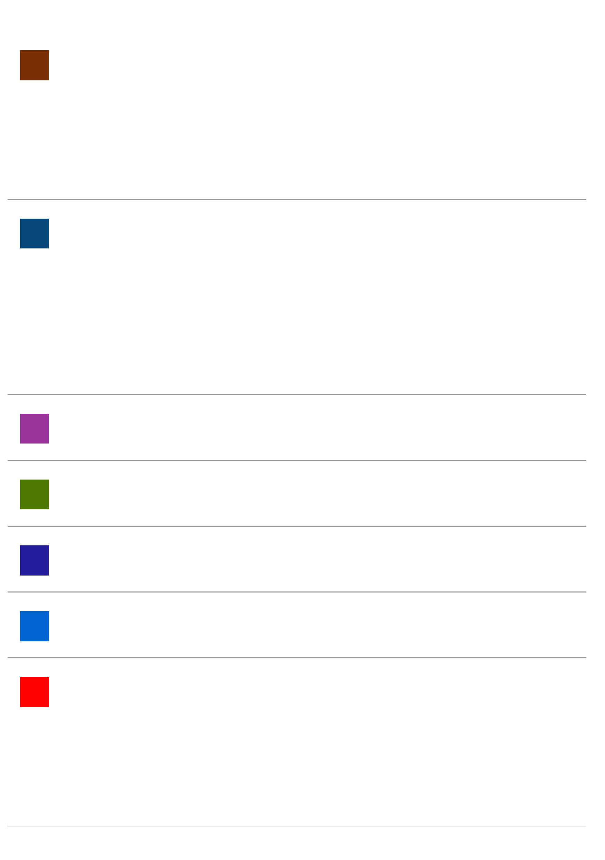

Rico Bagus Satrio, Achmad Kemal Hidayat, <1%
6
2
3
Amelia Hayati. "The Impact of Transjakarta
Bus Rapid Transit (BRT) Operationalization on
Economic Growth and Unemployment Rate in
DKI Jakarta Province", Quantitative Economics
and Management Studies, 2023
Publication
Vidya Anggraini, Sebastiana Viphindrartin, Edy <1%
6
Santoso, Rafael Purtomo Somaji, Nanik
Istiyani. "Determinants of Poverty Levels in
the Northern Coast of East Java", JAE ( JURNAL
AKUNTANSI DAN EKONOMI), 2023
Publication
Exclude quotes
On
Exclude matches
Oﬀ
Exclude bibliography On
