Analysis of the Influence of Brand Communication, Brand Image and Brand Personality on Brand Trust in The Body Shop Products

LAELI DHIKRIYAH, I MADE SUKRESNA
Faculty of Economics and Business, Diponegoro University, Indonesia

Abstract
This study aims to determine the effect of brand communication variables, brand image, brand trust on the brand trust of The Body Shop products. This research is a quantitative research The data sources used in this research are primary data and secondary data. The sampling applied in this study uses a method called the Non Probability Sampling technique. This research make use of Structural Equation Modeling (SEM) as a statistical instrument in an effort to test various hypotheses that have been determinedwith the help of AMOS software. The results showed thatBrand communication has a positive effect on brand image, brand image has a positive effect on brand personality, meaning that the better the brand image of a product will affect the brand personality. The results also show that Brand communication has a positive effect on brand trust, meaning that brand communication has no influence on brand trust and brand image has a positive effect on brand trust and that the better the brand image created by a product will increase trust in consumers and brand personality has a positive effect on brand trust. .
Keywords : Brand Communication; Brand Image; Brand Trust
INTRODUCTION
The rapid development in the business world has forced companies to face fairly fierce competition and competing to attract as many consumers as possible. This competition also occurs in terms of fulfilling needs, one of which is in terms of beauty, companies are required to be able to know and understand what consumers want, this is done so that companies can survive and can compete with other companies. The Indonesian cosmetic industry market provides opportunities for marketers to import beauty products. The Body Shop entered the Indonesian market since 1922.The Body Shop is a global cosmetics and beauty company that got the idea of ​​making it using natural ingredients and producing products that are based on ethical values. The Body Shop was founded in 1976. The Body Shop is now a large franchise worldwide, with approximately 2400 stores in 61 countries.The Body Shop can excel in several products as depicted on the Top Brand Index. The top brand index is measured using 3 parameters, namely top of mind, last usage, and future intention.
Several products from The Body Shop have not shown a significant percentage each year. Body mist and body butter products are still quite high in the Top Brand Index, while lip gloss and foot cream products have always decreased, even in 2017-2020 cream products were not included in the Top Brand Index, as well as lip gloss products. 2018-2020 is also not included in the Top Brand Index product line. The instability of the percentage of sales of The Body Shop products, so the steps to prevent the entry of competitors, the body shop should increase trust in consumers.
In addition to seeing data from the top brand index, researchers conducted initial interviews with consumers who have used the body shop's products. The results of interviews with consumers of the body shop show that there are complaints that are felt by consumers, such as a fairly expensive price, a mismatch on the skin, and a lack of promotion. With the existence of several problems, the researcher will conduct research on brand trust in The Body Shop products. Based on the results of previous research, there is still a gap between the variable brand communication and product trust, considering that brand communication is an important thing in product trust, it is interesting to do a repeat research. In addition, brand personality also has negative results on brand trust.
RESEARCH METHODS
This research is a quantitative study using primary data and secondary data. Sources of data used in this study are consumers who have used The Body Shop products. Secondary data in this study comes from various existing sources, in the form of documentation, records, government data, internet data, which are related to writing materials. The population in this study are consumers who have used The Body Shop products.This study focuses on the sample of respondents who use The Body Shop with an age range of 15-35 years. The theoretical framework of this research is as follows:
Brand Communication
Brand Image
Brand Personality
Brand Trust
Brand Communication
Brand Image
Brand Personality
Brand Trust

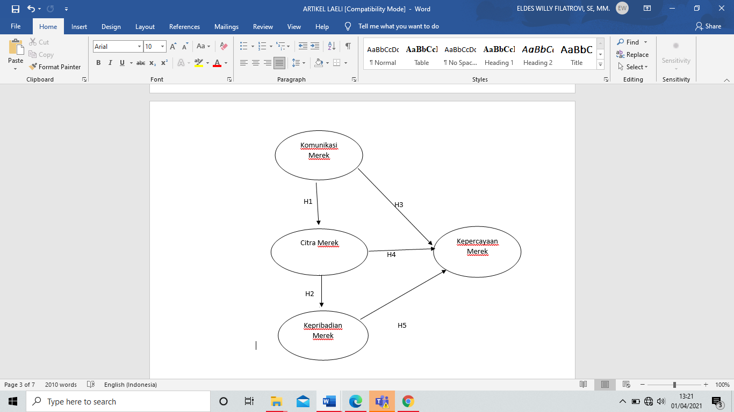

Through a framework that has been formed on the basis of the gaps the researcher finds, the hypotheses in this study are as follows:
H1: Brand Communication has a positive effect on Brand Image
H2: Brand Image has a positive effect on Brand Personality
H3: Brand Communication has a positive effect on Brand Trust
H4: Brand Image has a positive effect on Brand Trust
H5: Brand Personality has a positive effect on Brand Trust
RESULTS AND DISCUSSION
Based on the results of the normality test, it shows that the majority of univariate normality tests are normally distributed because the critical ratio (CR) for kurtosis (tapering) and skewness (inclination), is in the range of ± 2.58 Meanwhile, the multivariate data fulfills the normality assumption because the value is 2.105 in the ± 2.58 range. Mahalanobis distance value is used to see the existence of multivariate outliers. The Chi-square value in degrees of freedom is 18 (as the number of indicators), at the level of p <0.05 is x2 = 42.312 which can be used to calculate mahalanobis. The test results show that the Mahalanobis distance value is not detected with a value greater than the value 42.312, which means there are no outliers data.
SEM test results data indicate that the goodness of fit test. AGFI has a value of 0.81 which is smaller than 0.90, which means that the evaluation of the model gets marginal results, or close to fit, then GFI has a value of 0.849 which is smaller than 0.90, which means that the evaluation of the GFI model gets marginal results. CMIN / DF has a value of 1.704 smaller than 2.00, so it can be concluded that the evaluation of the CMIN model is good. NFI has a value of 0.887 less than 0.90, which means that the evaluation of the NFI model gets marginal results. TLI has a value of 0.940> 0.90, so it can be concluded that it is good or meets the criteria. CFI has a value of 0.949> 0.90, it can be concluded that it meets the criteria. RMSEA has a value of 0.072 smaller than 0.08, it can be concluded that it meets the criteria. From all the tests conducted, it can be concluded that TLI, RMSEA,
Based on testing the first hypothesis, it shows that brand communication has a positive effect on brand image as evidenced by the CR (Critical Ratio) value of 5.217 with a P value (Probability) of 0.000. These two values ​​indicate results that meet the requirements, namely above 2.00 for CR (Critical Ratio) and below 0.05 for the P value (Probability). The result of testing the second hypothesis is that brand image has a positive effect on brand personality, as evidenced by the CR (Critical Ratio) value of 8,480 while the P value (Probability) is 0,000. These two results indicate results that meet the requirements, which are above 2.00 for CR (Critical Ratio) and below 0.05 for the P value (Probability). Hypothesis testing 3 in this study is that brand communication has no effect on brand trust. This is evidenced by the CR (Critical Ratio) value of 1.635 while the P (Probability) value is 0.102. Both values ​​do not meet the requirements, namely above 2.00 for CR (Critical Ratio) and below 0.05 for the P value (Probability). Furthermore, testing hypothesis 4 in this study is that brand image has a positive effect on brand trust, as evidenced by the CR (Critical Ratio) value of 3,823, while the P value (Probability) is 0,000. These two values ​​meet the requirements, which are above 2.00 for the CR (Critical Ratio) value and below 0.05 for P (Probability). Testing hypothesis 5 in this study shows that brand personality has a positive influence on brand trust, as evidenced by the CR (Critical Ratio) value of 3.377 and the P value (Probability) of 0.000.
Suggestions for Future Research
This study has several limitations with the points previously described. Through these limitations, there are suggestions for future research, including:
- Future research may expand to other newer beauty products such as MS. glow, somethinc, avoskin, and more.
- Future research can measure other factors that can affect brand trust, such as satisfaction, brand identification and others.
REFERENCES
Aaker, David A. (1997) Brand Equity Management. Spectrum Jakarta, Indonesia.
Augusty, Ferdinand. (2014). Management Research Methods. Semarang. Diponegoro University Publishing Agency.
Azize, Şahin, Zehir Cemal, and Kitapçı Hakan. 2012. “Does Brand Communication Increase Brand Trust? The Empirical Research on Global Mobile Phone Brands. " Procedia - Social and Behavioral Sciences 58: 1361–69.
Bilson, Simamora. 2002. Aura Brand. Jakarta: PT Gramedia Pustaka Umum.
Chaudhuri, Arjun, and Morris B. Holbrook. 2001. "The Chain of Effects from Brand Trust and Brand Affect to Brand Performance: The Role of Brand Loyalty." Journal of Marketing 65 (2): 81–93.
Chinomona, Richard. 2016. "Brand Communication, Brand Image and Brand Trust as Antecedents of Brand Loyalty in Gauteng Province of South Africa." Economic and Management Studies 7 (1): 124–39.
Chiou, Jyh Shen, and Cornelia Droge. 2006. "Service Quality, Trust, Specific Asset Investment, and Expertise: Direct and Indirect Effects in a Satisfaction-Loyalty Framework." Journal of the Academy of Marketing Science 34 (4): 613–27.
Cretu, Anca E., and Roderick J. Brodie. 2007. "The Influence of Brand Image and Company Reputation Where Manufacturers Market to Small Firms: A Customer Value Perspective." Industrial Marketing Management 36 (2): 230–40.
Del Río, A. Belén, Rodolfo Vázquez, and Víctor Iglesias. 2001. "The Effects of Brand Associations on Consumer Response." Journal of Consumer Marketing 18 (5): 410–25.
Durrani, Baseer Ali, and Senior Lecturer. 2015. "Impact of Brand Image on Buying Behavior Among Teenagers." European Scientific Journal 11 (5): 155–68.
Garanti, Zanete, and Philip Siaw Kissi. 2019. "The Effects of Social Media Brand Personality on Brand Loyalty in the Latvian Banking Industry: The Mediating Role of Brand Equity." International Journal of Bank Marketing 37 (6): 1480–1503.
Kapferer, JN 2008. The New Strategic Brand Management: Creating and Sustaining Brand Equity Long Term.
Kautonen, T. 2008. Trust and New Technologies: Marketing and Management on The Internet and Mobile Media. edited by H. Karjaluto. Edward Elgar Publishing.
Keller, Kevin Lane. 1993. "Conceptualizing, Measuring, and Managing Customer-Based Brand Equity." Journal of Marketing 57 (1): 1.
Keller, Kevin Lane. 2013. Strategic Brand Management; Building, Measuring, and Managing Brand Equity. Brand. Vol. 58. England: Pearson Education Limited
Kotler, Philip and Keller, Kevin Lane. 2013. Marketing Management. Volume 2. Edition 13. Erlangga.
Kotler, Philip. 2000. Marketing Management. PT. Prenhallindo. Jakarta.
Kotler, Philip. 2011. Marketing Management in Indonesia: Analysis, Planning, Implementation and Control. Jakarta: Publisher Salemba Empat.
Kumar, Ramesh. 2015. Trends, Challenges & Innovations in Management. Zenon Academic.
Lau, Geok Theng, and Sook Han Lee. 1999. "Consumers' Trust in a Brand and the Link to Brand Loyalty." Journal of Market-Focused Management 4 (4): 341–70.
Lee, Kuan-yin, Hui-ling Huang, and Yin-chiech Hsu. 2007. "Trust, Satisfaction and Commitment- On Loyalty to International Retail Service Brands." Asia Pacific Management Review 12 (3): 161–69.
Mehtap Özşahin Yalova. 2011. “The Effects of Brand Communication and Service Quality In Building Brand Loyalty Through Brand Trust; The Empirical Research On Global Brands. " Social and Behavioral Sciences 24 (December): 1218–31.
Malhotra, Naresh. (2014). Basic Marketing Research. Pearson Education. England
Natarajan, Dr. R., and V. Sudha. 2016. "A Relationship Between Brands (A Study with Reference To FMCG)." Economic and Business Review 4 (May): 139–45.
Rosenberg, Larry J., and John A. Czepiel. 1983. "A Marketing Approach for Customer Retention." 45–51.
Rousseau, Denise M., Sim B. Sitkin, Ronald S. Burt, and Colin Camerer. 1998. "Not so Different after All: A Cross-Discipline View of Trust." Academy of Management Review 23 (3): 393–404.
Schultz, Don E., Beth E. Barnes, Heidi F. Schultz, and Marian Azzaro. 2015. Building Customer-Brand Relationship. Routledge.
Simamora, Bilson. 2004. Marketing Research. Jakarta: Gramedia Utama
Sorayaei, Ali, and Marjan Hasanzadeh. 2012. "Impact of Brand Personality on Three Major Relational Consequences (Trust, Attachment, and Commitment to the Brand): Case Study of Nestle Nutrition Company in Tehran, Iran." Australian Journal of Basic and Applied Sciences 6 (5): 79–87.
Tarigan, Pitiadani Br. 2013. "済 無 No Title No Title." Journal of Chemical Information and Modeling 53 (9): 1689–99.
Zehir, Cemal, Azize Şahin, Hakan Kitapci Gebze, Ballester, Elena Delgado. 2014. "BRAND TRUST SCALE Elena Delgado-Ballester." (October 2011).

