THE EFFECT OF BRAND EQUITY ON REPURCHASE: CONCEPTUAL RESEARCH

OSELL ANINDYA AYU ALDIONA, I MADE SUKRESNA
Fakultas Ekonomika dan Bisnis, Universitas Diponegoro, Indonesia

Abstract
This study aims to examine brand awareness, perceived quality, brand association, brand loyalty and repurchase interest. This research is a quantitative study with data sources used in this study are primary data and secondary data. The sampling applied in this study uses a plan using a method called the Non Probability Sampling technique. The population planned in this study are Starbucks Coffee visitors so that the sample is taken from buyers who make purchases at Starbuck Coffee outlets.

Keywords: Brand Awareness; Perceptions of Quality; Brand Associations; Brand Loyalty; Brand Awareness; Repurchase Interests

INTRODUCTION
The business environment in many parts of the world is currently developing rapidly. Of course, this fast development has made business competitions tougher and stronger. Intense competition and various challenges faced will require a businessman to be innovative and think dynamically to attract consumers. The business world that has experienced a significant increase today is the construction of various types of coffee shops. From various coffee shops around the world, there are coffee shops that offer a comfortable atmosphere and several supporting facilities to give a good and pleasant impression to its customers, namely Starbucks Coffee. Starbucks Coffee is a famous coffee shop originating from America. Starbucks is also a popular coffee shop in Indonesia. The first time Starbucks Coffee was built in Indonesia in 2002, to be precise in a shopping center in Jakarta, namely Mall Senayan. At that time, Starbucks Coffee received a positive response from buyers and coffee lovers in Indonesia. Currently, Starbucks already has 300 outlets throughout Indonesia. In addition to the increasing growth of Starbucks outlets, there are also many local coffee shops in Indonesia. Indeed, in this millennial era, the lifestyle of drinking coffee is becoming a trend among the community. Of course this can grow the coffee shop industry in Indonesia. Even though there are many enthusiasts, Starbucks still gets complaints from its customers. For example, the price is quite expensive compared to other coffee shops. As one example, the price of a caramel latte at a coffee shop promises the soul to be 25,000 while at starbucks the same drink costs 53,000 for its small size. For a little information, there are 3 sizes of drinks at Starbucks, namely tall, grande, and venti which is the largest size. Starbucks customers hope that the prices offered are more affordable and further increase the product variants of Starbucks Coffe.
In some industries, brand equity is considered the principal capital in a sale. A strong brand can certainly increase customer confidence in the product purchased. According to Yoo and Donthu (2001), brand image affects several things, including future company profits, consumers' willingness to pay premium prices, sustainable competitive advantage, and marketing success. The three main aspects of brand equity that are usually considered are financial perspective, customer-based perspective, and combined perspective (Keller, 1993). The sluggish sales growth at Starbucks Coffee is able to indicate that there is a problem with re-purchase interest which can be influenced by customer perceptions. Based on the description that has been described, the questions in the research concerned can be taken, namely:
1. Does Brand Awareness affect Repurchase Interest?
2. Does Quality Perception affect Repurchase Intention?
3. Does the Brand Association influence Repurchase Interest?
4. Does Brand Loyalty affect Repurchase Intention?
5. Do Brand Awareness, Perception of Quality, Brand Association, Brand Loyalty together influence Repurchase Intention?

LITERATURE REVIEW
Marketing
The definition of marketing according to the American Marketing Association (1960) is an organizational function and several processes for creating, communicating and providing value to customers and managing customer relationships. Marketing is also a business activity that directs the flow of goods and services from producers to consumers. Marketing involves customer satisfaction and needs. Marketers must understand consumer needs and then develop products to meet those needs. Then the marketer rates the product effectively, makes the product available in the market and informs the customer.
Brand Equity
Radulescu and Hudea (2018) state that a brand is defined as a sign to differentiate one company's products from another. Keller (2002) reveals that brand equity is an impact on brand knowledge on the way consumers react to brand marketing. If a brand gets a preferred response, it will have positive brand equity, which is equivalent to a higher level of brand association, awareness, and preference.
Brand Awareness
Brand awareness shows the ability of consumers to remember and recognize brands in different situations (Aaker, 1996). Brand awareness consists of brand recognition and brand recall which represents the customer to remember the brand name. Meanwhile, the other is the ability of customers to identify brands with brand cues. Brand awareness is the most important and fundamental limitation in searches related to brands and directly influences consumer purchasing decisions (Kapferer, 2008). Brand awareness is a long-lasting asset so it's sustainable. Brand awareness can be very difficult to let go of when brand awareness reaches the dominant level of awareness.
Perception of Quality
Perceived quality according to Aaker (1993), namely consumer perceptions of the superiority of a product and overall quality with the objectives expected of these consumers.
Brand Association
Brand association is an attribute that already exists in a brand and will be greater if consumers have a lot of experience with a brand. So it can be said that brand association is a bond between consumers and product attributes such as slogans, logos and so on (Grewal & Levy, 2008). A strong brand association is able to help consumers to receive and process information which in turn can influence decision making.
Brand Loyalty
Brand loyalty in Aaker (2002) is the core of a brand to strengthen loyalty in each segmentation. Loyal customers will be a problem for new competitors. The benefit of brand loyalty is that when a new competitor enters the market battle, the company has guaranteed a significant market share loss because it has consumers who are loyal to the brand.
Repurchase Interests
William & Auchil (2002) stated that repurchase interest is a consumer assessment by repurchasing at the same company. McDougall & Levesque (2002) also states that repurchase interest involves a customer assessment of the same company that also meets their needs.

RELATIONSHIP HYPOTHESIS

The effect of brand awareness on repurchase interest
In the buying interest that consumers have, brand awareness is needed, because more and more brands are following their predecessors. Even though they are not exactly the same, consumers can be fooled. Brand awareness is the fundamental and most important limitation in brand-related searches and directly influences consumer repurchase interest, according to Kapferer (2008).
H1: Brand awareness affects repurchase interest

The effect of perceived quality on repurchase intention
When consumers are interested in buying a product, of course, consumers already have their own perception of quality. This perception is an aid for a brand to help consumers and make repeat purchases. Chaudhuri (2002) states that perceived quality is an influencing factor, where the higher the perceived quality of consumers, the higher their purchase intention.
H2: Perception of quality affects repurchase interest

The effect of brand association on repurchase interest
Brand is very important in consumer repurchase interest. A brand can be so attached to the minds of consumers, it can also be forgotten by consumers. The memory of the brand can determine the buying interest in consumers.
H3: Brand association has an effect on repurchase interest

The effect of brand loyalty on repurchase interest
Reichheld and Teal (2001) reveal that consumers are ready to give their loyalty and are ready to buy back products from companies that are able to provide them with high-value products and services in contrast to competitors' offerings. If consumers already have a good memory about a brand, what might happen is that the customer will be loyal to the brand.
H4: Brand loyalty affects repurchase interest

RESEARCH METHODS
Primary data is obtained from questionnaires distributed to respondents who have purchased Starbucks Coffee drinks. While the data source in this study is Starbucks Coffee consumers in the city of Semarang. The measurement of the questionnaire that will be used is the Likert scale. The Likert scale is a method that can calculate positive responses to negative responses to a question, where the interval on the research questionnaire is determined on a scale of 1 to a scale 5. The answer form from the Likert scale is in the form of answers from strongly agree to totally disagree. On a scale of 1 a score is given strongly disagree until the last one on a scale of 5 is given a score of strongly agree

Picture 1. Research Model

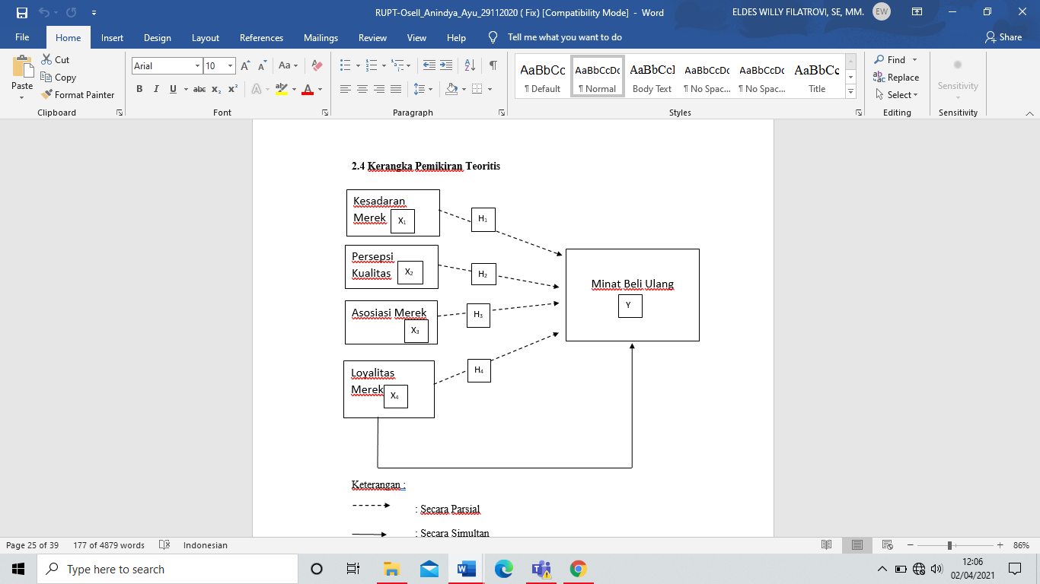
The population in this study were Starbucks buyers in Semarang City and the sample was Starbucks consumers who had purchased Starbucks Coffee beverage products. Sampling in this study using Google Form. Considering that the number of the study population is not known for sure, non-probability sampling techniques are used through accidental sampling. The minimum sample specified in this study was 100 respondents according to the criteria of Hair et al. (2010) for the Maximum Likelihood (ML) estimation technique in Structural Equation Modeling (SEM) analysis.

REFERENCES

Dabbous, A. and Barakat, K., 2020. Bridging the online offline gap: Assessing the impact of brands’ social network content quality on brand awareness and purchase intention. Journal of Retailing and Consumer Services, 53, p.101966.
Ariffin, S., Yusof, J., Putit, L., & Shah, M. (2016). Factors Influencing Perceived Quality and Repurchase Intention Towards Green Products. Procedia Economics And Finance, 37, 391-396. doi: 10.1016/s2212-5671(16)30142-3
Ahmad, Z., Jun, M., Khan, I., Abdullah, M., & Ghauri, T. (2016). Examining Mediating Role of Customer Loyalty for Influence of Brand Related Attributes on Customer Repurchase Intention. Journal Of Northeast Agricultural University (English Edition), 23(2), 89-96. doi: 10.1016/s1006-8104(16)30052-6
Foroudi, P., Jin, Z., Gupta, S., Foroudi, M., & Kitchen, P. (2018). Perceptional components of brand equity: Configuring the Symmetrical and Asymmetrical Paths to brand loyalty and brand purchase intention. Journal Of Business Research, 89, 462-474. doi: 10.1016/j.jbusres.2018.01.031
Graciola, A., De Toni, D., Milan, G., & Eberle, L. (2020). Mediated-moderated effects: High and low store image, brand awareness, perceived value from mini and supermarkets retail stores. Journal Of Retailing And Consumer Services, 55, 102117. doi: 10.1016/j.jretconser.2020.102117

