|  |  |  |  |  |  |  |  |  |  |  |
| --- | --- | --- | --- | --- | --- | --- | --- | --- | --- | --- |
| **Model Summaryb** | | | | | | | | | | |
| Model | R | R Square | Adjusted R Square | Std. Error of the Estimate | Change Statistics | | | | | Durbin-Watson |
| R Square Change | F Change | df1 | df2 | Sig. F Change |
| 1 | .698a | .487 | .460 | 1.55452 | .487 | 17.580 | 2 | 37 | .000 | 1.571 |
| a. Predictors: (Constant), X2, X1 | | | | | | | | | | |
| b. Dependent Variable: Y | | | | | | | | | | |

J

|  |  |  |  |  |  |
| --- | --- | --- | --- | --- | --- |
| **Model Summaryb** | | | | | |
| Model | R | R Square | Adjusted R Square | Std. Error of the Estimate |
|
| 1 | .698a | .487 | .460 | 1.55452 |
| a. Predictors: (Constant), X2, X1 | | | | | |
| b. Dependent Variable: Y | | | | | |

H

|  |  |  |  |  |  |  |
| --- | --- | --- | --- | --- | --- | --- |
| **ANOVAa** | | | | | | |
| Model | | Sum of Squares | df | Mean Square | F | Sig. |
| 1 | Regression | 84.963 | 2 | 42.482 | 17.580 | .000b |
| Residual | 89.412 | 37 | 2.417 |  |  |
| Total | 174.375 | 39 |  |  |  |
| a. Dependent Variable: Y | | | | | | |
| b. Predictors: (Constant), X2, X1 | | | | | | |

|  |  |  |  |  |  |  |  |  |
| --- | --- | --- | --- | --- | --- | --- | --- | --- |
| **Coefficientsa** | | | | | | | | |
| Model | | Unstandardized Coefficients | | Standardized Coefficients | t | Sig. | Collinearity Statistics | |
| B | Std. Error | Beta | Tolerance | VIF |
| 1 | (Constant) | 9.287 | 1.976 |  | 4.701 | .000 |  |  |
| X1 | .103 | .116 | .155 | .886 | .381 | .451 | 2.220 |
| X2 | .456 | .139 | .575 | 3.278 | .002 | .451 | 2.220 |
| a. Dependent Variable: Y | | | | | | | | |

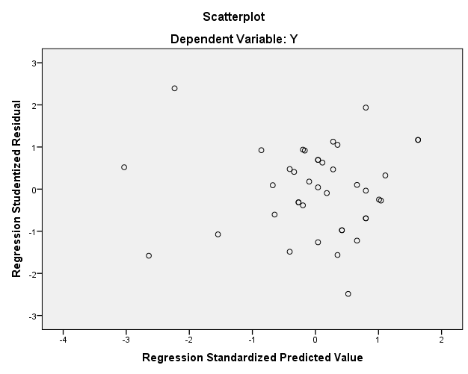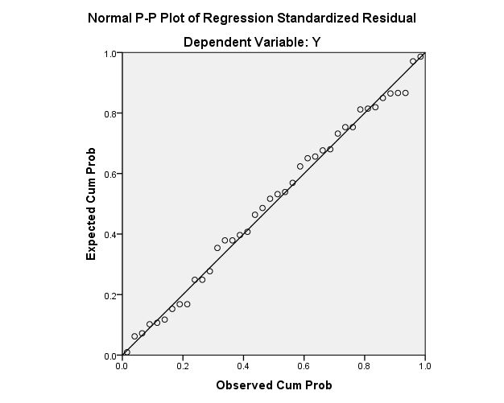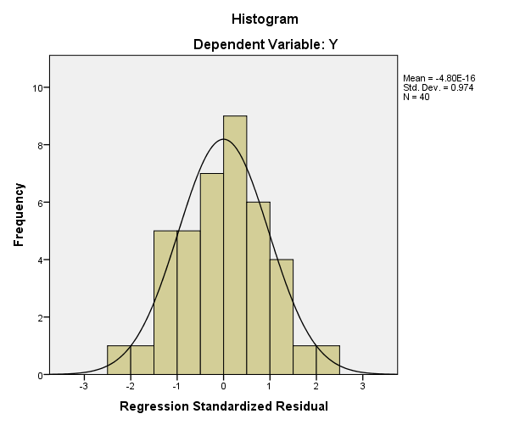

|  |  |  |
| --- | --- | --- |
| **One-Sample Kolmogorov-Smirnov Test** | | |
|  | | Unstandardized Residual |
| N | | 40 |
| Normal Parametersa,b | Mean | .0000000 |
| Std. Deviation | 1.51413471 |
| Most Extreme Differences | Absolute | .078 |
| Positive | .078 |
| Negative | -.054 |
| Test Statistic | | .078 |
| Asymp. Sig. (2-tailed) | | .200c,d |
| a. Test distribution is Normal. | | |
| b. Calculated from data. | | |
| c. Lilliefors Significance Correction. | | |
| d. This is a lower bound of the true significance. | | |

|  |  |  |  |  |  |  |  |
| --- | --- | --- | --- | --- | --- | --- | --- |
| **Correlations** | | | | | | | |
|  | | Y_1 | Y_2 | Y_3 | Y_4 | Y_5 | Y |
| Y_1 | Pearson Correlation | 1 | .742** | .454** | .103 | .082 | .678** |
| Sig. (2-tailed) |  | .000 | .003 | .528 | .614 | .000 |
| N | 40 | 40 | 40 | 40 | 40 | 40 |
| Y_2 | Pearson Correlation | .742** | 1 | .566** | .250 | .233 | .821** |
| Sig. (2-tailed) | .000 |  | .000 | .119 | .147 | .000 |
| N | 40 | 40 | 40 | 40 | 40 | 40 |
| Y_3 | Pearson Correlation | .454** | .566** | 1 | .081 | .077 | .622** |
| Sig. (2-tailed) | .003 | .000 |  | .621 | .635 | .000 |
| N | 40 | 40 | 40 | 40 | 40 | 40 |
| Y_4 | Pearson Correlation | .103 | .250 | .081 | 1 | .489** | .612** |
| Sig. (2-tailed) | .528 | .119 | .621 |  | .001 | .000 |
| N | 40 | 40 | 40 | 40 | 40 | 40 |
| Y_5 | Pearson Correlation | .082 | .233 | .077 | .489** | 1 | .600** |
| Sig. (2-tailed) | .614 | .147 | .635 | .001 |  | .000 |
| N | 40 | 40 | 40 | 40 | 40 | 40 |
| Y | Pearson Correlation | .678** | .821** | .622** | .612** | .600** | 1 |
| Sig. (2-tailed) | .000 | .000 | .000 | .000 | .000 |  |
| N | 40 | 40 | 40 | 40 | 40 | 40 |
| **. Correlation is significant at the 0.01 level (2-tailed). | | | | | | | |

|  |  |  |  |  |  |  |  |
| --- | --- | --- | --- | --- | --- | --- | --- |
| **Correlations** | | | | | | | |
|  | | X1_1 | X1_2 | X1_3 | X1_4 | X1_5 | X1 |
| X1_1 | Pearson Correlation | 1 | .655** | .623** | .590** | .479** | .818** |
| Sig. (2-tailed) |  | .000 | .000 | .000 | .002 | .000 |
| N | 40 | 40 | 40 | 40 | 40 | 40 |
| X1_2 | Pearson Correlation | .655** | 1 | .782** | .437** | .807** | .894** |
| Sig. (2-tailed) | .000 |  | .000 | .005 | .000 | .000 |
| N | 40 | 40 | 40 | 40 | 40 | 40 |
| X1_3 | Pearson Correlation | .623** | .782** | 1 | .364* | .778** | .861** |
| Sig. (2-tailed) | .000 | .000 |  | .021 | .000 | .000 |
| N | 40 | 40 | 40 | 40 | 40 | 40 |
| X1_4 | Pearson Correlation | .590** | .437** | .364* | 1 | .465** | .694** |
| Sig. (2-tailed) | .000 | .005 | .021 |  | .003 | .000 |
| N | 40 | 40 | 40 | 40 | 40 | 40 |
| X1_5 | Pearson Correlation | .479** | .807** | .778** | .465** | 1 | .850** |
| Sig. (2-tailed) | .002 | .000 | .000 | .003 |  | .000 |
| N | 40 | 40 | 40 | 40 | 40 | 40 |
| X1 | Pearson Correlation | .818** | .894** | .861** | .694** | .850** | 1 |
| Sig. (2-tailed) | .000 | .000 | .000 | .000 | .000 |  |
| N | 40 | 40 | 40 | 40 | 40 | 40 |
| **. Correlation is significant at the 0.01 level (2-tailed). | | | | | | | |
| *. Correlation is significant at the 0.05 level (2-tailed). | | | | | | | |

|  |  |  |  |  |  |  |  |
| --- | --- | --- | --- | --- | --- | --- | --- |
| **Correlations** | | | | | | | |
|  | | X2_1 | X2_2 | X2_3 | X2_4 | X2_5 | X2 |
| X2_1 | Pearson Correlation | 1 | .643** | .245 | .232 | .205 | .653** |
| Sig. (2-tailed) |  | .000 | .127 | .149 | .205 | .000 |
| N | 40 | 40 | 40 | 40 | 40 | 40 |
| X2_2 | Pearson Correlation | .643** | 1 | .542** | .487** | .505** | .843** |
| Sig. (2-tailed) | .000 |  | .000 | .001 | .001 | .000 |
| N | 40 | 40 | 40 | 40 | 40 | 40 |
| X2_3 | Pearson Correlation | .245 | .542** | 1 | .673** | .798** | .818** |
| Sig. (2-tailed) | .127 | .000 |  | .000 | .000 | .000 |
| N | 40 | 40 | 40 | 40 | 40 | 40 |
| X2_4 | Pearson Correlation | .232 | .487** | .673** | 1 | .694** | .763** |
| Sig. (2-tailed) | .149 | .001 | .000 |  | .000 | .000 |
| N | 40 | 40 | 40 | 40 | 40 | 40 |
| X2_5 | Pearson Correlation | .205 | .505** | .798** | .694** | 1 | .791** |
| Sig. (2-tailed) | .205 | .001 | .000 | .000 |  | .000 |
| N | 40 | 40 | 40 | 40 | 40 | 40 |
| X2 | Pearson Correlation | .653** | .843** | .818** | .763** | .791** | 1 |
| Sig. (2-tailed) | .000 | .000 | .000 | .000 | .000 |  |
| N | 40 | 40 | 40 | 40 | 40 | 40 |
| **. Correlation is significant at the 0.01 level (2-tailed). | | | | | | | |

|  |  |
| --- | --- |
| **Reliability Statistics** | |
| Cronbach's Alpha | N of Items |
| .683 | 5 |

Y

|  |  |
| --- | --- |
| **Reliability Statistics** | |
| Cronbach's Alpha | N of Items |
| .880 | 5 |

X1

|  |  |
| --- | --- |
| **Reliability Statistics** | |
| Cronbach's Alpha | N of Items |
| .821 | 5 |

X2