**INFLUENCER MARKETING SELECTION STRATEGY IN ORGANIZING THE GRAND OPENING MINI MARKET PROMOTIONAL ACTIVITIES PASARPRIMA YOGYAKARTA**

**Chriswardana Bayu Dewa S.E.,M.M.1), Lina Ayu Safitri S.E.,M.M.2)**

Universitas Bina Sarana Informatika1

Email : chriswardana.chb@bsi.ac.id

Universitas Bina Sarana Informatika2

Email : lina.las@bsi.ac.id

**Abstract**

*This study aims to analyze the influencer marketing selection strategy in organizing the grand opening promotional activities at the Pasarprima mini market, Yogyakarta. This research is a qualitative research with data collection methods used by interviews, observation and literature study. The result of this research is that using social media as the distribution of promotional content by using influencers can save costs because it has a high effectiveness from the results of creative content that is carried out to get the attention of the target market. From this study, the authors only look at the effectiveness of using influencers only from the amount of exposure (viewers, likes, followers and engagement) generated. For the next promotional activity, the marketing selection strategy can add other elements such as the number of sales and visitors during promotional activities.*

***Keywords:*** *Social Media Marketing, Strategy, Influencer*

1. **Introduction**

In recent years, the influencer marketing phenomenon has grown rapidly in the world of social media as a marketing communication strategy. This phenomenon replaces the phenomenon that occurred several decades earlier where celebrity endorsers are one of the marketing strategies that are often used by companies in promoting their business. The phenomenon that occurs today is that ordinary people or non-celebrities gain the trust of certain companies or brands to give messages to the public. Research conducted by Khamis and Ang (2017) states that ordinary people or non-celebrities have the opportunity to become famous in the world of social media so that they have the potential to become influencers. Harrison (2017) states that influencer marketing can be an effective strategy in marketing communications because it is cost-effective and has a positive impact on increasing sales.

The development of influencer marketing is influenced by the development of social media, especially on Instagram social media. Instagram is one of the social media platforms that is believed to produce a significant number of influencer marketing, especially to get the attention of generations Y and Z. Instagram is a social media platform that provides benefits for corporate brands and influencers (Baker, 2019). Companies can reach more consumers and get interaction with consumers if they have relevant content and have good visual appeal. Instagram has the advantage of being easy to use, providing features that make it easy to create interesting and inexpensive content when compared to other social media such as TikTok, Youtube and others.

According to data described by Marickar and Rajasekhar (2019), the majority of Instagram users are Generation Y with an age range of 25 to 34 years, accounting for 71% of the total population of Instagram users. After that followed by Generation Z with an age range between 18-24 years. This is a golden opportunity for marketers and business actors, especially micro businesses, to promote products and services through Instagram, especially if you have a target market of teenagers to young adults. Instagram can function as a medium to influence large-scale communities in large numbers through the use of social media influencers.

Social media influencers have a role to influence consumer behavior. The delivery of messages by social media influencers is considered reliable, increasing the number of followers, and even consumers tend to follow the recommendations of their favorite influencers (Talaverna, 2015). Social media influencers are considered to have more control over the brands they support and are able to build customer relationships, especially for businesses that have a millennial generation target market. Social media influencers are engaged in almost all business fields, such as clothing, lifestyle, gadgets, food and beverage and so on.

According to Purnomo Edi (2021), there are 521,000 MSMEs recorded in the Special Region of Yogyakarta, the number consists of 140,395 MSMEs in Sleman, 138,332 in Bantul, 111,655 in Gunungkidul, and the City of Jogja as many as 66,575 MSMEs. Of the total MSMEs in DIY, 98.7% are dominated by the non-agricultural sector. According to the Deputy Mayor of Jogja, Heroe Poerwadi, in the era of information technology, collaboration between MSME actors is needed to be able to survive and develop. Especially during the pandemic, this synergy will be mutually beneficial between MSME actors in utilizing digital services (Yosef Leon, 2022). Wahyu Karnadijaya stated that the online market could be the focus of MSME players during the current pandemic. Especially for UMKM, culinary products are quite promising during this pandemic, because Jogja is a tourist city so it has potential business opportunities, especially if it is developed using a digital platform as a promotional platform.

Pasarprima Mini Market is one of the MSMEs engaged in trading daily necessities in Yogyakarta. Pasarprima mini market is located at Jalan Mantrigawen Lor No.26 Panembahan Kraton Yogyakarta. This business is owned by Ms. Sesilia Jessy and only opened on February 18, 2022. The owner of the Pasarprima mini market has plans to carry out a grand opening promotion activity in collaboration with several influencers from Yogyakarta in the hope of introducing this store to the people of Yogyakarta.

With the rise of social media influencer marketing in Indonesia, the right strategy is needed for MSME owners to choose the right social media influencers with the products or services they offer, so as to increase their sales. Promotion strategies and the selection of social media influencers determine how many or few followers or consumers will see the promotion of the product or service that will be offered and is likely to have an effect on their sales. Currently, there are many social media marketing influencers who have quite a lot of followers and have good engagement so that it becomes a consideration for business actors to choose to spend advertising costs through this media because it is more cost-effective. The strategy of offering cooperation with social media influencers is one of the best ways in business promotion activities. But what is the right strategy for selecting social media influencers to increase sales of MSME actors. Therefore, based on this background, this study will discuss the strategy for selecting influencer marketing in promoting MSMEs.

1. **Theoretical Framework**

**Social Media**

Social media is a medium that is used to be able to carry out social interactions online without being limited by space and time. Social media is a medium that was created to facilitate two-way social interaction (Paramitha, 2011). Social media is based on internet technology which changes the old pattern of information dissemination from one to many to many to many. While Instagram is a social media application that is used to convey information quickly in uploading, editing and sharing photos and videos to other social media (Putri, 2013). Instagram is a social media application that has a function to share photos or videos so that many users who are also business actors participate in product promotion through Instagram (Nisrina, 2015). Instagram is one of the social media that can be used as a means of direct marketing communication, because through Instagram users can offer products or services by uploading photos or videos, so that potential consumers can see the product or service offerings.

According to Freberg (2011), social media influencers are independent third parties who post via social media about their experiences and opinions about a product or service from a particular brand, thereby shaping public attitudes towards the brand. According to Burke (2017), business actors or marketers use social media influencers as a tool to reach consumers, convey information and influence consumer perceptions of the brands, products or services offered. The large amount of dissemination of information on the internet makes the phenomenon of word of mouth spread at an extraordinary speed. Escobar-rodriguez and Bonson Fernandes (2016) state that word of mouth through social media is a great opportunity for businesses, because messages conveyed personally will have a significant impact on business reputation compared to information originating from the business itself. Previous research stated that consumers have switched their trust to internet media compared to traditional media (Johnson, 2008).

**Influencer**

Opinion leaders on social media are called influencers. Celebrity groups are the most traditional and first influencers on social media. This is due to the ownership of a large influence environment because it is formed by mass media coverage (Senft, 2013). Then came a group of influencers who were born purely from the internet. They are people who create works with content that attracts attention from fellow users of social media platforms. There are categories of influencers based on the topics they create (fashion, food, travel, etc.) and the number of followers they have. Micro Influencers are influencers who have more than 1000 followers, while premium influencers are influencers who have followers between 10,000 to 100,000. Macro Influencers have more than 100,000 followers. Usually macro influencers have the same success and fame as celebrities so that their status is elevated to celebrity.

Brorsson and Plotnikova (2017) divide the characteristics of influencers into several aspects, namely: generality, integrity, activity, social status and credibility. The general aspect explains that influencers can strengthen the brand they represent by creating content and spreading it through the social media they use. According to Schwartz et al (2013), the same message when shared by different users on social media, can be perceived differently by the recipient according to the attributes of the user (age, gender, external and psychological characteristics). The integrity aspect explains that influencers share their daily lives online with the aim of strengthening and increasing the number of content viewers, strengthening loyalty and strengthening their personal brand. The activity aspect explains that the activities carried out by influencers will have an impact on the message recipient's desire to have interaction with the content. Based on previous research, influencers who actively create activities on social media have the potential to increase followers, because the perceived content is always fresh and new. When an influencer has an increasing number of followers, the influence of the influencer will also increase. So the frequency of posting on social media plays an important role in strengthening credibility and building trust. The aspect of social status and credibility explains that on social media, social status affects a person's credibility, because social status is the easiest indicator to judge someone through social media. Social status can be seen in various elements such as wealth, marital status, popularity, hobbies, work and so on.

1. **Research Metodhology**

This study uses qualitative research with the aim of finding the factors that determine the selection of the right social media influencers as a promotional strategy for the grand opening of the Pasarprima mini market in Yogyakarta. The object of this research focuses on how the influencer selection strategy is in the promotion of the Pasarprima mini market grand opening.

The method of data collection was carried out using primary data sources derived from interviews with the owners of the Pasarprima mini market and observing methods during promotional activities as well as participating in marketing communication and documentation work. Meanwhile, data collection with secondary sources uses data collection based on reference sources from literature studies sourced from journals and books. The author uses a qualitative analysis method as a method of data analysis. Qualitative analysis uses descriptive research, so that in collecting information, the author emphasizes interviews in accordance with the theoretical basis described.

1. **Result and Discussion**

Findings

In the influencer selection strategy to promote the opening or grand opening of the Pasarprima mini market, there are three factors in the selection of influencers and two important stages, namely planning and implementation. The following are the factors for selecting influencers to promote the grand opening of the Pasarprima mini market.

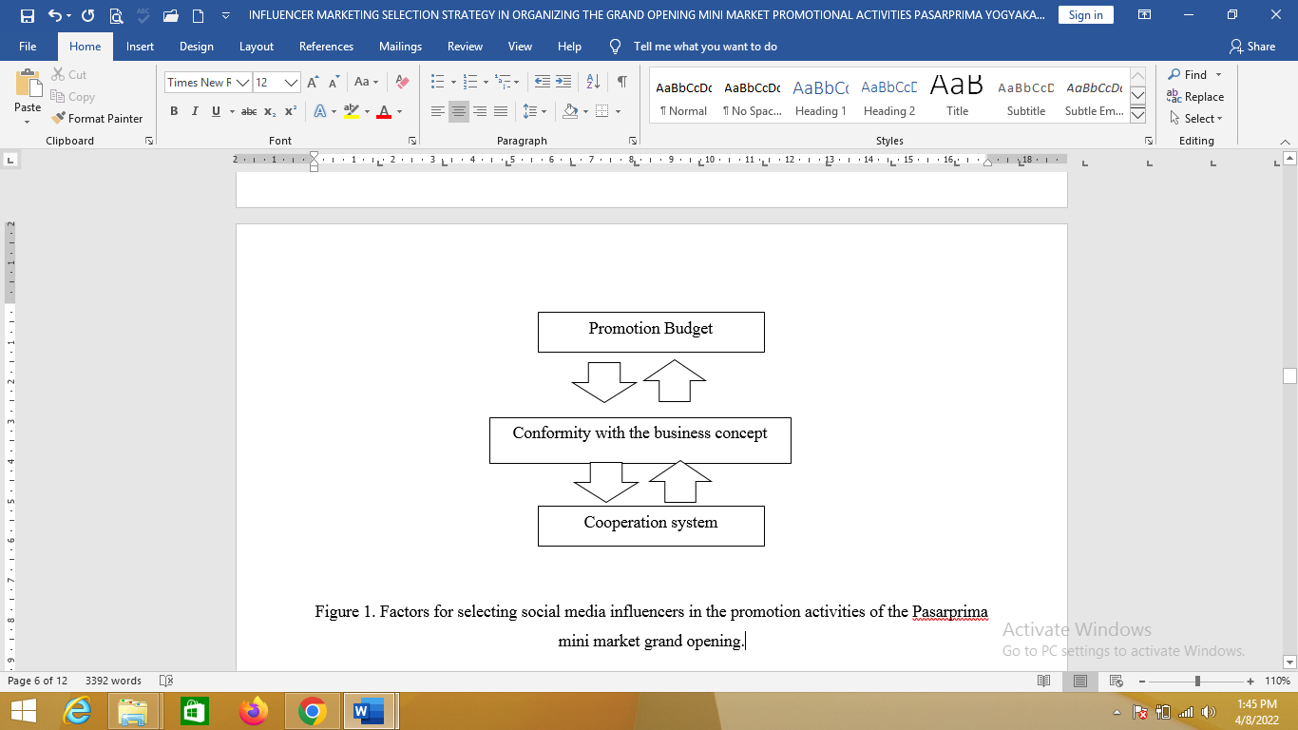

Figure 1. Factors for selecting social media influencers in the promotion activities of the Pasarprima mini market grand opening.

Referring to the picture above, the influencer selection strategy in organizing the grand opening promotion of the Pasarprima mini market is based on three main factors, namely, the budget stage, conformity with the business concept and the system of collaboration with influencers.

There are two important stages in the influencer selection strategy, namely the planning and implementation stages. The planning stage of the influencer selection strategy to promote the grand opening of the Pasarprima mini market can be seen in the following image.

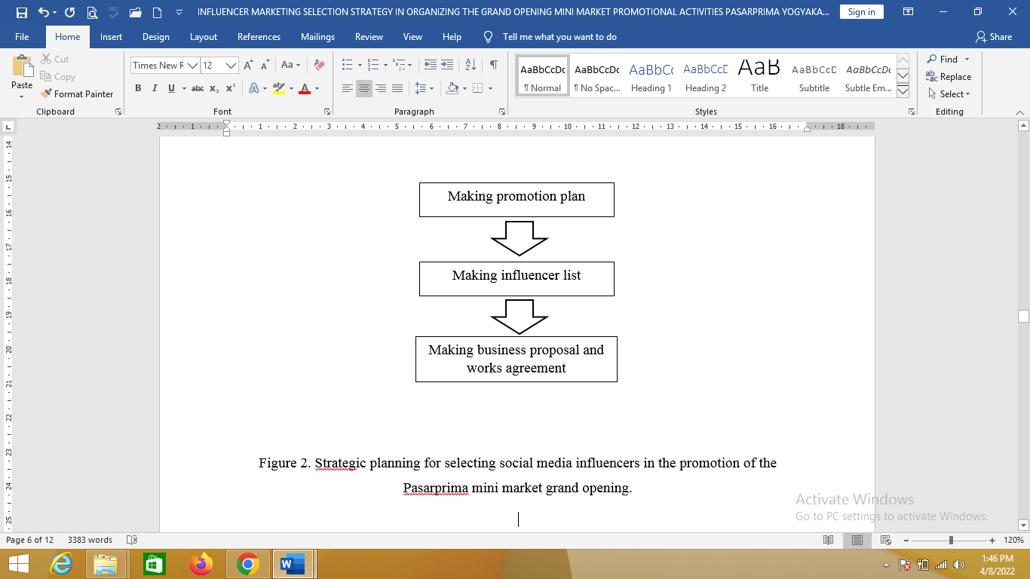

Figure 2. Strategic planning for selecting social media influencers in the promotion of the Pasarprima mini market grand opening.

The following is an explanation of the image above, namely the planning flow of social media influencer selection strategies in the promotion activities of the Pasarprima mini market grand opening.

1. At the stage of making a promotion plan, the owner makes a promotion schedule, determines which products will be given a discount, and determines the selling price of the promotion.
2. The owner makes a list of influencers that match the target market.
3. Owner makes cooperation proposals and SPK for influencers.

Table 1. List of target influencers for the promotion of the Pasarprima mini market grand opening.

|  |  |  |  |
| --- | --- | --- | --- |
| **No.** | **Influencer Name** | **Field** | **Social Media Platform** |
| 1 | Aullya Rachmawati | *lifestyle, food, beauty* | Youtube and instagram |
| 2 | Josephine Clarissa | *lifestyle, parenting, kids, beauty, food* | Instagram |
| 3 | Septian Adi Putra | *traveling, lifestyle, event* | Instagram |
| 4 | Hans Callaghan | *Fashion, lifestyle, traveling* | Instagram |
| 5 | Willy Isnan | *Comedy, lifestyle, edm* | Instagram and youtube |
| 6 | Jp Denny Siswanto | *Lifestyle, musician* | Instagram and youtube |
| 7 | Matthera | *Lifestyle, traveling, food* | Youtube and instagram |

After all stages of planning have been carried out, the owner will proceed to the implementation stage. The first activity carried out at the implementation stage is handling influencers. Starting with contacting the influencers from the list that has been made and sending a draft of the promotional activities to be carried out. The following is a flowchart of the stages of handling influencers at the grand opening promotion of the Pasarprima mini market.

Contacting influencers according to the list

Price negotiation

Make a deal

Submit advertising material to be posted

Meeting and discussing the concept of content to be created

Follow up until the content is posted on social media influencers

Monitoring the number of views, likes and engagement on the content that has been posted

Figure 3. Flowchart of handling influencer

The following is an explanation of the flowchart image above regarding the handling of influencers for the promotion of the Pasarprima mini market grand opening.

1. The owner contacts the influencer directly by asking for the price rate and offer package provided by the influencer.
2. Negotiation of prices, adjusted to the budget that has been made by the owner.
3. Make deals with influencers.
4. After an agreement is reached, the owner will submit advertising material which will then be posted by the influencer.
5. Influencers are asked to come to the Pasarprima mini market for a meeting and discuss the concept of content to be created. After that, the influencer immediately creates content and is accompanied by the owner.
6. The owner follows up with influencers regarding the schedule for posting promotional content that has been mutually agreed upon.
7. The owner monitors the number of viewers, likes and engagement between influencers and followers from the content that has been posted on the influencer's social media accounts.

**Discussion**

The use of social media as the distribution of promotional content is a good step because it is cost-effective and a promotional strategy using influencers is the right action because it has a high effectiveness from the results of creative content created to get the attention of the target market. The strategy begins with the planning stage, where the owner determines the appropriate influencers to promote the Pasarprima mini market grand opening. The selection of influencers focuses on the suitability of the influencer with the business concept and is also adjusted to the budget that has been determined by the owner. The entire influencer handling activity went well and had minimal problems. In the end, the owner decided to only collaborate with 2 influencers because of the limited budget. The chosen influencers are Josephine Clarissa who is engaged in lifestyle, parenting, kids, beauty, food and Aullya Rachmawati who is engaged in lifestyle, food, beauty. The content owned by the two influencers is considered suitable for the grand opening promotional activities that will be carried out by the Pasarprima mini market, namely lifestyle, beauty and food.

This research has a weakness in terms of presenting information from the results of influencer handling activities which can only be seen from the number of viewers and likes of promotional content posted on influencer's social media accounts. The author only looks at the effectiveness of using influencers through the number of viewers, likes, increasing followers of the Pasarprima mini market social media account and engagement between influencers and followers, not including the number of sales and visitors elements in promotional activities as a component of assessing the effectiveness of using influencers. This research has the advantage of presenting complete information, namely the stages of selecting influencers from the planning stage to the implementation of handling influencers.

1. **Conclusion**

The conclusion of the Pasarprima mini market grand opening promotion activity can be seen as follows:

1. Planning an influencer selection strategy in the promotion activities of the Pasarprima mini market grand opening begins with making a promotional plan, followed by making a list of influencers that are suitable for the target market and compiling a proposal for cooperation and SPK.
2. Implementation of the influencer selection strategy in the promotion activities of the Pasarprima mini market grand opening, starting with communicating with influencers until finally the promotional activities went well and the successful handling of influencers was marked by achieving a satisfactory amount of exposure.

**Suggestion**

In the promotional activities for the grand opening of the Pasarprima mini market, with 2 influencers, it was quite good, judging from the amount of exposure generated. But it will be even more leverage if you use more influencers. The content created will also be more numerous and varied, so it will attract many followers according to the type of content they like and want.

In this study, the authors only looked at the effectiveness of using influencers only from the amount of exposure (viewers, likes, followers and engagement) generated and did not include the components of the number of sales and the number of visitors. Suggestions for future research can include these elements and add other elements.

**References**

Belk, R.W. (1988). “Possesions and the extended self”. *Journal of Consumer Research,* 15(2), 139-168.

Brorsson, A. & Plotnikova, V. (2017). *Choosing the Right Social Media Influencer: A Quasi Experiment to Explore the Impact of Influencers’ Different Characteristics* (Master’s thesis). Linnaeus University,Sweden.

Burke, K. E. (2017). *Social Butterflies: How Social Media Influencers are the New Celebrity Endorsement* (Thesis). Virginia PolytechnicInstitute and State University Blacksburg,VA.

Edi, Purnomo (2021). 80 Persen UMKM di DIY Belum Melek Teknologi Internet. Merdeka.com.<https://www.merdeka.com/peristiwa/80-persen-umkm-di-diy-belum-> melek-teknologi-internet.html

Escobar-Rodríguez, T., Bonsón-Fernández, R. (2017). Analysing online purchase intention in Spain: fashion e-commerce. *Information* *Systems and e-Business Management*, 15, 599–622.

Freberg, K., Graham, K., McGaughey, K. & Freberg, L.A. (2011). Who are the social media influencers? A study of public perceptions of personality. *Public Relations Review*, 37(1), 90–92

Khamis, S., Ang, L., & Welling, R. (2017). Selfbranding, 'Micro-Celebrity' and the Rise of Social Media Influencers. *Celebrity* *Studies*, *8*(2), 191–208 <https://doi.org/10.1080/19392397.2016.1218292>

Leon, Yosef. (2022). UMKM Jogja Didorong Tangkap Peluang Pasar Online di Era Digital. Solopos.com.https://www.solopos.com/umkm-jogja-didorong-tangkap-peluang-pasar-online-di-era-digital-1250650

Marickar, S. & Rajasekhar, Dr. D. (2019). An Analysis of Growth and Usage Patterns of Instagram Users for Effective Brand Engagement in the Middle East. *Journal of* *Critical Reviews, 7*(2), 265–267.

Paramitha, C. R. P. (2011). *Analisis Faktor Pengaruh Promosi Berbasis Sosial Media Terhadap Keputusan Pembelian Pelanggan dalam Bidang Kuliner*. (Thesis). UniversitasDipenogoro, Semarang.

Putri S, E. A. (2013). *Aplikasi Instagram Sebagai Media Komunikasi Pemasaran Online Shop*.(Skripsi). Universitas Pembangunan NasionalVeteran, Surabaya

Schwartz, H. Andrew, Eichstaedt, Johannes C., Kern, Margaret L., Dziurzynski, Lukasz, Ramones, Stephanie M., Agrawal, Megha, Ungar, Lyle H. (2013). Personality, Gender and Age in the Language of Social Media: The Open-Vocabulary Approach. PLoS ONE, 8(9), E73791.

Talaverna, M. (2015). 10 Reasons Why Influencer Marketing is the Next Big Thing. Retrieved from <http://www.adweek.com/digital/10-> reasons-why-influencermarketingis-the-nextbig- thing