**Analysis of the relationship between Skills and Leadership Style to determine the effect on motivation and Lecturer Performance.**

Suparjo

Widya Mandala Catholic University, Surabaya, Indonesia

[managedoctor.suparjo.21@ukwms.ac.id](mailto:managedoctor.suparjo.21@ukwms.ac.id)

Institut Teknologi Adhi Tama Surabaya

[suparjo@itats.ac.id](mailto:suparjo@itats.ac.id)

Lydia Ari Widyarini  
Universitas Katolik Widya Mandala Surabaya  
[lydiaari@ukwms.ac.id](mailto:lydiaari@ukwms.ac.id)

**ABSTRACT**

This research was conducted to determine and analyze the effect of leadership skills and styles to determine the effect on the motivation and performance of lecturers. This study was chosen because of the phenomena and problems associated with job satisfaction. This, of course, relates to many factors, but the author has a provisional assumption that skills and leadership style factors will determine the effect on lecturer motivation and performance, both of which will affect and increase lecturer job satisfaction and performance. The method used in collecting data in this research is a questionnaire. The number of questionnaires given to respondents was 100 questionnaires. The data analysis technique uses descriptive analysis and questionnaire feasibility tests that have been tested first with validity tests, reliability tests, multicollinearity test, coefficient of determination test and Path analysis (Path Analysis) with smart-pls software. The research gives the following results: The model directly shows that leadership skills and styles have a significant positive effect on increasing lecturers' motivation and performance. In addition, motivation also has a significant positive effect on improving the performance of lecturers, so that the increasing motivation in life will improve the performance of lecturers better. The model indirectly uses motivation as a mediator variable, showing that skills and leadership style have no effect on increasing lecturer performance through motivational mediators The research gives the following results: The model directly shows that leadership skills and styles have a significant positive effect on increasing lecturers' motivation and performance. In addition, motivation also has a significant positive effect on improving the performance of lecturers, so that the increasing motivation in life will improve the performance of lecturers better. The model indirectly uses motivation as a mediator variable, showing that skills and leadership style have no effect on increasing lecturer performance through motivational mediators The study gave the following results: The model directly shows that leadership skills and styles have a significant positive effect on increasing lecturers' motivation and performance. In addition, motivation also has a significant positive effect on improving the performance of lecturers, so that the increasing motivation in life will improve the performance of lecturers better. The model indirectly uses motivation as a mediator variable, showing that leadership skills and styles have no effect on increasing lecturer performance through motivational mediators In addition, motivation also has a significant positive effect on improving the performance of lecturers, so that the increasing motivation in life will improve the performance of lecturers better. The model indirectly uses motivation as a mediator variable, showing that leadership skills and styles have no effect on increasing lecturer performance through motivational mediators In addition, motivation also has a significant positive effect on improving the performance of lecturers, so that the increasing motivation in life will improve the performance of lecturers better. The model indirectly uses motivation as a mediator variable, showing that leadership skills and styles have no effect on increasing lecturer performance through motivational mediators

Keywords: skills, leadership style, job satisfaction and performance

1. **Introduction:**

Employers in all sectors of business and government are increasingly calling for higher education providers to prepare graduates for the workforce. According to The Association of American Colleges and Universities (AACU) 2021 report on "How Colleges Contribute to Workforce Success: Employers' Views on What Matters Most," employers place a high value on effective interpersonal skills, communication, and problem-solving skills. (finley,2021, p. 6). Meyers & Jones defines active learning as “…providing opportunities for students to meaningfully speak and listen, write, read, and reflect on the content, ideas, issues, and concerns of an academic subject” (Meyers & Jones& Jones, 1993, p. 3). TherebySimilarly, a study by Vaughan et al.(2013) thinkthat while active learning requires effective teaching practices, it has the benefit of encouraging student participation, interaction, and engagement. A meta-analysis of 225 studies involving all types of active learning strategies in various disciplines found that active learning strategies consistently resulted in better student learning and reduced failure rates than lecture-based methods (Freeman et al., 2014). It is hoped that by involvingstudents are more active intheir learning will increase their skills for employability. Students generally view their learning as acquiring skills and abilities, applying knowledge and/or as a tool for learningpersonal development.Garcia-Aracilet al.,2021). A number of studies have shown that engaged students are more goal-oriented and tend to achieve higher levels of performancetall (Bakker et al., 2012;Christian et al., 2011;Salanova et al., 2010;Zepke & Leach, 2010). Learning environmentwhich foster an understanding of learning objectives, assignments, and workloads positively influence students' approaches to learning (Bryson & Hand, 2007). Therefore,abilityto engage in 'good learning', depending on the quality of the approach and the students' general beliefs. This too depends on the ability to cultivate a proactive attitude that allows students to be continuously open to new experiences and committed to continuous learning.Pegg et al., 2022). Withother words, studenthave great confidence in their ability to organize and carry out the actions necessary to produce a given achievement.Bandura, 1997).growThese beliefs may be relevant for instructors as they approach instructional design tasks.A servant leadership approach may be beneficial in more ways than originally thought. (Stewart Gary J, 2017, 1-5. In college At a high level, lecturers are one of the human resources that need special attention from the institution, not only in terms of quantity but also quality. This is because the lecturer has a very important role as the spearhead of implementing the entire educational process and as a distributor of knowledge to students. Therefore, in an effort to improve the quality of higher education, lecturers play a key role and position in the entire educational process, especially in higher education. One of the most influential factors for the success of a university in carrying out its vision and mission is the performance of the lecturers. Lecturer performance is the driving force for the success of the goals to be achieved by higher education institutions, both public and private. Mangkunegara (2004: 67) provides an understanding of performance is the result of work in quality and quantity achieved by a person in carrying out his duties in accordance with the responsibilities given to him. The performance of a lecturer in carrying out his duties and functions cannot stand alone, but is related and is also influenced by by other factors, both internal and external factors of the lecturers themselves. Several internal factors that affect the performance of a lecturer include: work motivation, job satisfaction, experience, competence or skill, or other individual traits. While external factors that can also affect the performance of a lecturer are organizational leadership style, work environment, friends or colleagues, compensation and others. Work motivation is an important factor that affects the performance of lecturers. Work motivation itself is a mental impulse that arises from within and outside the lecturer to carry out the task. Duncan in Uno (2007: 87) suggests that work motivation is related to the urge that arises from a person to do the overall task based on their respective responsibilities. For a lecturer, these duties and responsibilities can be seen in implementing the Tri Dharma of Higher Education. Therefore,

Based on the description above, this study aims to determine the effect of a lecturer's skills and leadership style on work motivation to improve lecturer performance for the better.

1. **Literature review**

Leadership on Job Satisfaction Research results (Lestari & Mariyono, 2017) with the title The Effect of Leadership and Employee Job Satisfaction Through Employee Motivation at LKP Lestari Computer Slawi, show that leadership and job satisfaction have a significant effect on performance through employee work motivation. And research (Hamsinah et al., 2017) entitled The Effect of Leadership Style and Job Stress on Employee Job Satisfaction. The results of his research explained that the leadership style shown by the leader had a positive and significant effect on job satisfaction.

Work Motivation on Employee Job Satisfaction In accordance with what is stated by (Moekijat, 2002) states that work motivation is a driving force. Work motivation will have an impact on the size of a person's business, trying or working hard and earnestly to achieve his needs. On the other hand, someone with low work motivation will never achieve results that exceed their motivation to work. The need must be created or encouraged first, in order to boost the high work motivation at work. Research (Eni Juniar et al., 2015) entitled The Effect of Motivation on Job Satisfaction and Performance of Civil Servants (PNS) at the Nusa Dua Bali Tourism College. Based on the results of the analysis, it turns out that work motivation has a positive and significant effect on job satisfaction.

According to Fatchur et al. (2011) performance is the result of work that can be achieved by a person or in a group within an organization in accordance with the authority and responsibility of each. So, it can be concluded from the explanation above, performance is a result of work in quality and quantity achieved by an employee in carrying out his duties according to the responsibilities given which are in accordance with the criteria determined by the company. An organization that has employees with a level of job satisfaction high levels tend to be more effective than organizations with low levels of job satisfaction (Robbins & Judge, 2013). Job satisfaction is individual, so each employee has a different job satisfaction according to his perception of his job.

***Partial Least-Square Structural Equation Modeling (*PLS SEM)**

There are two approaches in Structural Equation Modeling (SEM), namely covariance-based SEM or also called Covariance Based-SEM (CB-SEM) and the variance approach (VB-SEM) with Partial Least Squares-SEM (PLS-SEM) techniques. The PLS approach is more suitable because it assumes that all measures of variance are useful variances to explain.

The following are the steps in the analysis with PLS according to Hair, et al (Hair, Hault, Ringle, & Sarstedt, 2014):

1. **Specifying the Structural Model (Inner Model)**

The PLS-SEM analysis process begins with the specification of the structural model. Structural model is a model that describes the relationship between latent variables. The design of the structural model needs to be considered in order to represent the hypotheses and relationships in the theory being tested.

1. **Specifying the Measurement Model (Outer Model)**

The next step in the PLS-SEM analysis is to design a measurement model. The measurement model is a representation of the relationship between the construct and the indicator variables that measure it. The type of measurement model consists of a reflective measurement model and a formative measurement model, while the construct can be measured with single items and multi-items.

1. **Data Collection and Examination**

In the next stage, data is collected for PLS-SEM estimation. If an empty answer is found in the data set, it is necessary to insert a number that will not appear in the response to indicate a missing value. If the number of missing values ​​in the data set per indicator is relatively small (less than 5%), it is recommended to replace the mean value of 14 compared to casewise deletion. Another examination method that can be used is the diagnosis of outliers.

1. **PLS-SEM Path Model Estimation**

In path model estimation, the PLS algorithm estimates the path coefficient and other model parameters to maximize the variance that can be explained by the dependent variable. Variables, indicators are used as raw data input to estimate construct scores as part of the completion of the PLS-SEM algorithm (Hair, 2014). The relationship between indicator variables and reflective constructs is called outer loading, while the relationship between indicator variables and formative constructs is called outer weight. The PLS-SEM algorithm uses known elements for estimation, for that it is necessary to determine the construct score that is used as input for the partial regression model in the path model. As a result, estimates are obtained for all relationships in the measurement model (loading and weight) and structural model (path coefficient).

1. **Measurement Model Evaluation**

The purpose of the evaluation of the measurement model is to determine the validity and reliability of the indicators. For the reflective measurement model, the evaluation is carried out with composite reliability to assess internal consistency and individual indicator reliability, and average variance extracted to assess convergent validity.

1. **Structural Model Evaluation**

The purpose of evaluating the structural model at this stage is to see the significance of the relationship between latent variables by looking at the path coefficient which indicates whether or not there is a relationship between latent variables in the research model. To evaluate the structural model starting from looking at the R-Square (R2) value for each prediction from the structural model, the R2 value is used to explain the effect of certain latent (exogenous) variables on latent (endogenous) variables or how big their influence is.

1. **Conclusion**
2. **Research Thinking Framework**

The framework of thought in this study refers to a background that wants to know the effect of skills / competencies and leadership styles on work motivation to improve the quality of lecturer performance for the better in the scope of public and private universities.

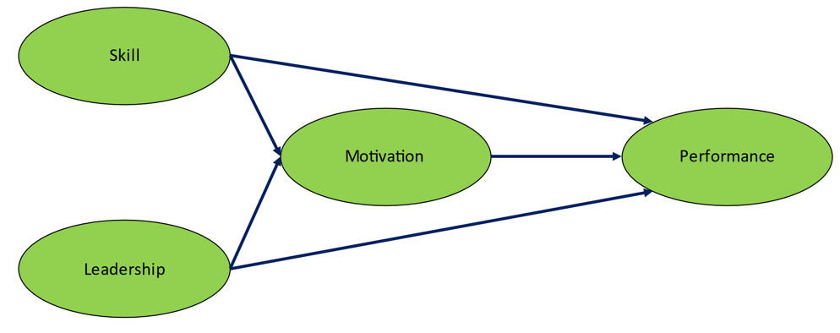

Figure 1. Research Thinking Framework

Hypothesis in research:

Based on the research concept framework, then The hypothesis proposed in this study is as follows:

H1: Skills have a significant effect on lecturers' work motivation.

H2: Leadership style has a significant effect on lecturers' work motivation.

H3: Skills have a significant effect on lecturer performance.

H4: Leadership style has a significant effect on lecturer performance.

H5: Work motivation has a significant effect on lecturer performance.

1. **Results**

The results of the validity test carried out on the item instrument used in the study, showed that all research instrument items can be used said to be valid, because it has met the criteria for testing the validity of the instrument items used, namely Pearson product moment correlation index value (r)≥ 0.3. These results indicate that the instrument that used can reveal data from variables that properly researched. Meanwhile, based on the test results the reliability of the instrument items used in the study showed that all research instrument items can be said reliable, because it has met the test criteria the reliability of the instrument items used, namely the value of Alpha Cronbach (alpha)≥0.6. This result shows that the instrument used can be trusted or reliable when used many times.

|  |  |  |  |  |
| --- | --- | --- | --- | --- |
|  | Cronbach's Alpha | rho_A | Composite Reliability | Average Variance Extracted (AVE) |
| X1(skills) | 0.704 | 0.712 | 0.805 | 0.509 |
| X2(Leadership Style) | 0.775 | 0.770 | 0.856 | 0.598 |
| Y1(Motivation) | 0.832 | 0.833 | 0.899 | 0.749 |
| Y2(Performance) | 0.880 | 0.881 | 0.926 | 0.806 |

The results of calculations with the help of smart-pls software obtained a path diagram along with the path coefficients as follows:

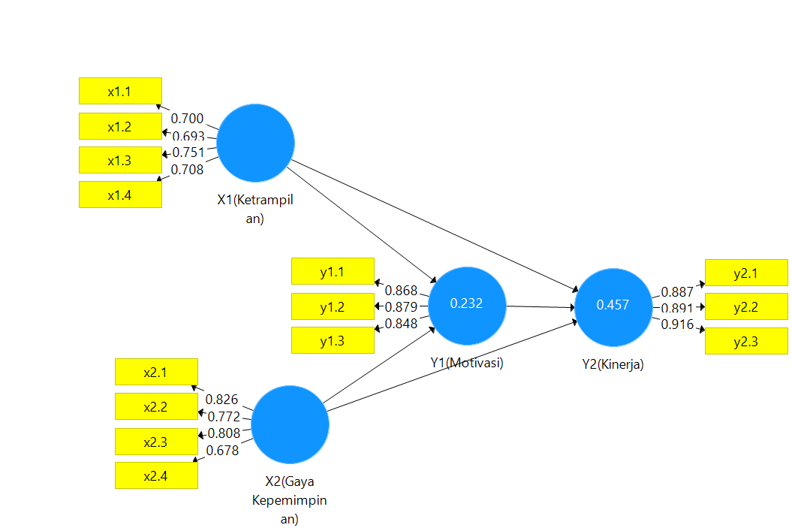

Figure 2. Research Path Diagram

The results of the estimation and parameter significance testing are shown in the following table

Table 1. Result of estimation of Direct Effect

|  |  |  |  |  |  |  |
| --- | --- | --- | --- | --- | --- | --- |
| No | Variable Relationship | Original Sample (O) | Sample Mean (M) | Standard Deviation (STDEV) | T Statistics (|O/STDEV|) | P Values |
| 1 | Skill -> Y1(Motivation) | 0.237 | 0.243 | 0.113 | 2.096 | 0.037 |
| 2 | Skill -> Y2(Performance) | 0.425 | 0.433 | 0.063 | 6,731 | 0.000 |
| 3 | X2(Leadership Style) -> Y1(Motivation) | 0.319 | 0.321 | 0.079 | 4.021 | 0.000 |
| 4 | X2(Leadership Style) -> Y2(Performance) | 0.344 | 0.344 | 0.078 | 4.383 | 0.000 |
| 5 | Y1(Motivation) -> Y2(Performance) | 0.137 | 0.138 | 0.067 | 2,059 | 0.040 |

1. The effect of skills on motivation.The test results listed in the table above can be seen that the T statistic value of the relationship between skills and motivation is 2.096 with a p-value of 0.037. The test results show that the value of T statistics > 1.96, indicating that there aresignificant relationship between skills and work motivation.
2. The effect of skills on performance directly.The test results listed in the table above can be seen that the T statistic value of the relationship between skills and performance is 6.731 with a p-value of 0.000. The test results show that the value of T statistics > 1.96, indicating that there aresignificant relationship between skills and performance.
3. The influence of leadership style on motivation. The test results listed in the table above can be seen that the T statistic value of the relationship between leadership style and teacher performance is 4,021 with a p-value of 0.000. The test results show that the value of T statistics > 1.96, so that there is a significant influence of leadership style on motivation.
4. The influence of leadership style on lecturer performance. The test results listed in the table above can be seen that the T statistic value of the relationship between leadership style and teacher performance is 4,383. The test results show that the value of T statistics > 1.96, so that there is a significant influence of leadership style on performance.
5. The effect of motivation on lecturer performance. The test results listed in the table above can be seen that the T statistic value of the relationship between motivation and teacher performance is 2,059. The test results show that the value of T statistics > 1.96, then there is a significant effect of motivation on lecturer performance.

Table 2. The estimation results of indirect effects

|  |  |  |  |  |  |
| --- | --- | --- | --- | --- | --- |
|  | Original Sample (O) | Sample Mean (M) | Standard Deviation (STDEV) | T Statistics (|O/STDEV|) | P Values |
| Skill -> Y1(Motivation) -> Y2(Performance) | 0.032 | 0.034 | 0.026 | 1.255 | 0.210 |
| X2(Leadership Style) -> Y1(Motivation) -> Y2(Performance) | 0.044 | 0.044 | 0.024 | 1.818 | 0.070 |

1. Based on the tests listed in the table above, it can be seen that the effect of skills on lecturer performance through motivation is obtained by the T statistics value of 1.255. The test results show that the value of T statistics < 1.96, so there is no significant effect of skills on lecturer performance through motivation.
2. The influence of leadership style on lecturer performance through motivation obtained the value of T statistics of 1.818. The test results show that the value of T statistics < 1.96, so there is no significant influence of leadership style on lecturer performance through motivation.

Based on the parameter estimation tests that have been carried out either directly or indirectly, the goodness of the model can also be measured using R square which is shown in the following table.

|  |  |  |
| --- | --- | --- |
|  | R Square | R Square Adjusted |
| Y1(Motivation) | 0.232 | 0.218 |
| Y2(Performance) | 0.457 | 0.443 |

Based on Table 3 above, it is known that the value of R square (R²) is 0.232 which means that, skills and leadership style together only affect 23.2% of motivation and this is categorized as low, because there are many other factors that influence motivation. need to be involved in this research. While motivation has an effect of 45.7% on the performance of lecturers. Motivation acts as a mediating variable that bridges between skills and leadership styles.

**5. Conclusion**

The results of the study provide the following results:

* The model directly shows that leadership skills and styles have a significant positive effect on increasing lecturers' motivation and performance. In addition, motivation also has a significant positive effect on improving the performance of lecturers, so that the increasing motivation in life will improve the performance of lecturers better.
* The model indirectly uses motivation as a mediator variable, showing that leadership skills and styles have no effect on increasing lecturer performance through motivational mediators.

**References**

Bakker, AB, Demerouti, E., & Lieke, L. (2012). Work engagement, performance, and active learning: The role of conscientiousness. Journal of Vocational Behavior, 80 (2), 555–564.

Bryson, C., & Hand, L. (2007). The role of engagement in inspiring teaching and learning. Innovations in Education & Teaching International, 44(4), 349–362.

Finley, A. (2021). How college contributes to workforce success: Employer views on what matters most. Hanover Research: Association of American Colleges and Universities. Retrieved from<https://www.aacu.org/aacu-news/newsletter/how-college-contributes-workforce-success>.

Fatchur, R., Armanu, and Novita, M. 2011. The Effect of Psychological Empowerment and Affective Commitment on Job Satisfaction and Employee Performance (Study at the City Planning and Building Supervision Office of Mataram City). Journal of Management Applications. Vol. 10. No. 1. ISSN : 1693

Fatchur, R., Armanu, and Novita, M. 2011. The Effect of Psychological Empowerment and Affective Commitment on Job Satisfaction and Employee Performance (Study at the City Planning and Building Supervision Office of Mataram City). Journal of Management Applications. Vol. 10. No. 1. ISSN : 1693

Robbins, S., & Judge, TA (2013). Organizational Behavior. Zhurnal Experimental'noi i Teoreticheskoi Fiziki. https://doi.org/10.12737/4477

Freeman, S., Eddy, S., McDonaough, M., Smith, M., Okoroafor, N., Jordt, H., & Wenderoth, H. (2014). Active learning increases student performance in science, engineering, and mathematics. Proceedings Of the National Academy Of Sciences Of the United States of America (PNAS), 111(23), 8410–8415. https://doi.org/ 10.1073/pnas.1319030111.

Garcia-Aracil, A., Monteiro, S., & Almeida, L. (2021). Students' perceptions of their preparedness for transition to work after graduation. Active Learning in Higher Education, 22(1), 49–62.

Salanova, M., Schaufeli, W., Martínez, I., et al. (2010). How obstacles and facilitators predict academic performance: The mediating role of study burnout and engagement. Anxiety, Stress & Coping, 23(1), 53–70.

Hair, J., Hault, G., Ringle, C., & Sarstedt, M. (2014). A Primer On Partial Least Structural Equations Modeling (PLS-SEM). Sage: United States of America.

Mangkunegara, Anwar Prabu. 2004. Company Human Resources Management. Bandung: PT Pemuda Rosdakarya.

Uno, Hamzah B. 2007. Motivation Theory & Its Measurement Analysis in Education. Jakarta: PT Bumi Aksara

Stewart J Gary. 2017. The Importance of Servant Leadership in Schools. International Journal of Business Management and Commerce, Vol. 2 No. 5; Octoberpp.1

Vaughan, N., Garrison, D., & Cleveland-Innes, M. (2013). Teaching in blended learning environments: Creating and sustaining communities of inquiry. Athabasca Canada: Athabasca University Press.

Zepke, N., & Leach, L. (2010). Improving student engagement: Ten proposals for action. Active Learning in Higher Education, 11(3), 167–177.

Eni Juniar, NK, Riana, IG, & Subudi, M. (2015). The Effect of Motivation on Job Satisfaction and Performance of Civil Servants (Pns) at the Nusa Dua Bali Tourism College, 11(4), 823–840.

Hamsinah, Sjahruddin, H., & Gani, M. (2017). The Influence of Leadership Style and Job Stress on Employee Job Satisfaction. Organization And Management, (No.2), 62–77.

Lestari, S., & Mariyono, J. (2017). The Influence of Leadership and Employee Job Satisfaction Through Employee Motivation at LKP Lestari Computer Slawi. MULTIPLIER, Vol. I(No. 2), 80–87.

Moekijat. (2002). Human Resource Management. Personnel Management. Jakarta: Mandar Maju.