*Gender Diversity Of Leaders On Organizational Performance*

*Through Organizational Culture*

**Muhammad Alwi**

Faculty of Economics and Business

Universitas Swadaya Gunung Jati

Email: [malwy1980@gmail.com](mailto:malwy1980@gmail.com)

Hunik Sri Runing Sawitri

Faculty of Economics and Business

Universitas Sebelas Maret

Email: huniksri_fe@staff.uns.ac.id

***Abstract***

***Objectives -*** The purpose of this paper is to examine the philosophical aspects, namely the construction of organizational culture which has been the concern of scientists in the fields of human resource management, psychology, and anthropology.

***Design/methodology/approach –*** This paper uses a literature study approach by mapping previous research related to organizational culture in articles, Scopus indexed journals and Google Scholar over the last five decades.

***Findings – The*** antecedents of organizational culture can come from internal factors and external factors such as a sense of achievement and company policies. From the organizational culture are organizational performance, job satisfaction, job performance, and company strategy.

***Originality*** – The purpose of this paper is to propose a schematic research model that shows the influence of organizational culture on organizational performance can be moderated by the gender diversity of employees.

***Keywords -*** Philosophy of Science, Organizational Culture

***Type of Writing –*** Concept writing

# PRELIMINARY

Gender and organizational culture are interesting to study related to the changing situation where nowadays many women are found to be leaders in an organization. Society in general often doubts the leadership of a woman in an organization. Changes to the organizational structure, which is currently also filled by a woman as a leader, is an interesting thing to study. The social dynamics of organizations have also changed, from being more rigid in the past to a more flexible hierarchy. The current organization is more inclusive, meaning that it is generally open and does not concern itself with 'gender' to occupy certain positions in the organization as long as it has competence. This of course makes women have a relationship in the organizational culture that is formed.

Organizational culture has long been attached to a man as a leader rather than a woman in its formation. Different expectations, roles and responsibilities are often found in our society for male and female leadership. The process of changing the position of women in organizations has been very long and tiring. This clearly visible change is the right time to see where women really are in shaping organizational culture. Women have now taken on many roles in organizations, not only as subordinates but now holding many leadership positions. It is certain that women influence and shape organizational culture as much as organizational culture influences them. This is an important argument because changes have occurred, organizational culture is not only represented by men's values, beliefs, practices, and behaviors, women are also starting to stand out. Thus research has started a new phase of examining 'women's leadership styles'. I haven't seen 'women's leadership styles' as distinct in shaping organizational culture, but at least researching them is a better start than nothing.

Understanding the influence of 'gender' in this case women in shaping organizational culture is very much needed. Leadership in the definition of some experts never mention 'gender' as a factor that supports or hinders organizational progress. Society in general often only puts the appropriateness of leadership only on men. It becomes important to understand leadership in shaping organizational culture based on 'gender' with a solid foundation. Fiedler (1967) defines that leadership is basically a pattern of relationships between individuals who use authority and influence on groups of people to work together to achieve goals. Yukl (2002) defines leadership as “the process of influencing others to understand and agree about what needs to be done and how it can be done effectively, and the process of facilitating individual and collective efforts to achieve common goals”. Northouse 2004, he defined leadership as "the process by which an individual influences a group of individuals to achieve a common goal". It is important to note that the two definitions have mainly three things in common. They emphasized the process of 'influencing' a 'group or individual' and neither of them stated the 'gender' of the leader or the person influencing the group. The culture that has existed in society for centuries has depicted a man as more worthy of being a leader. Female leaders are often perceived as weak and it seems natural for everyone to perceive that. Women seem weak, shy, and not a few are victims because of this understanding.

# LITERATURE REVIEW

Situational leadership theory was developed by Fred Fiedler in 1958 during his research on leader effectiveness in group situations (Fiedler). Fiedler believed that the effectiveness of a person to lead depends on their control over the situation and leadership style (Fiedler). In contrast to the Situational Theory of leadership, leader effectiveness depends on the leader's style being appropriate to the situation, not adapting to it, this theory assumes that styles are fixed, and that they cannot be adapted or modified (Gupta, 2009).

Hersey and Blanchard revealed a leadership theory known as the "Cycle Theory of Leadership" in 1982 which started from the cycle of human life. According to research they found that leadership styles tend to vary from situation to situation, to apply an effective leadership style to begin with diagnosing the situation as well as possible. Contingency theory states that there is no design and use of a management control system that can be implemented or implemented effectively for a particular organization or company situation. In other words, how does a company align the expected performance with its internal and external business environment (Homburg, Artz, & Wieseke, 2012). Leadership effectiveness is influenced by three factors, 1) Task behavior; 2) Relationship behavior; 3) Follower readiness (Hersey and Blanchard, 1982).

The idea or concept of OC has its roots in cultural anthropology. OC is a collection of beliefs, values, rituals, stories, myths, and certain shared languages that contribute to developing a feeling of community among organizational members (Iriani, 2005). Several practitioners of the discipline of anthropology have produced a very important literary framework during the 1940s and 1950s in which their research relates directly to organizational work habits and traditions. Hatch (1993) says that although OC studies began to appear in the 1970s it was not until the 1980s that management scholars have adopted the concept of OC much. A large and diverse group of authors have used the metaphor of an organization as a 'small society', as a social system equipped with socialization processes, norms and social structures. It is in this very broad metaphor that the concept of OCi becomes important. If organizations are miniature societies, then they must show evidence of distinct cultural traits (Hatch, 1993).

OC is defined by (Brown 1998) is part of the overall internal and external environmental factors in which the existing leadership must struggle to obtain a response or reaction in order to achieve company goals. According to Robbins (2002: 247), OC is a shared perception held by members of the organization; a system of shared meanings. The definition of OC put forward by Schein (1992:12) formulates OC as:

“A pattern of shared basic assumptions that the group learned as it solved its problem of external adaptation and internal integration, that haw worked well enough to be considered valid and therefore, to be taught to new members as the correct way to perceive, think, and feel in relation to those problems”.

Schein (1992:16) states that OC refers to a system of shared meanings adopted by its members to differentiate the organization from other organizations. Schein explains the elements of culture, namely: science, belief, art, morals, law, customs, behavior / habits (norms) of society, basic assumptions, value systems, learning / inheritance, and problems of external adaptation and internal integration. There are seven main characteristics of OC, namely:

1. Innovation and the courage to take risks, in this case related to the extent to which members are encouraged to be innovative and dare to take risks.
2. Attention to detail, i.e. members are expected to exercise precision, analysis and attention to detail.
3. Results orientation is about the extent to which management focuses on results rather than on the techniques and processes used to achieve those results.
4. People orientation, related to the extent to which management decisions consider the effect of these results on people in the organization.
5. Team orientation. The extent to which the organization's work activities are on a team rather than on an individual.
6. aggressiveness. Regarding the degree to which people are aggressive and competitive rather than relaxed.
7. Stability. The degree to which organizational activities emphasize maintaining the status quo in comparison to growth.

Schein (1992:16) states that culture consists of 3 (three) layers or levels, namely:

1. ***Artifacts*** , the first/top level where activities or organizational forms look like organizational structures and processes, the physical environment of the organization and the products produced.
2. ***Espoused Values*** , the second level is the supported values, consisting of the strategy, goals, and philosophy of the organization. This level has an important meaning in leadership, these values must be instilled in every member of the organization.
3. ***Underlying Assumption*** , the underlying assumption, which is a belief that is considered to have existed within each member about the organization which includes aspects of beliefs, thoughts and feelings of attachment to the organization.

According to Luthans (2008) mentions a number of important characteristics of OC, including:

1. The rules of behavior, namely language, terminology and rituals commonly used by members of the organization.
2. Norms are standards of behavior that include instructions on how to do something.
3. Dominant values are the main values that are expected from the organization to be carried out by members, such as high product quality, low absenteeism, and others.
4. Philosophy of policies that the organization believes in what its employees and customers like.

The word *culture* first appeared in 1871 by Edward B. Taylor who was an anthropologist. Culture according to Taylor in Brown ( 1998: 4) is a collection of knowledge, belief, art, morals, law, customs and capabilities and habits acquired by a person as a member of a particular association or community. This definition was further developed in the discipline of sociology. Sociology broadly uses this word to describe various phenomena that occur in certain groups of people or communities. Culture in sociology, translated as a collection of symbols, myths and rituals that are important in understanding a social reality. Sociology uses an approach to the attitude of a certain group of people or communities in responding to various phenomena that occur around them. The subsequent development of the concept of culture was continued by many organizational experts. The word culture is closely related to various aspects of organizational development.

The publication of a Business Week article in 1980 on corporate culture generated considerable interest and a number of books on the topic (Deal and Kennedy 1982; Allen and Kraft 1982; Peters and Waterman 1982). Indeed, the proposition that organizations are cultural in nature, that they reproduce meaning, values and beliefs, that they nurture legends, myths and stories, and are embellished with rites, rituals and ceremonies has gained popularity rapidly. However, this fame can turn a complex, difficult but seminal concept into a banal fad, reducing it to nothingness. if entertaining, the catch-all construct explains everything and nothing! Indeed, with a few notable exceptions, cultural appeals are not followed by any elaboration. It is assumed that the word 'culture' is a stenographic cue for 'values, norms, beliefs, customs' or some other convenient set of identifiers chosen from among the various definitions available in a random selection of texts from cultural anthropology.

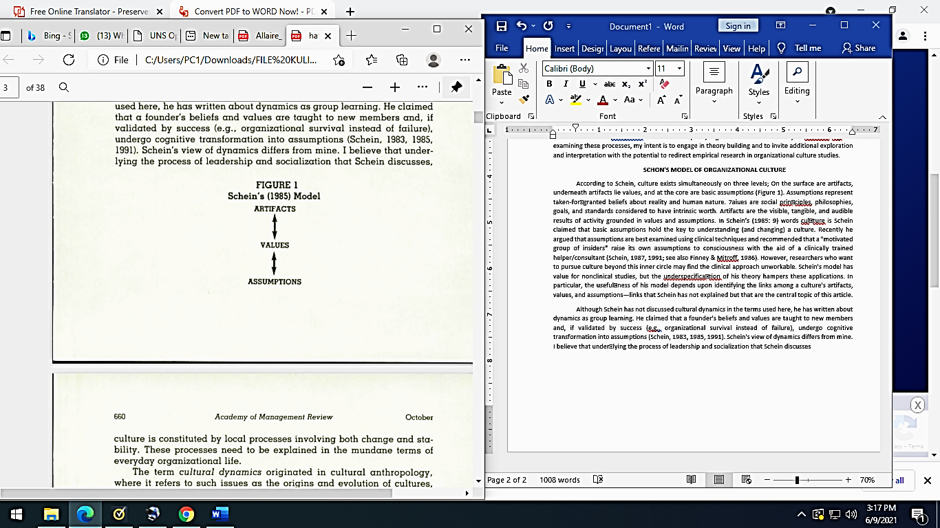Schein 1983, 1985, 1991, claims that founding beliefs and values are taught to new recruits and, if validated by success (eg, organizational survival not failure), undergo cognitive transformation into assumptions. Schein's claim is shown by the model in the following figure:

Figure 1. Schein model 1985

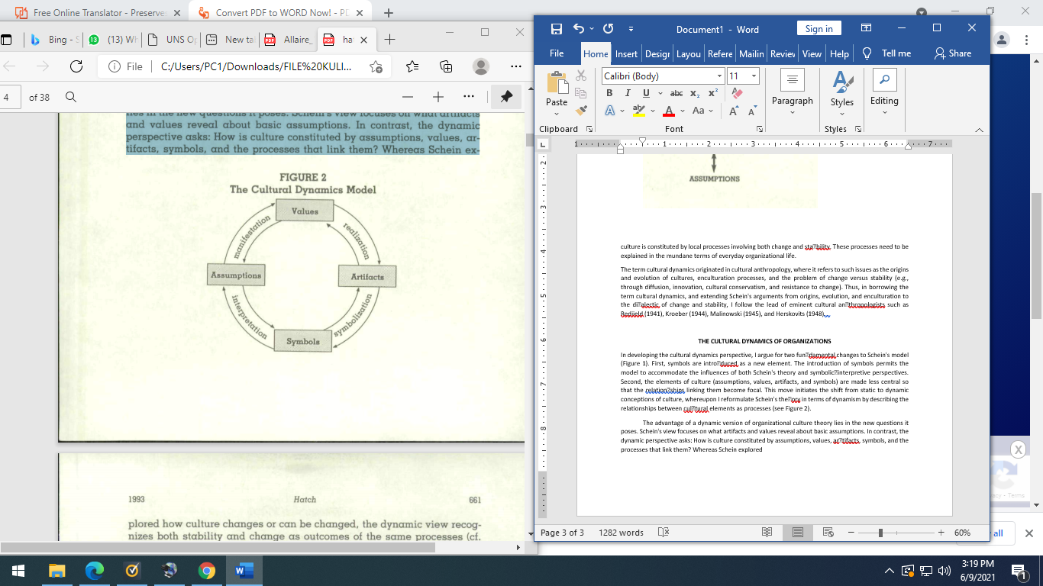Hatch 1993 argues that cultural dynamics do not undermine Schein's interests; it goes beyond them towards a more complex and process-based understanding of OC. According to the new model, proposed by Hacth that culture is formed by manifestation, realization, symbolization, and interpretation processes. Although Schein (1985) used the terms manifest and realization (often interchangeably). The new model can be seen in the image below:

Figure 2. The 1993 Hatch Culture Dynamics Model

At this time known the term OC (Brown, 1998: 5 -6). The concept of OC began to receive attention as an organizational success factor since the 1980s when Peters *and* Waterman in Alvesson (2002:2) identified the characteristics of companies in the United States (US) that performed very well. The work of Ouchi (1981) which discusses the key to the success of Japanese companies operating in the United States also emphasizes the role of OC carried out by Japanese companies.

Ingvar Kamprad, founder of IKEA. The source of the OC who grew up at IKEA is the founder. Habits, traditions, and general ways of doing things that exist in an organization today are the result or result of what has been done before and how much success it has achieved in the past. This leads to the highest source of an organization's culture: its founders. Traditionally, the founders of an organization have had a major influence on the organization's initial culture. The founders of the organization had no constraints due to previous habits or ideologies. The small size that usually characterizes new organizations further makes it easier for founders to impose their vision on all members of the organization. The process of creating culture occurs in three ways. First, founders only hire and retain employees who think and feel like them. Second, the founders indoctrinate and socialize their way of thinking and behaving to employees.

Finally, the founder's own behavior acts as a role model that encourages employees to identify with themselves and, in so doing, internalize the founder's beliefs, values, and assumptions. If the organization achieves success, the founder's vision is then seen as the main determining factor for that success. At this point, the entire personality of the founders became attached to the OC. OC shows certain traits, traits, or characteristics that show their similarities. The roots of OC are a set of core characteristics that are collectively valued by all members of the organization. OC characteristics show the characteristics, properties, elements, or elements contained in an OC. Each organization will show its characteristics and characteristics based on the characteristics of its OC (Wibowo, 2010:35).

Linda Smircich stated that the development of cultural studies in organizations is also in line with the growing assumption that organizations are not value-free, meaning that one organization may be different from another even though both are engaged in the same field, because each organization has its own culture and values. . This opinion is also supported by Hofstede who says that the theory of organization/management that is built and applied in one place cannot automatically apply in another place, one of which is because of differences in culture and values where each organization exists.

The founders of the organization have traditionally had an important impact on the formation of the organization's initial culture. They have a vision or mission of how the organization should be. They are not hindered by previous habits or by ideology. The small size that usually characterizes every new organization further helps the founders to apply their vision to the members of the organization. Because the founders are the ones who came up with the original ideas, they also usually have a bias about how those ideas should be met. OC is the result of the interaction between (1) the biases and assumptions of the founders and (2) what the first members of the organization, who were employed by the founders, learned from their own experience.

The benefits of OC for employees are (Uha, 2013):

(1) Provide direction or guidelines for behavior within the organization; (2) In order to have the same steps and vision in carrying out their duties and responsibilities. Each individual can improve its function and develop the level of interdependence between individuals/sections because between individuals/sections with other individuals/sections complement each other in organizational activities; (3) Encouraging to achieve better work performance or productivity; and (4) To achieve certainty about their careers in the organization so as to encourage them to be consistent with their respective duties and responsibilities.

In relation to the social aspect, culture serves as a social glue that helps unite an organization by providing precise standards of what employees should say and do. Finally, culture serves as a meaning-making mechanism and constraint that guides and shapes employee attitudes and behavior (Gordon, 1998). According to Atmossoeprapto (2001), there are several elements of OC, namely:

1. The business environment will determine what must be done to achieve success.
2. Values are the basic concepts and beliefs of an organization.
3. Exemplary, that is, people become role models for their employees because of their success.
4. Ceremonies, which are routine events held by the company in giving awards to its employees who excel.
5. Network *,* an informal communication network within the company that can be a means of spreading cultural values.

According to McKinsey & Company (in Peters and Waterman, 1982) there are seven variables that influence the success of an organization which are summarized in the 7- SMcKinsey , namely system, structure and strategy, *style,* system, *staff* , *skills* and *shared values* (OC which is *software* *of organizations)* .

According to Ndraha ( 1997: 21) OC functions as:

1. As the identity and image of a society
2. To bind a society
3. As a resource
4. Become a driving force
5. As the ability to form added value
6. Be a guide to behavior patterns
7. As inheritance
8. Substitute for formalization
9. As an adaptation mechanism to change
10. As a process that makes the nation congruent with the state so as to form *a nation-state* .

There are several benefits that can be obtained from both parties, both the organization and its members. These benefits are to provide guidelines for decision-making actions, increase organizational commitment, increase the behavior of organizational members' behavior consistency and also reduce the doubts of organizational members, because the culture tells them something is done and is also considered important (Mangkunegara, 2007).

Graham et al. (2001) shows that the work style adopted by women is communicative, collaborative and cooperative. These traits of female employees along with competitive orientation and analytical mindset of male employees working in the same group help to achieve superior performance compared to simple single gender groups. Such a combination may be more useful in certain complex settings such as projects that require extensive information management and processing.

# METHODOLOGY

This study uses a literature review approach by mapping previous research related to OC obtained during the last 5 decades through the Scopus and Google Scholar databases with the keywords “Organizational Culture”, “ *Organizational Culture* ”, “antecedents and consequences of organizational culture” , and "determinants and outcomes of organizational culture" by limiting the search to the fields of human resource management, psychology, and anthropology because studies related to *organizational culture* can extend to various fields of science.

# FINDINGS

This section discusses the antecedents and consequences of OC. What is meant by antecedents here are factors that can affect OC, while consequences are factors that can be influenced by OC. The proposed model scheme will then be discussed after the antecedents and consequences of OC.

## OC antecedent

A number of factors that can influence OC have been studied by previous studies (Abdussamad J., 2015). This paper groups these factors into two categories. The first category consists of top management variables in the organization and the second category is the socialization variables in the organization.

A culture of cooperation and professionalism can be built because transformational leaders will facilitate their employees to dialogue, discuss, and plan work together. The cooperation formed from this activity will make it easier for them to remind each other in carrying out their duties and work. In addition, transformational leadership can affect organizational culture. Organizational culture is often the creation of its founders. In particular, the leadership exercised by the organization's founders and successors helps to establish a culture of shared values and assumptions guided by the personal beliefs of the founders and leaders of the organization.

The results of this study confirm the opinion of Bass and Avolio, (1993) and Schein, (2004) which states that a leader shapes the culture and in turn is shaped by the resulting culture. Schein, (2004) says that organizational culture and leadership are interrelated. He illustrates this interconnection by looking at the relationship between leadership and culture in the context of the organizational life cycle, then organizational culture will also influence the attitudes and behavior of all members of the organization. A strong culture in an organization can provide coercion or encouragement to its members to act or behave as expected by the organization. With the observance of the rules and company policies, it is expected to optimize the performance and productivity of employees to achieve organizational goals. In the end, performance appraisal has an important role in increasing motivation at work. This performance appraisal is basically a key factor in developing an organization effectively and efficiently.

Furthermore, Hafidhuddin et. al, (2003:60) states that, the creator of culture is a leader. Every leader must have a certain vision and mission which is then disseminated to his subordinates and then becomes habits and in the end this becomes a culture. If every company leader does the same thing, the results will be better, because if the work atmosphere has been formed with a positive atmosphere. If it is conducive, employees will enjoy their work more, then their creativity will emerge.

Organizational culture is able to increase the motivation and performance of women compared to male respondents. This shows that organizational culture influences the work motivation of female respondents more than male respondents. Female employees tend to feel comfortable with the work culture applied in the office. In addition, female respondents are often unaware that their behavior can offend other employees. Lips (2007) in Nuri Herachwati and Bhaskaroga Dwiatmaja Basuki (2012) defines gender as cultural expectations of men and women. For example, women are known to be gentle, beautiful, emotional and motherly. In character, women are gentle, loving, more emotional, more expressive than men.

Based on the analysis of the role of organizational culture in improving the performance of both male and female employees, the amount is the same. This means that the organizational culture between men and women goes as expected and is able to absorb the values of the organizational culture that was formed to improve their performance. Employees are encouraged to work innovatively, have confidence in doing work, encourage employees to work carefully, and pay more attention to detail and pay attention to the vision and mission to be achieved at work so that the culture created is able to improve their performance.

Based on the level of education, undergraduate employees have a greater influence than employees with lower levels of education. This means that undergraduate level employees are better able to innovate and take risks, result oriented, and work stabilization in terms of doing criticism, are consistent with plans and want to be considered in terms of opinion.

Characteristics of organizational culture are innovation and risk taking, attention to detail, results orientation, people orientation, team orientation, aggressiveness, stability. Here the basis for selecting these characteristics is because the chosen character is considered to be able to represent or capture the nature of organizational culture. The word culture as a concept is rooted in the study or discipline of Anthropology; the one by Killman. et. Al in Nimran, ( 2004: 134) is defined as philosophy, ideology, values, assumptions, beliefs, expectations, attitudes and norms that are shared and bind a society. Howard Schult in Antonius (2005:316) says that organizational culture is work habits of all management and employees of a company that have been accepted as standards of work behavior, and make them emotionally attached to the company.

## Consequences of OC

Organizational culture is a subject that has long been discussed, reflected and explored in organizational analysis. Gender is another subject that is treated as such in various fields. What is surprising is that gender is often given a secondary position when it comes to understanding basic organizational processes and is rarely a topic of organizational research. More often than not the concept of gender is believed to be culturally determined, refined and shaped in a male-dominated environment. What is interesting is that gender, as a construct, is shaped and shaped by the culture of society. This makes a strong argument to be made in favor of the study of gender in organizations. Key concepts in organizational studies such as leadership, decision making, motivation, and team building are often male-centred and are used as general terms even for female employees. Such a blank portrayal leaves a large part of the population and leaves room for a false and inaccurate picture of the organization. This review study is a step towards recognizing that the number of women in higher positions and in organizations in general is increasing and that is why we need new ways of analyzing organizational culture in terms of organizational culture.

Organizational culture and gender have shared difficult areas along with organizations that are often blamed for being too 'gender' or too 'biased'. It is believed and often found in research that female employees face discrimination and have difficulty establishing their own identity, especially in male-dominated organizations. What needs more attention and more work is the fact that the organizational structure is gradually changing. The social dynamics of companies are also changing. What was once highly hierarchical and rigid is now turning into a flatter and more fluid system. This means that management styles, processes, ways of dealing with employees, decision making and teamwork have changed to better accommodate female employees with all their femininity, which was previously considered a weakness. In the last decade or two, organizations have begun to become more inclusive, although cases of discrimination, both overt and subtle, cannot be ignored. Inclusivity has made clear the type of relationship that female employees have with the organizational culture.

Becker Brian and Gerhart's research (1996), entitled: The Impact of human resources management on organizational performance, concludes that the speed of changes in the economic environment, changes in consumer and investor demand, and competition in the product market are variables in Human Resource Management (HRM), which affect organizational performance.

Research by Kotter and Heskett (1992) with a sample of 207 companies observed, resulted in the following conclusions: (1) corporate culture has a significant impact on the company's economic performance in the long term; (2) corporate culture may be a more important factor in determining a company's success or failure in the next decade; (3) corporate culture supports strong financial performance in the long term and internalization of corporate culture makes its values understood by everyone in the organization, giving employees the ability to adapt to their environment; (4) corporate culture can be formed to improve achievement.

Kirk L. Rogga's research from Michigan State University, in July 2001, entitled Human resource practices, organizational climate and employee satisfaction, was based on his observations of 385 car dealership companies in the United States. In his research, Kirk treats human resources as an independent variable, while organizational climate as an intermediate variable and employee satisfaction as the dependent variable. The results of Kirk L. Rogga's research conclude: (1) human resources have a 69% influence on organizational culture; (2) organizational culture has an impact of 90% on employee job satisfaction.

The results of Delaney and Huselid's (1996) research entitled: The Impact of human resource practices on perceptions of organizational performance state that: Progressive HR management (which affects employee skills, employee motivation, and presentation structure) is positively correlated with organizational performance.

Stajkovic Alexander D and Fred Luthans in 1997 conducted a study entitled Effect of Corporate Culture on Work Performance. This study was conducted on companies that have more than 7000 employees. From this number, 182 employees were taken as samples. In his research, corporate culture which is treated as an independent variable is determined by the interaction of internal and external forces. Internal strengths consist of a sense of achievement, development and advancement, nature of work; recognition; responsibilities. Meanwhile, external forces consist of: company policy; supervision; working conditions; salary and interpersonal relations. Processing the data using ANCOVA (analysis of covariance) and the result is that the internal strength group plays a more important role in determining the quality of work.

Arnita Hamid's research (Airlangga University, 2002) entitled "The Influence of New Organizational Culture on Motivation and Work Performance at PT Nusantara IV (Persero) North Sumatra". The use of Structural Equation Modeling (SEM) in this study aims to: (1) determine the effect of new organizational culture constructs on work motivation and work performance and (2) to determine the effect of work motivation on work performance. The results of the SEM analysis show: (a) there is a significant effect of the new organizational culture on work motivation; (b) there is a significant effect of new work motivation on employee performance; (c) there is a significant influence of the new organizational culture on work performance.

Research by Chatman Jennifer and Bersade, in 1997 entitled: Employee Satisfaction, Factor Associated With Company Performance, took a sample of 102 service companies in America. This study aims to see the relationship between corporate culture and company performance. The findings related to this strong organizational culture are: (1) A strong organizational culture helps the performance of business organizations because it creates an extraordinary level in employees; (2) A strong organizational culture helps organizational performance because it provides the structure and control needed without having to rely on a rigid formal bureaucracy that can suppress the growth of motivation and innovation.

There is not much research that uses contingency leadership theory with a situational approach and transformational leadership theory, although several studies have examined it from the point of view of top management and middle management.

This paper focuses on the consequences of OC on organizational performance.

## Moderating Variables

The moderating variable used is employee gender diversity. The antecedents that have been introduced in this paper have been reviewed by previous studies showing inconsistent results. Abdussamad J. (2015) shows that organizational culture influences the work motivation of female respondents more than male respondents. Female employees tend to feel comfortable with the work culture applied in the office. In addition, female respondents are often unaware that their behavior can offend other employees. Because of this strong positive relationship and the importance of OC, perceived gender diversity could be a moderating variable for the previous literature related to organizational performance.

## Proposed Model Schematic for OC

Through the framework of contingency leadership theory with a situational approach and two-factor theory as well as mapping the results of previous research, this paper proposes a model scheme as shown in Figure 5. The effect of OC on organizational performance is moderated by employee gender diversity.

**Internal**

* *sense of achievement*
* *development and advancement*
* *nature of work*
* *recognition*
* *responsibility*

**Variabel Moderasi**

* Keragaman gender karyawan

***Organizational Culture***

* *Assumptions*
* *Values*
* *Artifacts*
* *Symbols*

Kinerja Organisasi

**Kepemimpinan Transformasional**

* *company policy*
* *supervision*
* *working condition*
* *salary*
* *interpersonal relation*

.

Figure 5. Proposed Research Model Schematic for OC

# CONCLUSION

The antecedent of organizational culture can be sourced from internal and external factors of the company. The consequences of OC are organizational performance , job satisfaction, job performance, and company strategy . This paper proposes an OC research model scheme for further research, namely the effect of OC on organizational performance is moderated by employee gender diversity.

# BIBLIOGRAPHY

AA Anwar Prabu Mangkunegara. 2007, Human Resource Management, Seventh Edition, PT. Rosdakarya Youth, Bandung.

Abdussamad J. (2015). Analysis of Organizational Culture in Improving Performance at the Youth and Sports Education Office of Gorontalo Province. repository.UNG.

Atmo, Soeprapto, Krisdarto. 2001. Towards Empowered HR. Jakarta: Alex Media Kompatindo.

Good job, Lawrence. 1996. Dictionary of Philosophy. Jakarta: Publisher Gramedia Pustaka Utama. Ministry of Education and Culture, 1989. Indonesia Dictionary. Jakarta: Balai Pustaka.

Brown, A. 1998. *Organizational Culture.* Singapore: Prentice Hall.

Deal, TE, Kennedy, AA 1982 *Corporate Cultures: The Rites and Rituals of Corporate Life. Addison Wesley Publishing Company, Reading,* 126.

Harsono Mugi. 2004. Organizational Citizenship behavior in the study of philosophy of science. Journal of economics and entrepreneurship volume 4 number 1, 1-7.

Hatch Mary Jo. 1984. *The Dynamic of Organizational Culture* . The Academy of Management Review Vol. 18, No. 4 (Oct., 1993), pp. 657-693 (37 pages). Published By: Academy of Management.

Hatch Mary Jo. 1993. *The Dynamics of Organizational Culture* . October 1993 [The Academy of Management Review](https://www.researchgate.net/journal/The-Academy-of-Management-Review-0363-7425) 18(4):657 DOI: [10.2307/258594](http://dx.doi.org/10.2307/258594) .

Hersey, Paul and Blanchard, Kenneth H. and Johnson, Dewey E. 1996. Management of Organizational Behavior, 7th Edition. New Jersey: Prentice Hall, Inc.

Iriani Ismail, 2005. [The influence of organizational culture on leadership and employee performance of district governments in Madura .](https://repository.unair.ac.id/32217/) Dissertation thesis, Universitas Airlangga.

Jones R. Gareth, 2013. *Organizational Theory, Design, and Change* . *Seventh Edition* . Pearson Education Limited. England.

Kring, AM, & Gordon, AH (1998). *Sex differences in emotion: Expression, experience, and physiology* . Journal of Personality and Social Psychology, 74(3), 686–703

Luthans, Fred. 2008. Organizational Behavior. McGraw-Hill Companies, Inc. New York.LutLu

Ndraha, Taliziduhi. 1997 Organizational Culture. Rineka Cipta, Jakarta.

[RF Allen](https://www.semanticscholar.org/author/R.-F.-Allen/50635599) , [C. Kraft](https://www.semanticscholar.org/author/C.-Kraft/2072126963) P. 1982. *The organizational unconscious: how to create the corporate culture you want and need* . *Political Science* .

Robbins, Stephen P. 2002. Principles of Organizational Behavior. Fifth Edition. Translated by: Halida, Dewi Sartika. Jakarta: Erlangga Publisher.

Rousseau M. Denise, Robert A. Cooke. *Behavioral Norms and Expectations: A Quantitative Approach To the Assessment of Organizational Culture* . eptember 1988 [Group & Organization Management](https://www.researchgate.net/journal/Group-Organization-Management-1059-6011) 13(3):245-273 DOI: [10.1177/105960118801300302](http://dx.doi.org/10.1177/105960118801300302)

Schein, EH 1984. *Coming to a new awareness oi organizational culture* . Sloan Management Review. 25(2): 3-16.

Schein, 1985. *Organizational Culture and Leadership* . San Francisco: Jossey-Bass.

Schein, EH 1987. *The clinical perspective in fieldwork* . Newbury Park. CA: Sage.

Schein, EH 1991. What is culture? In P. Frost, L. Moore, M. Louis, C. Lundberg, 8t J. Martin (Eds.), fleframing organizational culture: 243-253. Newbury Park. CA: Sage.

Schien. 1992. *Organizational Culture and Leadership. San Francisco* : Jossey-Bass.

Sekaran, Uma 1981 " *Nomological networks and the understanding of organizations in different cultures* ." Proceedings of the Academy of Management: 54-58.

Sidi Gazalba, 1992. Philosophy Systematics Volumes 1- 2. Jakarta: The Moon and the Stars.

Thomas J. Peters and Robert H. Waterman Jr., In Search of Excellence: Lessons from America's Best-Run Companies, New York: Harper & Row, 1982.

Uha, IN 2013. Organizational culture Leadership and Performance: Formed Process, Growth and Development, Dynamics, and Organizational Performance. Jakarta: Kencana. ISBN 978-602-7985-33-9.

Wibowo. 2010. Performance Management. Jakarta: Rajawali Press.