**Analysis of Factors Affecting SME Performance through Employee Job Satisfaction**

**Suparjo**

Widya Mandala Catholic University, Surabaya

Adhi Tama Surabaya Institute of Technology

Email : [managedoctor.suparjo.21@ukwms.ac.id](mailto:managedoctor.suparjo.21@ukwms.ac.id) ; [suparjo@itats.ac.id](mailto:suparjo@itats.ac.id)

**ABSTRACT**

This research was undertaken to understand and analyze the impact of leadership style and skill on lecturers' motivation and output. This study was chosen to address the issues and trends relating to job satisfaction. Although several components are involved, the authors have a preliminary hunch that the skill factor and leadership style may impact lecturer motivation and performance, affecting and boosting job satisfaction and lecturer performance. A questionnaire is the tool of choice for gathering data for the study. There were 30 questionnaires distributed to the respondents. Descriptive analysis and questionnaire feasibility tests were employed as data analysis approaches. These tests were previously validated using tests for reliability, validity, multicollinearity, coefficient of determination, and Path Analysis (Path Analysis) with smart-pls software. According to the study's findings, The model depicts SME performance, work environment, job happiness, communication style, and leadership style. The model demonstrates that while leadership style does not affect either job happiness or SME performance, communication and the workplace environment have a significant positive impact. A good work environment and job satisfaction can improve SMEs' performance well. The indirect model shows that what influences enhancing the performance of SMEs through reasonable job satisfaction is good communication and a good and optimal work environment.

**Keywords :** Leadership Style, Communication, Work Environment, Job Satisfaction, and SME Performance

1. **Introduction**

Human resources in SMEs play an essential role in this case. The aim of improving the performance of SMEs is better. Human Resources includes all employees involved in all SME company business processes, from the lowest to the highest. Human resources, like employees, are a key company asset. Businesses need employees for the continuity of business development and production activities. The company does many things to fulfill the wishes of employees to increase productivity and maintain employee job satisfaction. Satisfied employees will work without a burden, give more effort, and be loyal to the company and its leaders. Companies can pay less attention to the needs and desires of their employees, so job satisfaction decreases. This ultimately causes many problems at work, such as decreased employee discipline and high employee turnover, and drastically reduces company performance. This is very detrimental to the company because the company has to incur various costs, such as severance pay and recruiting new employees, which costs a lot. According to Timotius (2016: 244), job satisfaction is a pleasant state experienced by individuals in the organization due to various things that cause it. (Saputra & Andani, 2021). Many factors influence job satisfaction to support increased company performance and are interrelated. According to research by Wuwungan et al. in 2017, employee satisfaction is influenced by the work environment and motivation. The work environment is everything in the worker's environment that can affect him in carrying out the assigned tasks. The work environment where employees work is essential in increasing employee job satisfaction. A good work environment can support work implementation so that employees have the enthusiasm to work and increase employee job satisfaction. Research by Saputra and Andri (2017) states that the work environment influences employee job satisfaction. Another factor, according to Sedarmayanti in 2017, is that leadership style management plays a significant role because it can affect employee performance in achieving organizational goals (Sedarmayanti, 2017). According to Kartono in Laksana (2018), indicators of leadership style include the ability to make decisions, the ability to motivate, the ability to communicate, control subordinates, responsibility, and the ability to control emotions.

In achieving reasonable company goals, employees in carrying out an action or job originate from the interaction between motives and the factors of the environmental situation they are facing and can be improved through an excellent corporate communication relationship. There is a connection between communication and job satisfaction; the more excellent good communication is established, the greater the creation of a positive climate within the company's scope. Suppose a company already has a positive environment. In that case, this can be used as initial capital for the formation of a successful process resulting from job satisfaction and targets that each member of the company meets so that it can provide success to the company (Khulfatya, 2019).

This study will find out the factors that influence employee satisfaction so that it can improve the performance of SME companies better. The elements used are leadership style, communication, and work environment.

**Literature review**

Job satisfaction ,According to Moh. As'ad In Khotimah et al. (2017), the activities of human life are diverse, and one of the forms of all existing activities is work. Work means carrying out a task that ends with the fruit of work that can be enjoyed by the human being concerned. This is driven by the human desire to fulfill their needs that must be met. According to Davis, Keith, in Wardani et al. (2017), Job satisfaction is a psychological atmosphere about pleasant or unpleasant feelings towards their work.Meanwhile, according to Moh. As'ad, Joseph Tiffin in Khotimah et al. (2017) defines job satisfaction as an employee's attitude towards work, work situations, and cooperation between leaders and fellow employees. According to Haq et al. (2022); Koswara et al. (2021), The large number of employees who feel unsuited to work in the company indicates that if the management system is not in sync with employee expectations, then anxiety occurs. Employee dissatisfaction, labor strike. Luthans in Sekartini (2016) also states that job satisfaction results from employees' perceptions of how well their work provides things that are considered essential. According to Sutrisno (2013) in Harahap & Khair (2020), several factors can affect job satisfaction, namely psychological, social, physical, and financial aspects. Meanwhile, according to Fred Luthans in Sekartini (2016), the dimensions and indicators of job satisfaction are work, income or salary, promotion, supervision, and coworkers.

**Leadership Style**

Robbins in Agustin et al. (2019) states that Leadership Style is a method someone uses to influence a group towards achieving goals. Meanwhile, according to Rivai in Prayatna & Made (2016), Leadership Style is the overall pattern of the leader's actions, both visible and invisible to his subordinates. Meanwhile, Hasibuan in Herman & Nasruji (2018) Leadership is the way or style of a leader influencing the behavior of subordinates. Hence, they want to work together and work productively to achieve organizational goals.

Maintaining and developing the organization will be easier if the organization can understand its employees (employees). Job satisfaction is a thing that can represent the behavior of employees (employees) in a good organization. Handoko in Rieka et al.'s research (2019) states that job satisfaction can be interpreted as a pleasant or unpleasant employee emotional state that employees view from the point of view of their work. Employee job satisfaction will affect the attitude and behavior of employees at work, especially their behavior, which will be reflected in the level of work accidents, absenteeism, morale, and labor turnover, which will affect the level of employee productivity. Luthans, in the research of Rieka et al. (2019), states that things that influence job satisfaction include the work itself, the satisfaction that arises from work done, the opportunity to learn, and the opportunity to accept responsibility.

Guiding and directing employees (employees) so that they can work towards achieving organizational goals and creating employee satisfaction at work are the duties and responsibilities of corporate leaders. Therefore, a leader is needed who can be a driver of change or an innovator for the organization's progress. Leadership style is an exciting issue and significantly influences the sustainability of organizational life. Riko & Susanti (2019) state that leadership is the ability to exert a constructive influence on others to carry out a cooperative effort to achieve planned goals.

Leaders must instill organizational commitment in employees by communicating a good vision, mission, and goals to build employee loyalty and trust. (Yusuf & Darman, 2017) That organizational commitment shows strong belief and support for achieving the values and goals.

# Research Method

*Partial Least-Square Structural Equation Modeling (* PLS-SEM)

In structural equation modeling (SEM), there are two approaches: variance approach (VB-SEM) with partial least squares technique (PLS-SEM), also known as covariance-based SEM (CB-SEM), and variance approach (CB-SEM).

Assuming that all variance measurements contribute to the explanation, the PLS method is more appropriate. There are two approaches in Structural Equation Modeling (SEM), namely covariance-based SEM or also called Covariance Based-SEM (CB-SEM), and the variance approach (VB-SEM) with Partial Least Squares-SEM (PLS-SEM) technique. The PLS approach is more suitable because it assumes that all variance measures help explain.

Hair et al. (2014) .'s (Hair, Hault, Ringle, & Sarstedt) description of the steps in the analysis with PLS is as follows:

1. **Specifying the Structural Model (Inner Model)**

In the PLS-SEM analysis procedure, defining the structural model comes first.

The structural model is a theoretical framework for explaining the relationship between latent variables. Considering the structural model design when illustrating the connections and hypotheses in theory under consideration is necessary.

1. **Specifying the Measurement Model (Outer Model)**

A measurement model must be created as the following step in the PLS-SEM analysis.

The construct's relationship with the indicator variables that measure it is depicted in some way by the measurement model. Reflective and formative measurement models are among the different measuring tools, and both single-item and multiple-item measures of constructs are possible.

1. **Data Collection and Examination**

Data collection for PLS-SEM estimation occurs in the following phase.

If the data collection contains any empty replies, it is essential to enter a number to represent a missing value that will not appear in the response. Contrary to casewise deletion, it is advised to replace the mean value of 14 if the proportion of missing values in the data set for each indicator is reasonably low (less than 5%). Outlier diagnosis is another examination strategy that is possible.

1. **PLS-SEM Pathway Model Estimation**

The PLS algorithm uses the route coefficient and other model parameters to estimate the path model to maximize the variance that the dependent variable can explain. Input variables and indicators are utilized to estimate construct scores as part of the PLS-SEM technique (Hair, 2014). The association between indicator variables and reflective constructs is called outer loading. In contrast, the relationship between indicator variables and formative constructs is called the extreme weight. It is required to ascertain the score of the construct used as input for the partial regression model in the path model since the PLS-SEM technique needs known elements for an estimate. As a result, it is possible to derive estimates for each relationship in both the structural model (path coefficient) and measurement model (loading and weight).

1. **Evaluation of Measurement Models**

A measurement model evaluation is required to ascertain the accuracy and dependability of the indicators. Internal consistency, individual indicator reliability, average variance extracted, and concurrent validity assessments were used to evaluate the reflective measurement model.

1. **Structural Model Evaluation**

By analyzing the path coefficient, which shows whether or not there is a relationship between latent variables in the research model, this step of structural model evaluation aims to ascertain the significance of the relationship between latent variables. When evaluating the structural model, one starts by looking at the R-Square(R2) value for each prediction made by the structural model. The R2 value describes the effect of some latent (exogenous) factors on latent (endogenous) variables or how significant the product is.

1. **Conclusion**

The results of the decision concluded.

**Data Sources and Research Flow**

The primary data used in this study is preliminary data sourced from MSME actors. The number of respondents consisted of 30 samples. The framework in this study refers to the background that wants to know the factors that influence performance for product businesses, as follows:

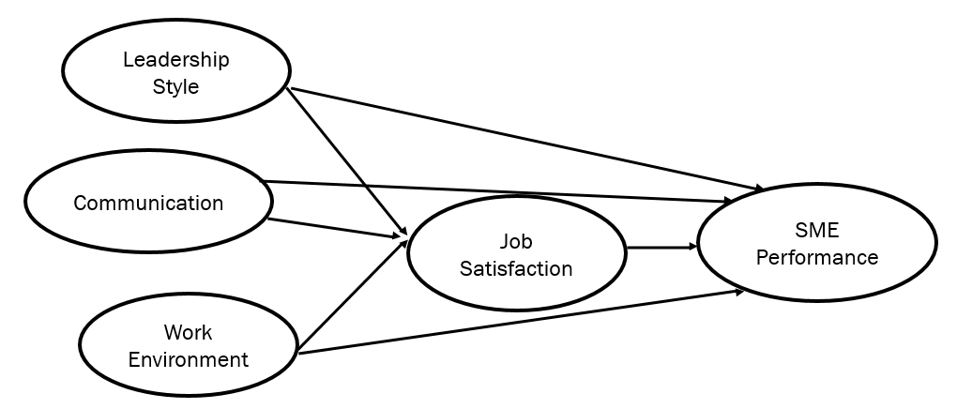

H3

Figure 1. Research framework

**Description of Research Variables**

Table 1. Indicators of Latent Variables

|  |  |  |
| --- | --- | --- |
| **Latent Variable** | **Indicator** | **Information** |
| X1 (Leadership Style) | X1.1 | Decision-making ability |
| X1.2 | Controlling subordinates |
| X1.3 | Responsibility |
| X1.4 | Emotional control ability |
| X2 (Communication) | X2.1 | Communication from the bottom level to the top level |
| X2.2 | No miscommunication |
| X2.3 | There is feedback |
| X2.4 | Communication delivered |
| Y1 (Job Satisfaction) | Y1.1 | Supportive working conditions |
| Y1.2 | Decent salary or wages |
| Y1.3 | Personality compatibility with work |
| Y1.4 | Supportive coworkers |
| Y2 (SME Performance) | Y2.1 | increase in knowledge |
| Y2.2 | creativity and willingness of the workforce |
| Y2.3 | Product Quality |
| Y2.4 | Employee performance |
| X3 (Work Environment) | X3.1 | Lighting |
| X3.2 | Air exchange |
| X3.3 | Security |
| X3.4 | Work equipment |

The analysis steps carried out in this study are as follows:

1. Obtain a concept- and theory-based model to design a structural model.
2. Design a measurement model.
3. Make a path diagram (path diagram).
4. Convert path diagrams to equations.
5. Estimating parameters consist of weight estimation, path coefficient estimation, and average estimation.
6. Evaluate the SEM-PLS model.
7. I am doing hypothesis testing.
8. Conclude.
9. **Results of Analysis and Discussion**

Measurement Models

Before doing hypothesis testing to determine the relationship between latent variables in a structural model, an assessment of the measurement model is carried out to confirm indicators and latent variables that can be evaluated later.

According to the findings of the validity test conducted on the research instrument items, all of them can be regarded as valid because they all meet the requirements for determining if an item instrument is suitable. Namely, Pearson moment product correlation index value (r)≥ 0.3. These findings suggest that the tool can reveal the information from which variable has been correctly investigated. However, based on the reliability tests done on the instrument items used in research, it can be concluded that all instrument items are dependable since they all pass the reliability tests. Namely the value Alpha Cronbach (alpha)≥ 0.6. _ These results show that the instrument used can be trusted or dependable when used many times.

Table 2. Outer model measurement results

|  |  |  |  |  |
| --- | --- | --- | --- | --- |
|  | **Cronbach's Alpha** | **rho_A** | **Composite Reliability** | **Average Variance Extracted (AVE)** |
| **X1 (Leadership Style)** | **0.816** | **0.822** | **0.878** | **0.644** |
| **X2 (Communication)** | **0.825** | **0.826** | **0.884** | **0.655** |
| **X3 (Work Environment)** | **0.791** | **0.793** | **0.865** | **0.617** |
| **Y1 (Job Satisfaction)** | **0.820** | **0.827** | **0.881** | **0.649** |
| **Y2 (SME Performance)** | **0.788** | **0.817** | **0.863** | **0.613** |

The results of calculations with the help of smart-pls software obtained path diagrams along with path coefficients as follows:

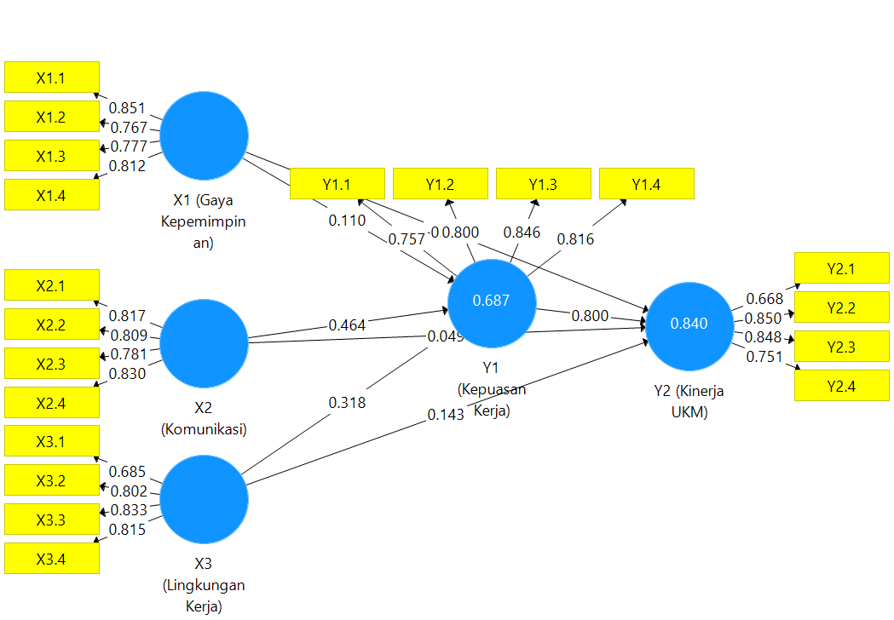

**Figure 2.** Estimation of Path Chart parameters

1. Structural Models

A model that defines the link between latent variables, assessed using the path coefficient, R 2, is known as the structural model (inner model). Table 3 displays the outcomes of the path coefficients and t-statistic values determined by the bootstrapping procedure using a sample size of 100 for resampling and 5000 iterations.

**Table 3.** Direct Effect Estimation Results

|  |  |  |  |  |  |
| --- | --- | --- | --- | --- | --- |
| **No** |  | **Coefficient** | **T Statistics (|O/STDEV|)** | **P Values** | **Information** |
| **H1** | **X1 (Leadership Style) 🡪Y1 (Job Satisfaction)** | 0.110 | 1,493 | **0.136** | **No effect** |
| **H2** | **X2 (Communication) 🡪Y1 (Job Satisfaction)** | 0.464 | 5,807 | **0.000** | **Take effect** |
| **H3** | **X3 (Work Environment) 🡪Y1 (Job Satisfaction)** | 0.318 | 4,002 | **0.000** | **Take effect** |
| **H4** | **X1 (Leadership Style) 🡪Y2 (SME Performance)** | -0.050 | 0987 | **0.324** | **No effect** |
| **H5** | **X2 (Communication) 🡪Y2 (SME Performance)** | 0.049 | 0.866 | **0.387** | **No effect** |
| **H6** | **X3 (Work Environment) 🡪Y2(SME Performance)** | 0.143 | 2,649 | **0.008** | **Take effect** |
| **H7** | **Y1 (Job Satisfaction) 🡪Y2 (SME Performance)** | 0.800 | 15,282 | **0.000** | **Take effect** |

**Discussion of Direct Effects:**

After analyzing and testing statistics, leadership style, communication, and work environment variables influence job satisfaction and SME performance.

1. Hypothesis 1: (The Influence of Leadership Style on Job Satisfaction)

The test results in the table above show that the T statistics value for the relationship between the leadership style model and job satisfaction is 1.493, with a *p-value* of 0.136. The test results show that the T statistics value is <1.96, indicating an insignificant relationship between leadership style and job satisfaction.

1. Hypothesis 2: Effect of communication on job satisfaction

The test results in the table above show that the T statistics value of the relationship between the effect of communication on job satisfaction is 5,807 with a *p-value* of 0,000. The test results show that the T statistics value is >1.96, indicating a significant relationship between communication and job satisfaction. So with an increase in touch by 10%, job satisfaction will increase by 46.4 %.

1. Hypothesis 3 : (The Influence of the Work Environment on Job Satisfaction)

Hypothesis Formulation: It is believed that the workplace atmosphere significantly enhances job happiness. The test results are in table 3, explaining that the work environment has an impact on job satisfaction with a positive direction with a path coefficient value of 0.318 and a significant level of influence with a T-statistics value of 4.002 > 1.96, indicating that there is a substantial relationship between the work environment and job satisfaction. So the more comfortable the work environment arrangement, the more job satisfaction will increase.

1. Hypothesis 4: The effect of leadership style on SME performance.

Formulation of the hypothesis: Allegedly, leadership style has a significant positive effect on the performance of SMEs. The test results explain that leadership style has no effect on the performance of SMEs with a T-statistic value of 0.987 <1.96, and the direction is unfavorable. In this case, it shows that there is no significant influence of leadership style on the performance of SMEs.

1. Hypothesis 5: Effect of communication on SME performance.

The accompanying table of test results demonstrates that the T statistics value for the association between communication and SMEs performance is 0.866 with a *p-value* of 0.387. The test results show that the T statistics value is <1.96, indicating an insignificant relationship between leadership style and UKM performance.

1. Hypothesis 6 : (The Influence of the Work Environment on SME Performance)

Hypothesis Formulation: It is believed that the workplace has a substantial positive impact on SMEs' performance. The test results are in table 3, explaining that the work environment has an effect on the performance of SMEs with a positive direction of influence with a path coefficient value of 0.143 and a significant level of impact with a T-statistics value of 2.649 > 1.96, indicating that there is an important relationship between work environment and SME performance. So the more comfortable the work environment arrangement, the more directly improve the performance of SMEs.

1. Hypothesis 7: Effect of job satisfaction on SME performance.

Formulation of the hypothesis: Allegedly, job satisfaction can significantly influence the performance of SMEs. The results of Table 3 show that the T statistics value for the relationship between job satisfaction and UKM performance is 15.282 with a *p-value* of 0.000. The test results show that the T statistics value is > 1.96, indicating a significant relationship between job satisfaction and UKM performance.

The results of statistical hypothesis testing show that communication and work environment has a significant positive effect. In contrast, leadership style does not affect job satisfaction or SME performance. A good work environment and job satisfaction can improve SMEs' performance well. A supportive work environment makes it easier for individuals to complete the work assigned. Individuals with a supportive work environment also generate self-confidence and are motivated to work optimally.

Table 4. Indirect Effect Estimation Results

|  |  |  |  |
| --- | --- | --- | --- |
|  | **Original Sample (O)** | **T Statistics (|O/STDEV|)** | **P Values** |
| **X1 (Leadership Style) 🡪Y1 (Job Satisfaction) 🡪Y2 (SME Performance)** | 0.088 | 1,477 | **0.140** |
| **X2 (Communication) 🡪Y1 (Job Satisfaction) 🡪Y2 (SME Performance)** | 0.371 | 5.307 | **0.000** |
| **X3 (Work Environment) 🡪Y1 (Job Satisfaction) 🡪Y2 (SME Performance)** | 0.254 | 4,075 | **0.000** |

1. A leader's style's impact on SMEs' productivity is seen in job satisfaction.

Formulation of the hypothesis: It is suspected that the leadership style affects improving the performance of SMEs through job satisfaction. The results of hypothesis testing show that the T-statistics value is 1.477 with a *p*-value of 0.140. Where the deal of T-statistics < 1.96, it can be concluded that leadership style does not indirectly affect improving SMEs' performance through job satisfaction.

1. The influence of communication on the performance of SMEs through job satisfaction

Formulation of the hypothesis: It is suspected that communication has a significant effect on improving the performance of SMEs through job satisfaction. The results of the hypothesis testing show that the T-statistics value is 5.307 with a *p-value* of 0.000, where the T-statistics is > 1.96, so it can be concluded that communication significantly improves SME performance indirectly through job satisfaction.

1. The work environment's influence on SMEs' performance on job satisfaction.

Formulation of the hypothesis: The work environment is suspected to significantly improve SMEs' performance through job satisfaction. The results of the hypothesis testing show that the T-statistics value is 4.075 with a *p-value* of 0.000, where the T-statistics > 1.96, so it is concluded that the work environment significantly improves the performance of SMEs indirectly through job satisfaction.

The model's goodness can also be assessed using R square, displayed in the accompanying table, based on the parameter estimation tests conducted directly and indirectly.

Table 5. R Square Results

|  |  |  |
| --- | --- | --- |
|  | **R Square** | **R Square Adjusted** |
| **Y1 (Job Satisfaction)** | 0.687 | 0.682 |
| **Y2 (SME Performance)** | 0.840 | 0.836 |

R square (R2) is known to be 0.687 based on Table 5 above, which indicates that leadership style, communication, and work environment together have an effect of 68.7% on the speed of innovation, categorized as a medium, meaning that the structural model. The results obtained have predictions of relevance and the need to improve leadership styles in companies to encourage increased job satisfaction. Meanwhile, the type of leadership, communication, and work environment together have an effect of only 84% on the performance of SMEs. This means that the most influential in improving the performance of SMEs is communication and the work environment. The maximum success of business activities, especially SMEs, cannot be separated from the conditions of a comfortable and conducive work environment.

1. **Conclusion :**

The results of the study provide several conclusions, namely:

* The model shows that communication and work environment has a significant positive effect, while leadership style does not affect job satisfaction and SME performance. A good work environment and job satisfaction can improve SMEs' performance well.
* The indirect model shows that what influences improving the performance of SMEs through reasonable job satisfaction is good communication and a good and optimal work environment.
* The work environment related to a sound work system, the attitude of cooperation between employees, and the treatment of UKM owners towards employees by assisting with learning can improve the abilities of these employees (Indriyani & Dewi, 2020). SMEs are essential in building employee awareness in achieving goals and performance measures. Samani et al. (2015) say a quality work environment will improve employee performance. Conditions of the work environment can influence employees to work well and encourage job satisfaction so that they can improve the performance of SMEs well

References

Agustin, AP, Suharso, P., & Sukidin, S. (2019). Strategy for the Influence of Leadership Style on Employee Performance at Pt.Pln (Persero) Situbondo Area. Journal of Economic Education: Scientific Journals of Education, Economics and Social Sciences, 13(1), 20. <https://doi.org/10.19184/jpe.v13i1.10415>

Harahap, DS, & Khair, H. (2020). The Effect of Theft on Surrounding Communities. Maneggio: Scientific Journal of the Master of Laws, 2(1), 69–88.

Haq, S. ., Asbari, M., Sukriyah, Novitasari, D., & Abadiyah, S . . (2022). The Homeschooling Head Performance: How The Role of Transformational Leadership, Motivation, and Self-Efficacy? International Journal of Social and Management Studies, 3(1), 167–179. <https://doi.org/10.5555/ijosmas.v3i1.96>

Indriyani, R., & Dewi, M. (2020). The Influence of the Work Environment on Performance through HR Competence as an Intervening Variable in Malang Tempe Chips UKM. *Journal of Hospitality Management*, 53-61.

Koswara, D., Hardhienata, S., & Retnowati, R. (2021). Increasing Teacher's Organizational Commitment Through Strengthening Teamwork, Situational Leadership, and Self-Efficacy. Journal of Industrial Engineering & Management Research, 2(4), 228 - 238. <https://doi.org/10.7777/jiemar.v2i4.17>

Khotimah, S., Widiyastuti, L., & Supriyanto, A. (2017). The Effect of Job Satisfaction on Employee Performance at Pt Nabati Agrotech Persada, Pangkalan Bun Branch. Magenta, 6(1), 21–27

Khulfatya, A. (2019). *The Effect of Organizational Communication on Employee Job Satisfaction at PT. Hadji Kalla Toyota Cab. Pare-Pare.* UPT LIBRARY UNM.

Laksana, Markus JW (2018). The Effect of Leadership Style, Work Environment, and Job Satisfaction on Employee Performance. Management. Faculty of Economics. Yogyakarta Sanata Dharma University.

Prayatna, AH, & Made, S. (2016). The Effect of Leadership Style on Job Stress and Employee Job Satisfaction at Fave Hotel Seminyak. Udayana University Management E-Journal, 5(2), 252587.

Rieka, R., Ardi, P., & Yana, U. (2019). The influence of leadership style, organizational culture, and motivation on job satisfaction and organizational commitment. Journal of Management, 11(2), 195–202.

Riko, J., & Susanti, F. (2019). The Influence of Leadership Style and Organizational Culture on Employee Performance at Uptd Baltekkomdik Education Office of West Sumatra Province. College of Economics "KBP," 1–13. <https://doi.org/10.31227/osf.io/bzq75>

Samani, SA, Razid, RZA, Sofian (2015). Perceived personal control over the work environment, employee satisfaction, and work performance. Performance Improvement, 54(9).

Saputra, S., & Andani, KW (2021). Factors Affecting Employee Job Satisfaction at PT Citra Crocotama International in Jakarta. *Journal of Managerial and Entrepreneurship, Volume III*, 98-106.

Saputra, Apandi and Andri, Seno (2017) The Influence of the Work Environment and Organizational Commitment on Employee Job Satisfaction (Case Study at the Ratu Mayang Garden Hotel Pekanbaru). LET'S FISIP. Vol.4 No.2:1-15

Sedarmayanti. (2017). Human Resource Management: Bureaucratic Reform and Management of Civil Servants. Bandung: Refika Aditama.

Sekartini, NL (2016). Effect of workability, work discipline, and work motivation on job satisfaction and performance of administration employees at the University of Warwadewa. Jagadhita: Journal of Economics & Business, 3(2), 64–75. <https://doi.org/10.22225/jj.3.2.130.64-75>

Wardani, DK, Cahyono, D., & Herlambang, Toni Qomariah, N. (2017). The Effect of Leadership Style on Job Satisfaction and Performance with Organizational Commitment as an Intervening Variable at the Lumajang Effect Islamic Hospital. Indonesian Journal of Management Science & Business, 7(2), 208–231.

Wuwungan, Ronna Yulia, Rita N. Taroreh and Yantje Uhing (2017) The Influence of the Work Environment and Work Motivation on Employee Job Satisfaction at Cinema XX Lippo Plaza Manado. EMBA Journal. Vol.5 No.2 : 298 – 307

Yusuf, RM, & Darman, S. (2017). Organizational Commitment Definition, Influenced & Influencing. In Makassar: Nas Media Pustaka Publisher (Vol. 11, Issue 1)