**DEVELOPMENT OF PATTERN DESIGN TO INCREASE THE VALUE OF DAMA KARA FASHION PRODUCT**

## Luthfiya Rahmi1, Putri Merak Jingga Sametto2, Setia Galuh Santoso3, Arini Arumsari4

**Magister Desain**

**Fakultas Industri Kreatif**

**Universitas Telkom**

*E-mail: 1*[*Luthfiyarahmii@student.telkomuniversity.ac.id*](mailto:Luthfiyarahmii@student.telkomuniversity.ac.id)*,* [*2putrimerakjingga@student.telkomuniversity.ac.id*](mailto:2putrimerakjingga@student.telkomuniversity.ac.id)*,* [*3setiagaluhsantoso@student.telkomuniversity.ac.id*](mailto:3setiagaluhsantoso@student.telkomuniversity.ac.id)*, 4ariniarumsari@telkomuniversity.ac.id*

**Abstract:***Topics on the issue of Sustainability are becoming increasingly crucial in the business world, including the fashion industry. The sustainable fashion movement has been echoing louder lately along with the promotion of the Sustainable Development Goals (SDG) by the United Nations (UN). Although currently there are many fashion brands that are engaged in the fast fashion sector, there are also those that do not follow this trend, and instead prioritize social and environmental issues through ethical and sustainable fashion discourse, one of which is Dama Kara. This study aims to determine the ability of autistic children to make motif designs as added value to improve a product that promotes sustainable fashion at Dama Kara. The method chosen in this study is a qualitative method with the Design Thinking approach. Through the strategic skills given to autistic children in expressing ideas and thoughts that are felt, it is assessed that they can be improved and become a benchmark in the development of dama kara motif designs as a reference for future product development. The author concludes that there is no free development in Dama kara regarding the drawing potential of every autistic child. In addition, dama kara has provided special therapy for them to get to know the colors and motifs according to the specified application. Considering that there are still many things that are lacking in the future from this research, the suggestion is to study the design of development motives for autistic children in batik skills that are applied to autistic children to improve skills so that this research can utilize skill-based. learn by making batik artwork.*

***Keywords:*** *Dama Kara, People with Autism, Medium of Skills, Batik.*

# Introduction [Times New Roman 12 bold]

Along with the development of globalization, it has brought the world community to a very practical and sophisticated lifestyle, so that everything can be done quickly and tends to be instantaneous, which then encourages exploration and innovation in all aspects of life. Spreading to the world of fashion which is even a basic necessity, world textile production has continued to increase in recent years. Featherstone (2001) writes that the side of people's life that is currently so important as an indicator for the emergence and development of lifestyles is fashion, especially in terms of clothing. The existence of basic human needs for textiles has led to an increase in demand for textiles due to global population growth and increased living standards, as well as excessive consumption due to the trend of fast fashion. Brazil, Bangladesh, India, Turkey, China, together with Indonesia have shown their participation in taking advantage of the fashion cycle (Bestari, 2020). The high demand for the amount of clothing production indirectly affects the production chain and the long process that must be carried out. The more mass production of clothing, the more natural resources and labor are needed to meet these needs.

The fashion industry's business model currently does not apply sustainable principles, especially due to population growth and increased levels of consumption throughout the world which can encourage widespread environmental damage. Then, please note that the way we make, use, and dispose of clothes, all have an impact on the environment, so it is necessary to change behavior in a sustainable direction. One of the principles of an appropriate approach, namely sustainable fashion, is to extend the life cycle of a product. This approach needs to be done to reduce excessive consumption of fashion products. The fashion concept aims to build awareness for both consumers and producers to ensure environmental sustainability and social welfare. The sustainable fashion movement has been echoing louder lately along with the promotion of the Sustainable Development Goals (SDG) by the United Nations (UN) (Bestari, 2020). In the SDGs, there are seventeen aspects with the basic principle of "meeting current needs without disturbing the rights of future generations to live with quality." The whole world is now busy using the SDGs point of view in various aspects. Say in the realm of fashion, international forums such as the Copenhagen Fashion Summit, Sustainable Fashion Forum, and getredress are actively carrying out campaigns to present dark facts in the fashion industry with the aim of changing the mindset of producers and consumers about the industry. Among them are aimed at the contribution that has been made by the fashion industry towards achieving the SDGs, in particular SDG 12 related to "Ensuring sustainable patterns of consumption and production".

In the process of building their own sustainability, fashion companies will simultaneously work towards achieving these SDGs. At this time, we know there are many new things in the industrial world with the aim of improving the lives of people in the world. Besides economic growth, there are things that often escape our attention regarding the fashion business in the world and especially Indonesia. Say in the realm of fashion, there are not many companies that have been established with a background of raising social issues that have made them leading fashion brands that can increase awareness of self-care by providing work space for people with disabilities, especially people with autism. Human rights apply to all people in the world. Likewise with persons with disabilities, they have equal rights with other people (Purinami, 2018). Until now, there are several sustainable fashion businesses that have sprung up and are gaining popularity in Indonesia, one of which is Dama Kara. Which focuses on adding value to fashion products in environmental issues through sustainable fashion and social discourse.

Dama Kara was founded by Nurdini Prihastiti (founder) in January 2020. Dama Kara's vision and mission is to become a leading fashion brand that can increase awareness of self-care by providing work space for people with disabilities, especially people with autism, through adding value to its stakeholders. . Dama Kara includes sustainable fashion as one of its values in marketing its products, which consist of odd volume collections and even volume collections. The odd volume collection was produced using the stamped batik technique, and the even volume collection was produced using a fabric printing technique using motifs made by people with autism who were directly involved with Dama Kara through collaboration with the Our Dream Indonesia community and the Widyatama Art Therapy Center.

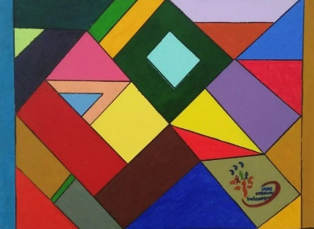 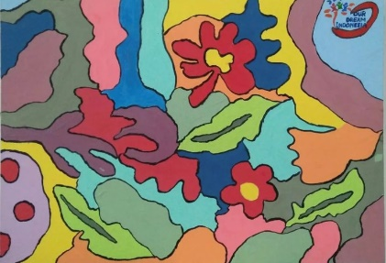 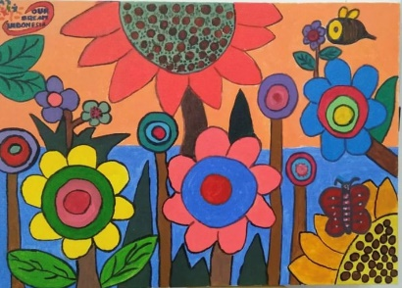

**Figure 1.1** Image of Color Media Results for Children with Autism

The process of drawing children with disabilities, especially people with autism, together with the founder of Damakara at the company's location in the Pasir Honje area, which was carried out based on the development of the work, was only limited to distributing color media in the images that had been provided, then redeveloped by Dama Kara, followed by modifying a more simplified form in the arrangement of the motifs according to the composition, the selected works are applied to the fabric motifs of the even volume collection products, and get royalties on each product sales proceeds. However, along the way, Dama Kara often encounters problems when selling even volume collection products, as shown in Diagram 1.1 that the percentage of sales of even volume products is only 12%, this is much smaller than the percentage of odd volume products which is 88%. This is because there are still concerns about consumer perceptions regarding the issue of employing disabilities.



**Produk Penjualan**

**Produk Volume Genap 12%**

**Produk Volume Ganjil 88%**

Produk Ganjil Produk Genap

**Diagram 1.1** Dama Kara Product Sales Data

(Source: Author Processed, 2022)

This concern has resulted in dama kara's vision and mission as a sustainable fashion actor that prioritizes environmental and social issues has not been properly conveyed to its consumers. In addition, the production process for making even volume products still uses digital printing and screen printing techniques that are not yet environmentally friendly.

Previous research related to the development of fashion products involving autistic children has mostly focused on batik training to increase the potential skills of children with autism, this is in line with the problem of dakara which is still limited in the development of therapeutic motifs which are still through color media. In addition, previous studies have not discussed much regarding the development of batik motifs made by children with autism which can influence consumer perceptions to buy products made by children with autism, therefore this research is entitled "Development of Motif Designs in Increasing Value in Dama Kara Fashion Products." ”. Which aims to develop motifs as a medium to improve the process skills of children with autism, Result in the development of motifs that can influence consumer perceptions to buy the work of children with autism, Develop batik motifs that can clearly convey messages from these motifs to consumers, and Develop motifs in techniques which can prioritize environmental and social issues in accordance with Dama Kara's vision and mission.

# Research Method

This study aims to determine the ability of children with autism in making batik motifs and designs as a media skill to increase the value of a product that promotes sustainable fashion in Dama Kara. Based on the research objectives, according to Arikunto (2006, p. 160) "The research method is the method used by researchers in collecting research units". The research method is a way that can be used to collect the data needed in the research and is also used as a guide in conducting research. The method chosen in this study is to use a qualitative approach method used in this research is Design Thinking.

1. Empathy The stages carried out at the beginning of the research started from the empathy stage to explore issues with the problems faced. At the empathy stage, interviews, observations, and literature studies will be conducted directly with the Founder Dama Kara and stakeholders who work with children with autism in the Our Dream Indonesia community and the Widyatama Art Therapy Center.

2. Define The second stage, namely define, aims to combine all inventions and analyze user needs to define innovation opportunities. On At this stage, an analysis of data collection that was carried out previously at the empathy stage will be carried out, supported by data measurement through the analysis of the Marketing Mix'7Ps stages.

3. Ideas The third stage, ideation, aims to produce a series of design ideas to address unmet needs. At this stage 10 sketches of ideas will be proposed which will then be selected 1 best idea to be the solution to the research problem.

4. Prototypes The fourth stage, namely prototyping, aims to build representations for a subset of ideas.

5.Test The fifth stage, namely test, aims to evaluate the prototype by asking the user to use it.

# Results and Discussion

# Data Description

A. Dama Kara

Dama Kara was founded by Nurdini Prihastiti (founder) in January 2020. Dama Kara's vision and mission is to become a leading fashion brand that can increase awareness of self-care by providing work space for people with disabilities, especially people with autism, through adding value to its stakeholders. . Dama Kara includes sustainable fashion as one of its values in marketing its products, which consist of odd volume collections and even volume collections. The odd volume collection was produced using the stamped batik technique, and the even volume collection was produced using a fabric printing technique using motifs made by people with autism who were directly involved with Dama Kara through collaboration with the Our Dream Indonesia community and the Widyatama Art Therapy Center.

B. People with Autism

Children with autism in their work can freely express their feelings and imagination. His work is an expression of the heart, the way he communicates and interacts with others. By drawing, children with autism can use art as a means of self-knowledge and self-expression, which Dubowski emphasized; Autistic children and youth do not have a specific formula they can follow to achieve effective communication with the world around them or express how they feel when they lack speech skills. Art therapy may be particularly beneficial for these people as it is known to help people gain self-understanding and assist in self-expression (Evans & Dubowski, 2007). Children with autism have high imagination, because their imagination is not hindered by various meanings about what they are facing at that time, so they are very free in imagining and expressing it when they are used to drawing habits. This makes the drawings of children with autism very unique, both in terms of ideas and ideas but also the depiction of objects or shapes, color selection, and composition.

C. Creative Process

In particular, this study aims to describe an imaginative creative process in the dynamics of visual aesthetics. Creativity itself can be interpreted as an interest in social activities. In clothing, the target market tends to choose clothes with timeless designs and can be used repeatedly so they are not fixated on trends. The target market also often applies traditional elements in clothing (batik). a process and the ability to find new forms or the ability to innovate existing forms into new forms. Campbell (2017) in (S. Sunarto, 2018) explains that Creativity can be interpreted: 1) the ability to respond, respond and provide solutions to all existing solutions; 2) the ability to involve oneself in the discovery process for problems; 3) intelligence ability, cognitive style, and personality/motivation; 4) the ability to produce or create something new. Therefore this creativity is based on: flexibility, fluency, skill, and intelligence.

# Discussion

A. Emphaty

Results The interviews were conducted with in-depth interviews with Founder Dama Kara Nurdini Prihastiti and four teachers within Our Dream Indonesia stakeholders. The purpose of this interview is to find out about the problems felt by dama kara related to the development of therapeutic motives for autistic people still through color media, consumer perceptions of product expectations, messages from motives that have not been conveyed clearly, and product development implementation that has not prioritized environmental issues and social according to Dama Kara's vision and mission. From the results of direct observation to Dama Kara, product sales are divided into two collections, namely the odd collection and the even collection. Each product has various techniques in the process, which is for odd products, namely batik and even products, which are the result of collaboration between stakeholders and the work of children with autism.

B. Define

Results Based on the data findings from the empathy stage process for the problems faced. The second stage, namely define, aims to combine all findings and analyze user needs to define innovation opportunities. At this stage an analysis of data collection that was carried out previously at the empathy stage will be carried out, supported by data measurement through an analysis of the 7P marketing mix stages.

C. Ideation Results

• Product Design The design or design stage of the motif design in batik skills for children with autism is adjusted to the previous analysis stage. At this stage, the product motif design is a batik design that is different from the usual batik motif designs. Batik skills are designed using floral (plant) and animal motif designs. Next, several selected sketches are made to be applied to the right design direction. The following are several stages of design including literature study, initial exploration, further exploration (designing motifs), and making digital motifs.

a. Literature Study The human capacity to receive input and produce extraordinary thoughts is limited. Reality provides more input than can be received by human processing systems. Humans reduce input to some extent. Therefore the packaging of information determines the capacity of information . As an illustration, messages/information packaged in images are far more efficient than information in the form of verbal symbols. The saying goes, one picture is worth a thousand words. Visual communication as a process of sending and receiving messages from communicators to communicants by using symbols or visual symbols is a daily human activity.

b. Initial Exploration

The use of decoration in batik is not just one type of motif decoration only but several kinds of decorative motifs are combined into a new form. The elements of the batik motif are divided into two, namely the main ornaments and filler ornaments which function as fillers for the main ornaments. Isen batik motifs to fill the main ornaments in the form of dots, lines, combinations of dots and lines. Some forms of decoration include geometric decoration, fauna and flora decoration, human decoration and combination decoration with several other types of decoration. In designing batik motifs this time, the main motive is the making of the motifs that have been agreed with the dama kara focusing on plant and animal motifs where the results of the drawings of the creative process of children with autism can be proposed for the next stage. Raihan Abiyudda is a child with low level of autism who has an interest in drawing from a young age until now, often works with Dama Kara and always produces his best work. At this time the author wants to develop Raihan's work with the results of his own drawings with the guidance of researchers.

C. Advanced Exploration (motive design)

At this stage, the results of the initial exploration are then assembled into batik motifs. Various elements of plant and animal motif ornaments result from the creative process of children with autism. The series of ornaments resulting from the initial exploration resulted in several variations of batik motifs.

D. Prototype Results

Designing batik motifs digitally uses the Adobe Illustrator and Corel Drew applications as a tool for designing and facilitating the process of selecting color compositions and repeating motifs. The results of the arrangement of batik ornaments produce several pictures of both plant and animal motifs. In addition, each motif has a different color combination to provide variety. In designing this batik motif, alternative color options are also produced which describe the elements of the story in it with various color combinations. then prototyping was carried out which aims to simulate how the drawings of children with autism can be formed into batik motif designs, along with the design results drawn:

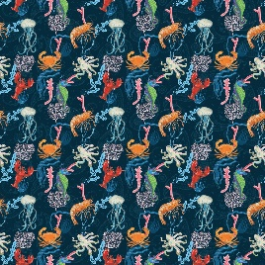 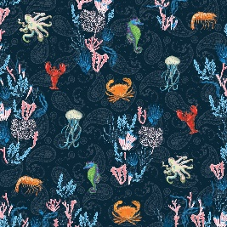 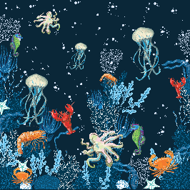

**Figure 1.2** Animal Batik Motif Design

[Source: Personal Data, April 2023]

In Figure 1, the prototype for this animal motif design has several options which are then discussed again with the dama kara to serve as further motifs as a reference for motif designs that can be applied to batik techniques. lies in an attractive appearance aimed at modifying the most dominant and striking motif designs so as to increase customer attractiveness. By selecting a color tone that matches the theme raised, it will make the appearance more attractive. In addition, the background story in the picture is presented with the aim of knowing that children with autism do not only have special needs, but they can work freely and can convey the stories they experience in the form of a work. Besides that, it can be a special icon in a concept.

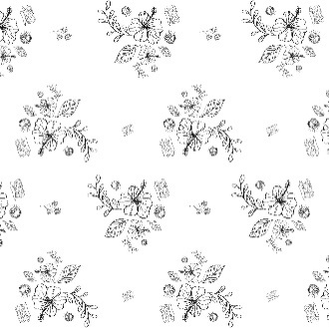 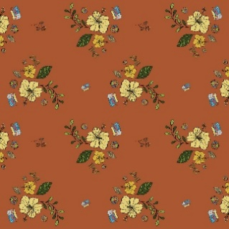

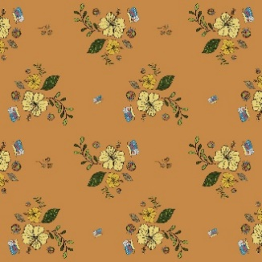 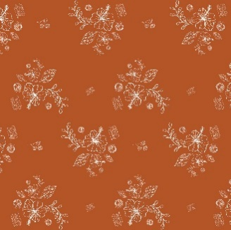

**Figure 1.3** Plant Batik Motif Design

[Source: Personal Data, April 2023]

The prototype for this motif design has several options which are then discussed again with the dama kara to be used as a follow-up motif as a reference for motif designs that can be applied to batik techniques. lies in an attractive appearance aimed at modifying the most dominant and striking motif designs so as to increase customer attractiveness. By selecting a color tone that matches the theme raised, it will make the appearance more attractive. In addition, the background story in the picture is presented with the aim of knowing that children with autism do not only have special needs but they can work freely and can convey the stories they experience in the form of a work. Besides that, it can be a special icon in a concept.

E. Test

Results In the test results, a trial was carried out on consumers to see consumer interest in the work values of children with autism. Questionnaires are a way to obtain data in a relatively short time, because at the same time many people can be asked to fill out the written answer choices provided (Soewardikoen, 2019). This questionnaire was distributed online and addressed to the target dama kara consumers as a sample of this study. The questionnaire method is used to obtain data on the audience's aspects so that it can be known what perceptions are captured by the audience towards the object being studied. In this study the scale used is the Likert Type Scale. According to Sekaran (2006:31), the Likert scale is designed to examine how strongly the subject agrees or disagrees with the question.

The number of respondents to the questionnaire is not limited. In this study the questionnaire serves as supporting data that validates the research. This research is in a qualitative research frame so that there is no special formula used in quantitative research.

# Conclusion

The author concludes that in Dama kara there is no specific development freely given regarding the drawing potential possessed by every child with autism. Besides that, dama kara has provided special therapy for them to get to know the colors and motifs according to the application that has been determined. Through the skills strategy given to children with autism in expressing ideas and thoughts that are felt, it is considered to be able to improve and become a benchmark in the development of dama kara motif designs as a future reference for developing products and refuting issues related to exploitation of children with autism. Development of motif designs that were previously developed by dama kara through digital print, embroidered, and embroidery media. Now researchers offer new learning media and continue to utilize existing techniques in dama kara, namely batik learning that includes children with autism as media for learning batik to improve skills in children with autism.

# Reference

[1] A. Muazimah, "THE EFFECT OF FAST FASHION ON CONSUMERISM CULTURE AND ENVIRONMENTAL DAMAGE IN INDONESIA," vol. 7, pp. 1–15, 2020

[2] Bestari, A. G. (2020). Making Tote Bags With Textile Painting Decorations as a Sustainable Fashion Effort. Proceedings of Fashion Catering Engineering Education, 15(1).

[3] Collopy, F. (2019). Why the failure of systems thinking should inform the future of Design Thinking (06.07.09). Design Issues, 35(2), 97–100. doi: [https://doi.org/10.1162/desi_a_0053 8](https://doi.org/10.1162/desi_a_0053%208)

[4] Doellah, H.S. (2002). Batik: The influence of time and environment. Solo: Danar Hadi Batik

[5] Endrayana, J. P. M. & Retnasari, Dian. (2020). IMPLEMENTATION OF SUSTAINABLE FASHION AND ETHICAL FASHION IN DEALING WITH NEGATIVE IMPACT OF FASHION. Proceedings of Clothing Engineering Education, FT UNY, 1.

[6] Featherstone, Mike. 2001. Postmodernism and Consumer Culture. Student Library.

[7] Fakhrunissa, M. (2016). FASHION STYLE AS A MEDIA FOR THE FORMATION OF MUSIC IDENTITY OF WHITE SHOES AND THE COUPLES COMPANY. e-Journal “Acta Diurna”, 1.

[8] Fauzi. Fauziah. Ma'arif. (2020). The Effectiveness of the Direct Instruction Learning Model to Improve Batik Skills in Elementary School Students at the Cikadu Batik Studio. Pgsd Stkip Syekh Mansur, Indonesia. Social Sciences, Unsera, Indonesia. Vol.4 No.1 January 2020. Accessed: <Http://Dx.Doi.Org/10.33578/Pjr.V4i1.7894>

[9] Ganatra, J., Patil, V., & Nayakawadi, A. (2021). Sustainable Fashion. Journal of Textile and Clothing Science, 15–25. Our Reworked: Fast Fashion Causes Millions of Textile Waste Every Year. (2022, October 19). Retrieved November 11, 2022 from https://www.republika.co.id/berita/rjzmcs349/our-reworked-fast-fashion-sebabkan-ada-ju taan-limbah-tekstil-tipeta-tahun

[10] Jalil, A., M, F., & Kasnelly, S. (2020). Rising Unemployment Rates Amid the Pandemic (Covid19). Journal of Islamic Economics, 2(unemployment due to covid 19), 45–60.

[11] Kasyan. tt. Traditional Ornamental Variety. Yogyakarta: Yogyakarta State University

[12] Rahayu, S. M. (2013). Fulfilling the Rights of Children with Special Needs Early Childhood Through Inclusive Education. Journal of Child Education, 2. Accessed: DOI: <https://doi.org/10.21831/jpa.v2i2.3048>

[13] Rahayu, S.M. (2013). Fulfilling the Rights of Children with Special Needs Early Childhood Through Inclusive Education. Journal of Child Education, 2. Accessed: DOI: <https://doi.org/10.21831/jpa.v2i2.3048>

[14] Sunarto, S. (2018). Development of Innovative Creativity in Art Education Through Mukidi Learning. Educational Reflections: Educational Scientific Journal, 8(2). <https://doi.org/10.24176/re.v8i2.2348>

[15] Wulandari, Ari. (2011). Batik Nusantara: Philosophical Meaning, Manufacturing Method and Batik Industry.