**Lampiran 1 Kuesioner**



Kementerian Riset, Teknologi, dan Pendidikan Tinggi Program Pasca Sarjana Universitas Jember

**Program Studi Magister Manajemen**

Perihal : Permohonan Pengisian Kuesioner

# Daftar Pernyataan

* + 1. **Partisipasi Penyusunan Anggaran**

Bapak/Ibu/Sdr/i dimohon untuk menjawab pernyataan pada kolom dibawah ini dengan memberikan tanda ceklist (√) pada salah satu jawaban yang anda pilih, menurut anda tepat dan atau sesuai dengan kondisi kerja anda saat ini. Keterangan:

STS : Sangat Tidak Setuju S : Setuju

TS : Tidak Setuju SS : Sangat Setuju N : Netral

|  |  |  |  |  |  |  |
| --- | --- | --- | --- | --- | --- | --- |
| **No** | **Pernyataan** | **STS** | **TS** | **N** | **S** | **SS** |
| 1. | Saya ikut dalam proses penyusunan Rencana Kerja maupun Anggaran (RKA)  di SKPD |  |  |  |  |  |
| 2. | Saya memiliki pengaruh yang besar dalam penyusunan Rencana Kerja maupun  Anggaran (RKA) di SKPD |  |  |  |  |  |
| 3. | Saya memiliki dasar dalam merivisi Rencana Kerja maupun Anggaran (RKA)  di SKPD |  |  |  |  |  |
| 4. | Saya sering memberikan usulan tentang Rencana Kerja maupun Anggaran (RKA) kepada atasan saya |  |  |  |  |  |

# Komitmen Organisasi

Bapak/Ibu/Sdr/i dimohon untuk menjawab pernyataan pada kolom dibawah ini dengan memberikan tanda ceklist (√) pada salah satu jawaban yang anda pilih, menurut anda tepat dan atau sesuai dengan kondisi kerja anda saat ini. Keterangan:

STS : Sangat Tidak Setuju S : Setuju

|  |  |  |  |  |  |  |
| --- | --- | --- | --- | --- | --- | --- |
| **No** | **Pernyataan** | **STS** | **TS** | **N** | **S** | **SS** |
| 5. | Saya siap bekerja keras untuk membantu kesuksesan Pemerintah Kabupaten Bondowoso |  |  |  |  |  |
| 6. | Saya merasakan bahwa nilai-nilai yang ingin saya capai terdapat dalam nilai-nilai Pemerintah Kabupaten Bondowoso |  |  |  |  |  |
| 7. | Lingkungan Pemerintah Kabupaten Bondowoso tempat saya bekerja menimbulkan inspirasi bagi saya untuk berprestasi |  |  |  |  |  |
| 8. | Saya sangat senang telah memilih Pemerintah Kabupaten Bondowoso untuk tempat bekerja dibandingkan Pemerintah Kabupaten/Kota lainnya |  |  |  |  |  |

TS : Tidak Setuju SS : Sangat Setuju N : Netral

* + 1. **Kinerja Manajerial**

Bapak/Ibu/Sdr/i dimohon untuk menjawab pernyataan pada kolom dibawah ini dengan memberikan tanda ceklist (√) pada salah satu jawaban yang anda pilih, menurut anda tepat dan atau sesuai dengan kondisi kerja anda saat ini. Keterangan:

STS : Sangat Tidak Setuju S : Setuju

TS : Tidak Setuju SS : Sangat Setuju N : Netral

|  |  |  |  |  |  |  |
| --- | --- | --- | --- | --- | --- | --- |
| **No** | **Pernyataan** | **STS** | **TS** | **N** | **S** | **SS** |
| 9. | Saya merencanakan tujuan, waktu pelaksanaan, rekening pendapatan dan/atau belanja, dan jumlah anggaran dalam Rencana Kerja maupun Anggaran (RKA) di SKPD |  |  |  |  |  |
| 10. | Saya melakukan tukar-menukar informasi dalam SKPD untuk mengkoordinasikan dan menyesuaikan Rencana Kerja maupun Anggaran (RKA) di SKPD |  |  |  |  |  |
| 11. | Saya mengarahkan, memimpin dan mengembangkan para bawahan yang ada pada unit/sub unit saya |  |  |  |  |  |
| 12. | Saya menilai dan mengukur apakah Rencana Kerja maupun Anggaran (RKA) yang telah disusun dapat terealisasi 100% |  |  |  |  |  |

# Budaya Organisasi

Bapak/Ibu/Sdr/i dimohon untuk menjawab pernyataan pada kolom dibawah ini dengan memberikan tanda ceklist (√) pada salah satu jawaban yang anda pilih, menurut anda tepat dan atau sesuai dengan kondisi kerja anda saat ini. Keterangan:

STS : Sangat Tidak Setuju S : Setuju

TS : Tidak Setuju SS : Sangat Setuju N : Netral

|  |  |  |  |  |  |  |
| --- | --- | --- | --- | --- | --- | --- |
| **No** | **Pernyataan** | **STS** | **TS** | **N** | **S** | **SS** |
| 13. | Dalam pekerjaan, saya menetapkan tujuan |  |  |  |  |  |
| 14. | Saya siap membantu orang lain yang yang membutuhkan saya dikantor sesuai  kemampuan saya |  |  |  |  |  |
| 15. | Bagi saya, kerjasama tim dapat membantu menutupi kekurangan setiap  individu |  |  |  |  |  |
| 16. | Di perusahaan tempat saya bekerja,  pimpinan memberikan petunjuk kerja yang jelas kepada karyawan baru |  |  |  |  |  |
| 17. | Organisasi tidak menekankan auditor untuk tetap menjaga dan mempertahankan  stabilitas dalam kerja. |  |  |  |  |  |

**Lampiran 2. Rekapitulasi Kuisioner**

| **X1.1** | **X1.2** | **X1.3** | **X1.4** | **X2.1** | **X2.2** | **X2.3** | **X2.4** | **Z.1** | **Z.2** | **Z.3** | **Z.4** | **Z.5** | **Y.1** | **Y.2** | **Y.3** | **Y.4** |
| --- | --- | --- | --- | --- | --- | --- | --- | --- | --- | --- | --- | --- | --- | --- | --- | --- |
| 2 | 2 | 2 | 2 | 4 | 4 | 4 | 5 | 3 | 3 | 3 | 3 | 4 | 5 | 5 | 4 | 4 |
| 3 | 3 | 3 | 4 | 4 | 4 | 4 | 4 | 4 | 4 | 3 | 4 | 4 | 4 | 4 | 4 | 3 |
| 3 | 3 | 3 | 3 | 5 | 4 | 4 | 5 | 3 | 3 | 3 | 3 | 4 | 5 | 5 | 4 | 4 |
| 4 | 4 | 4 | 4 | 5 | 5 | 4 | 5 | 3 | 4 | 4 | 4 | 4 | 5 | 4 | 4 | 4 |
| 4 | 4 | 4 | 4 | 4 | 4 | 4 | 2 | 2 | 2 | 2 | 2 | 4 | 4 | 4 | 4 | 4 |
| 4 | 2 | 2 | 4 | 5 | 5 | 4 | 5 | 4 | 4 | 2 | 4 | 4 | 5 | 5 | 4 | 2 |
| 3 | 3 | 3 | 3 | 5 | 5 | 5 | 5 | 3 | 3 | 3 | 3 | 5 | 5 | 5 | 5 | 5 |
| 4 | 2 | 2 | 4 | 5 | 3 | 4 | 4 | 2 | 4 | 2 | 3 | 5 | 4 | 5 | 4 | 2 |
| 4 | 3 | 3 | 3 | 5 | 4 | 4 | 4 | 4 | 4 | 3 | 3 | 4 | 4 | 4 | 4 | 3 |
| 4 | 4 | 4 | 5 | 4 | 4 | 4 | 4 | 4 | 4 | 3 | 4 | 4 | 4 | 5 | 4 | 5 |
| 3 | 3 | 3 | 3 | 4 | 4 | 3 | 3 | 3 | 3 | 3 | 2 | 5 | 5 | 5 | 3 | 2 |
| 5 | 5 | 5 | 5 | 5 | 4 | 4 | 4 | 5 | 5 | 5 | 5 | 4 | 5 | 5 | 5 | 5 |
| 5 | 5 | 5 | 5 | 5 | 5 | 5 | 5 | 4 | 5 | 5 | 5 | 5 | 5 | 5 | 5 | 2 |
| 5 | 5 | 5 | 5 | 5 | 4 | 5 | 5 | 5 | 5 | 3 | 5 | 5 | 5 | 5 | 5 | 2 |
| 5 | 3 | 5 | 5 | 5 | 5 | 5 | 5 | 5 | 1 | 5 | 5 | 5 | 5 | 5 | 5 | 5 |
| 5 | 5 | 4 | 5 | 5 | 5 | 5 | 5 | 5 | 5 | 4 | 4 | 5 | 5 | 5 | 4 | 1 |
| 5 | 4 | 5 | 4 | 5 | 5 | 4 | 5 | 5 | 5 | 1 | 5 | 5 | 5 | 5 | 4 | 2 |
| 2 | 2 | 2 | 2 | 4 | 4 | 3 | 5 | 2 | 2 | 2 | 2 | 4 | 4 | 4 | 4 | 2 |
| 3 | 2 | 2 | 3 | 4 | 4 | 3 | 5 | 2 | 4 | 2 | 2 | 4 | 4 | 4 | 4 | 3 |
| 4 | 2 | 2 | 4 | 5 | 5 | 5 | 4 | 4 | 4 | 4 | 4 | 5 | 5 | 5 | 4 | 2 |
| 4 | 4 | 4 | 5 | 4 | 4 | 5 | 4 | 4 | 5 | 4 | 4 | 2 | 4 | 4 | 4 | 4 |
| 4 | 4 | 4 | 4 | 4 | 4 | 4 | 4 | 4 | 4 | 4 | 4 | 3 | 4 | 4 | 4 | 4 |
| 4 | 4 | 4 | 4 | 4 | 4 | 4 | 4 | 4 | 4 | 4 | 3 | 3 | 4 | 3 | 4 | 4 |
| 4 | 4 | 4 | 5 | 5 | 5 | 4 | 5 | 4 | 5 | 5 | 5 | 4 | 5 | 5 | 4 | 5 |
| 4 | 4 | 3 | 4 | 4 | 4 | 4 | 3 | 3 | 4 | 4 | 4 | 4 | 4 | 4 | 4 | 4 |
| 4 | 4 | 4 | 5 | 4 | 4 | 4 | 5 | 4 | 5 | 4 | 3 | 2 | 4 | 3 | 4 | 4 |
| 3 | 3 | 4 | 5 | 3 | 3 | 4 | 4 | 4 | 5 | 4 | 4 | 3 | 3 | 4 | 3 | 4 |
| 5 | 5 | 2 | 5 | 4 | 4 | 4 | 4 | 4 | 5 | 4 | 5 | 2 | 4 | 5 | 5 | 4 |
| 3 | 3 | 4 | 5 | 2 | 2 | 3 | 4 | 4 | 5 | 3 | 3 | 3 | 2 | 3 | 3 | 3 |
| 5 | 5 | 4 | 5 | 4 | 4 | 4 | 2 | 4 | 5 | 4 | 5 | 4 | 4 | 5 | 5 | 4 |
| 5 | 5 | 4 | 5 | 4 | 4 | 4 | 5 | 4 | 5 | 4 | 5 | 3 | 4 | 5 | 5 | 4 |
| 5 | 5 | 5 | 4 | 4 | 4 | 4 | 4 | 5 | 4 | 4 | 5 | 5 | 4 | 5 | 5 | 4 |
| 5 | 5 | 4 | 4 | 4 | 4 | 4 | 5 | 4 | 4 | 4 | 5 | 5 | 4 | 5 | 5 | 4 |
| 3 | 3 | 5 | 5 | 4 | 4 | 4 | 4 | 5 | 5 | 4 | 5 | 5 | 4 | 5 | 5 | 2 |
| 3 | 3 | 4 | 4 | 4 | 4 | 4 | 5 | 4 | 4 | 4 | 5 | 3 | 4 | 5 | 5 | 4 |
| 5 | 5 | 4 | 5 | 4 | 4 | 3 | 4 | 4 | 5 | 4 | 4 | 5 | 4 | 4 | 5 | 2 |
| 3 | 3 | 4 | 5 | 4 | 4 | 4 | 4 | 4 | 5 | 4 | 4 | 4 | 4 | 4 | 3 | 4 |
| 3 | 3 | 4 | 4 | 4 | 4 | 5 | 5 | 4 | 4 | 5 | 5 | 2 | 4 | 5 | 3 | 5 |
| 4 | 4 | 5 | 5 | 4 | 4 | 4 | 4 | 5 | 5 | 4 | 4 | 2 | 4 | 4 | 4 | 4 |
| 3 | 3 | 4 | 4 | 4 | 4 | 3 | 4 | 4 | 4 | 2 | 5 | 2 | 4 | 5 | 4 | 2 |
| 4 | 4 | 4 | 4 | 4 | 4 | 4 | 4 | 4 | 4 | 4 | 4 | 4 | 4 | 4 | 2 | 2 |
| 2 | 4 | 3 | 3 | 4 | 4 | 2 | 5 | 4 | 4 | 2 | 5 | 4 | 4 | 4 | 4 | 4 |
| 4 | 4 | 5 | 5 | 4 | 4 | 5 | 5 | 4 | 4 | 5 | 4 | 4 | 4 | 4 | 5 | 5 |
| 4 | 4 | 4 | 4 | 4 | 4 | 2 | 4 | 4 | 4 | 2 | 5 | 4 | 4 | 4 | 4 | 4 |
| 4 | 4 | 2 | 4 | 4 | 4 | 4 | 5 | 4 | 4 | 4 | 5 | 4 | 4 | 4 | 4 | 4 |
| 4 | 4 | 4 | 4 | 4 | 4 | 4 | 4 | 4 | 4 | 4 | 4 | 4 | 4 | 2 | 4 | 4 |
| 4 | 4 | 2 | 4 | 4 | 4 | 4 | 4 | 4 | 4 | 4 | 4 | 3 | 4 | 4 | 4 | 4 |
| 4 | 4 | 3 | 3 | 4 | 4 | 4 | 5 | 4 | 4 | 4 | 5 | 5 | 4 | 4 | 4 | 4 |
| 4 | 4 | 2 | 4 | 5 | 5 | 4 | 4 | 5 | 5 | 4 | 4 | 3 | 5 | 5 | 4 | 4 |
| 4 | 4 | 4 | 4 | 5 | 4 | 4 | 5 | 5 | 4 | 4 | 5 | 5 | 5 | 4 | 4 | 4 |
| 5 | 5 | 5 | 5 | 5 | 5 | 5 | 5 | 5 | 5 | 5 | 5 | 5 | 5 | 4 | 5 | 5 |
| 3 | 4 | 5 | 4 | 4 | 4 | 5 | 5 | 4 | 4 | 5 | 5 | 5 | 4 | 4 | 4 | 3 |
| 5 | 5 | 5 | 5 | 5 | 5 | 5 | 5 | 5 | 5 | 5 | 5 | 5 | 5 | 4 | 5 | 5 |
| 3 | 4 | 3 | 3 | 4 | 4 | 3 | 5 | 4 | 4 | 3 | 3 | 3 | 4 | 2 | 3 | 3 |
| 5 | 5 | 5 | 5 | 5 | 5 | 5 | 5 | 5 | 5 | 5 | 5 | 3 | 5 | 5 | 5 | 5 |
| 3 | 3 | 3 | 2 | 3 | 3 | 4 | 4 | 3 | 3 | 4 | 2 | 5 | 3 | 5 | 2 | 2 |
| 4 | 4 | 4 | 4 | 4 | 5 | 4 | 4 | 4 | 5 | 4 | 4 | 3 | 4 | 2 | 4 | 4 |
| 4 | 4 | 5 | 4 | 4 | 4 | 4 | 5 | 4 | 4 | 4 | 4 | 3 | 4 | 3 | 4 | 4 |
| 4 | 4 | 4 | 4 | 4 | 5 | 4 | 4 | 4 | 5 | 4 | 4 | 4 | 4 | 2 | 4 | 4 |
| 3 | 3 | 4 | 3 | 3 | 3 | 4 | 4 | 3 | 3 | 4 | 3 | 3 | 3 | 3 | 3 | 3 |
| 4 | 5 | 4 | 5 | 4 | 5 | 4 | 4 | 5 | 4 | 4 | 4 | 4 | 4 | 4 | 5 | 4 |
| 4 | 5 | 5 | 4 | 5 | 4 | 4 | 4 | 5 | 5 | 4 | 4 | 4 | 5 | 4 | 5 | 5 |
| 4 | 5 | 4 | 3 | 4 | 3 | 4 | 2 | 5 | 5 | 5 | 4 | 4 | 4 | 4 | 5 | 5 |
| 4 | 5 | 4 | 3 | 4 | 3 | 4 | 2 | 5 | 5 | 5 | 4 | 4 | 4 | 4 | 4 | 3 |
| 4 | 4 | 2 | 4 | 2 | 4 | 4 | 2 | 4 | 4 | 4 | 4 | 4 | 2 | 4 | 2 | 4 |
| 3 | 4 | 4 | 3 | 4 | 3 | 3 | 4 | 4 | 4 | 4 | 4 | 4 | 4 | 4 | 4 | 3 |
| 3 | 3 | 3 | 3 | 3 | 3 | 3 | 4 | 3 | 3 | 4 | 3 | 4 | 3 | 3 | 3 | 3 |
| 4 | 4 | 5 | 4 | 5 | 4 | 4 | 2 | 4 | 4 | 4 | 4 | 4 | 5 | 4 | 5 | 4 |
| 4 | 3 | 4 | 3 | 4 | 3 | 4 | 4 | 3 | 3 | 3 | 4 | 4 | 4 | 2 | 4 | 3 |
| 4 | 3 | 3 | 3 | 3 | 3 | 4 | 4 | 3 | 3 | 3 | 4 | 4 | 3 | 3 | 3 | 3 |
| 4 | 3 | 3 | 3 | 3 | 3 | 4 | 4 | 3 | 3 | 3 | 3 | 5 | 3 | 3 | 4 | 3 |
| 4 | 4 | 3 | 4 | 3 | 4 | 4 | 4 | 4 | 4 | 4 | 4 | 4 | 3 | 4 | 4 | 4 |
| 4 | 4 | 4 | 4 | 4 | 4 | 4 | 4 | 4 | 4 | 4 | 4 | 5 | 4 | 4 | 4 | 4 |
| 4 | 4 | 4 | 4 | 4 | 4 | 4 | 4 | 4 | 4 | 4 | 4 | 4 | 4 | 4 | 4 | 4 |
| 4 | 4 | 4 | 4 | 4 | 4 | 4 | 5 | 4 | 4 | 4 | 5 | 5 | 4 | 4 | 4 | 4 |
| 4 | 2 | 2 | 3 | 2 | 3 | 4 | 4 | 2 | 4 | 3 | 2 | 3 | 2 | 3 | 4 | 3 |
| 4 | 4 | 3 | 3 | 3 | 3 | 4 | 5 | 4 | 4 | 4 | 4 | 4 | 3 | 3 | 4 | 3 |
| 5 | 5 | 4 | 4 | 4 | 4 | 5 | 3 | 5 | 5 | 5 | 5 | 4 | 4 | 4 | 5 | 4 |
| 5 | 5 | 5 | 4 | 5 | 4 | 5 | 5 | 5 | 4 | 5 | 5 | 4 | 5 | 4 | 5 | 4 |
| 4 | 3 | 3 | 3 | 3 | 3 | 4 | 2 | 3 | 4 | 4 | 4 | 3 | 3 | 3 | 4 | 3 |
| 4 | 3 | 3 | 3 | 3 | 3 | 4 | 4 | 3 | 3 | 3 | 3 | 5 | 3 | 3 | 4 | 3 |
| 4 | 4 | 3 | 4 | 3 | 4 | 4 | 4 | 4 | 4 | 4 | 4 | 5 | 3 | 4 | 4 | 4 |
| 4 | 4 | 4 | 4 | 4 | 4 | 4 | 4 | 4 | 4 | 4 | 4 | 5 | 4 | 4 | 4 | 4 |
| 4 | 4 | 4 | 4 | 4 | 4 | 4 | 3 | 4 | 4 | 4 | 4 | 5 | 4 | 4 | 4 | 4 |
| 4 | 4 | 4 | 4 | 4 | 4 | 4 | 5 | 4 | 4 | 4 | 5 | 4 | 4 | 4 | 4 | 4 |
| 4 | 2 | 2 | 3 | 2 | 3 | 4 | 2 | 2 | 4 | 3 | 2 | 4 | 2 | 3 | 4 | 3 |
| 4 | 4 | 3 | 3 | 3 | 3 | 4 | 4 | 4 | 4 | 4 | 4 | 3 | 3 | 3 | 4 | 3 |
| 5 | 5 | 4 | 4 | 4 | 4 | 5 | 4 | 5 | 5 | 5 | 5 | 4 | 4 | 4 | 5 | 4 |
| 5 | 5 | 5 | 4 | 5 | 4 | 5 | 4 | 5 | 4 | 5 | 5 | 3 | 5 | 4 | 5 | 4 |
| 4 | 3 | 3 | 3 | 3 | 3 | 4 | 5 | 3 | 4 | 4 | 4 | 3 | 3 | 3 | 3 | 3 |
| 4 | 4 | 4 | 5 | 4 | 4 | 5 | 3 | 4 | 5 | 4 | 4 | 3 | 4 | 4 | 4 | 5 |
| 4 | 4 | 4 | 4 | 4 | 4 | 4 | 5 | 4 | 4 | 4 | 4 | 4 | 4 | 4 | 4 | 4 |
| 4 | 4 | 4 | 4 | 4 | 4 | 4 | 4 | 4 | 4 | 4 | 3 | 4 | 4 | 4 | 4 | 4 |
| 4 | 4 | 4 | 5 | 5 | 5 | 4 | 4 | 4 | 5 | 5 | 5 | 4 | 5 | 4 | 4 | 5 |
| 4 | 4 | 3 | 4 | 4 | 4 | 4 | 4 | 3 | 4 | 4 | 4 | 4 | 4 | 4 | 3 | 4 |
| 4 | 4 | 4 | 5 | 4 | 4 | 4 | 2 | 4 | 5 | 4 | 3 | 2 | 4 | 4 | 4 | 5 |
| 3 | 3 | 4 | 5 | 3 | 3 | 4 | 5 | 4 | 5 | 4 | 4 | 4 | 3 | 3 | 4 | 5 |
| 5 | 5 | 2 | 5 | 4 | 4 | 4 | 4 | 4 | 5 | 4 | 5 | 5 | 4 | 5 | 2 | 5 |
| 3 | 3 | 4 | 5 | 2 | 2 | 3 | 5 | 4 | 5 | 3 | 3 | 5 | 2 | 3 | 4 | 5 |
| 5 | 5 | 4 | 5 | 4 | 4 | 4 | 5 | 4 | 5 | 4 | 5 | 3 | 4 | 5 | 4 | 5 |

**Lampiran 3. Statistik Deskriptif**

|  |  |  |  |  |  |
| --- | --- | --- | --- | --- | --- |
| **X1.1** | | | | | |
|  | | Frequency | Percent | Valid Percent | Cumulative Percent |
| Valid | 2.00 | 3 | 3.0 | 3.0 | 3.0 |
| 3.00 | 20 | 20.0 | 20.0 | 23.0 |
| 4.00 | 56 | 56.0 | 56.0 | 79.0 |
| 5.00 | 21 | 21.0 | 21.0 | 100.0 |
| Total | 100 | 100.0 | 100.0 |  |

|  |  |  |  |  |  |
| --- | --- | --- | --- | --- | --- |
| **X1.2** | | | | | |
|  | | Frequency | Percent | Valid Percent | Cumulative Percent |
| Valid | 2.00 | 8 | 8.0 | 8.0 | 8.0 |
| 3.00 | 24 | 24.0 | 24.0 | 32.0 |
| 4.00 | 45 | 45.0 | 45.0 | 77.0 |
| 5.00 | 23 | 23.0 | 23.0 | 100.0 |
| Total | 100 | 100.0 | 100.0 |  |

|  |  |  |  |  |  |
| --- | --- | --- | --- | --- | --- |
| **X1.3** | | | | | |
|  | | Frequency | Percent | Valid Percent | Cumulative Percent |
| Valid | 2.00 | 14 | 14.0 | 14.0 | 14.0 |
| 3.00 | 21 | 21.0 | 21.0 | 35.0 |
| 4.00 | 47 | 47.0 | 47.0 | 82.0 |
| 5.00 | 18 | 18.0 | 18.0 | 100.0 |
| Total | 100 | 100.0 | 100.0 |  |

|  |  |  |  |  |  |
| --- | --- | --- | --- | --- | --- |
| **X1.4** | | | | | |
|  | | Frequency | Percent | Valid Percent | Cumulative Percent |
| Valid | 2.00 | 3 | 3.0 | 3.0 | 3.0 |
| 3.00 | 23 | 23.0 | 23.0 | 26.0 |
| 4.00 | 44 | 44.0 | 44.0 | 70.0 |
| 5.00 | 30 | 30.0 | 30.0 | 100.0 |
| Total | 100 | 100.0 | 100.0 |  |

|  |  |  |  |  |  |
| --- | --- | --- | --- | --- | --- |
| **X2.1** | | | | | |
|  | | Frequency | Percent | Valid Percent | Cumulative Percent |
| Valid | 2.00 | 5 | 5.0 | 5.0 | 5.0 |
| 3.00 | 14 | 14.0 | 14.0 | 19.0 |
| 4.00 | 57 | 57.0 | 57.0 | 76.0 |
| 5.00 | 24 | 24.0 | 24.0 | 100.0 |
| Total | 100 | 100.0 | 100.0 |  |

|  |  |  |  |  |  |
| --- | --- | --- | --- | --- | --- |
| **X2.2** | | | | | |
|  | | Frequency | Percent | Valid Percent | Cumulative Percent |
| Valid | 2.00 | 2 | 2.0 | 2.0 | 2.0 |
| 3.00 | 19 | 19.0 | 19.0 | 21.0 |
| 4.00 | 62 | 62.0 | 62.0 | 83.0 |
| 5.00 | 17 | 17.0 | 17.0 | 100.0 |
| Total | 100 | 100.0 | 100.0 |  |

|  |  |  |  |  |  |
| --- | --- | --- | --- | --- | --- |
| **X2.3** | | | | | |
|  | | Frequency | Percent | Valid Percent | Cumulative Percent |
| Valid | 2.00 | 2 | 2.0 | 2.0 | 2.0 |
| 3.00 | 10 | 10.0 | 10.0 | 12.0 |
| 4.00 | 70 | 70.0 | 70.0 | 82.0 |
| 5.00 | 18 | 18.0 | 18.0 | 100.0 |
| Total | 100 | 100.0 | 100.0 |  |

|  |  |  |  |  |  |
| --- | --- | --- | --- | --- | --- |
| **X2.4** | | | | | |
|  | | Frequency | Percent | Valid Percent | Cumulative Percent |
| Valid | 2.00 | 9 | 9.0 | 9.0 | 9.0 |
| 3.00 | 5 | 5.0 | 5.0 | 14.0 |
| 4.00 | 48 | 48.0 | 48.0 | 62.0 |
| 5.00 | 38 | 38.0 | 38.0 | 100.0 |
| Total | 100 | 100.0 | 100.0 |  |

|  |  |  |  |  |  |
| --- | --- | --- | --- | --- | --- |
| **Z.1** | | | | | |
|  | | Frequency | Percent | Valid Percent | Cumulative Percent |
| Valid | 2.00 | 6 | 6.0 | 6.0 | 6.0 |
| 3.00 | 16 | 16.0 | 16.0 | 22.0 |
| 4.00 | 57 | 57.0 | 57.0 | 79.0 |
| 5.00 | 21 | 21.0 | 21.0 | 100.0 |
| Total | 100 | 100.0 | 100.0 |  |

|  |  |  |  |  |  |
| --- | --- | --- | --- | --- | --- |
| **Z.2** | | | | | |
|  | | Frequency | Percent | Valid Percent | Cumulative Percent |
| Valid | 1.00 | 1 | 1.0 | 1.0 | 1.0 |
| 2.00 | 2 | 2.0 | 2.0 | 3.0 |
| 3.00 | 11 | 11.0 | 11.0 | 14.0 |
| 4.00 | 51 | 51.0 | 51.0 | 65.0 |
| 5.00 | 35 | 35.0 | 35.0 | 100.0 |
| Total | 100 | 100.0 | 100.0 |  |

|  |  |  |  |  |  |
| --- | --- | --- | --- | --- | --- |
| **Z.3** | | | | | |
|  | | Frequency | Percent | Valid Percent | Cumulative Percent |
| Valid | 1.00 | 1 | 1.0 | 1.0 | 1.0 |
| 2.00 | 8 | 8.0 | 8.0 | 9.0 |
| 3.00 | 17 | 17.0 | 17.0 | 26.0 |
| 4.00 | 57 | 57.0 | 57.0 | 83.0 |
| 5.00 | 17 | 17.0 | 17.0 | 100.0 |
| Total | 100 | 100.0 | 100.0 |  |

|  |  |  |  |  |  |
| --- | --- | --- | --- | --- | --- |
| **Z.4** | | | | | |
|  | | Frequency | Percent | Valid Percent | Cumulative Percent |
| Valid | 2.00 | 7 | 7.0 | 7.0 | 7.0 |
| 3.00 | 16 | 16.0 | 16.0 | 23.0 |
| 4.00 | 44 | 44.0 | 44.0 | 67.0 |
| 5.00 | 33 | 33.0 | 33.0 | 100.0 |
| Total | 100 | 100.0 | 100.0 |  |

|  |  |  |  |  |  |
| --- | --- | --- | --- | --- | --- |
| **Z.5** | | | | | |
|  | | Frequency | Percent | Valid Percent | Cumulative Percent |
| Valid | 2.00 | 7 | 7.0 | 7.0 | 7.0 |
| 3.00 | 20 | 20.0 | 20.0 | 27.0 |
| 4.00 | 45 | 45.0 | 45.0 | 72.0 |
| 5.00 | 28 | 28.0 | 28.0 | 100.0 |
| Total | 100 | 100.0 | 100.0 |  |

|  |  |  |  |  |  |
| --- | --- | --- | --- | --- | --- |
| **Y.1** | | | | | |
|  | | Frequency | Percent | Valid Percent | Cumulative Percent |
| Valid | 2.00 | 5 | 5.0 | 5.0 | 5.0 |
| 3.00 | 14 | 14.0 | 14.0 | 19.0 |
| 4.00 | 57 | 57.0 | 57.0 | 76.0 |
| 5.00 | 24 | 24.0 | 24.0 | 100.0 |
| Total | 100 | 100.0 | 100.0 |  |

|  |  |  |  |  |  |
| --- | --- | --- | --- | --- | --- |
| **Y.2** | | | | | |
|  | | Frequency | Percent | Valid Percent | Cumulative Percent |
| Valid | 2.00 | 5 | 5.0 | 5.0 | 5.0 |
| 3.00 | 17 | 17.0 | 17.0 | 22.0 |
| 4.00 | 49 | 49.0 | 49.0 | 71.0 |
| 5.00 | 29 | 29.0 | 29.0 | 100.0 |
| Total | 100 | 100.0 | 100.0 |  |

|  |  |  |  |  |  |
| --- | --- | --- | --- | --- | --- |
| **Y.3** | | | | | |
|  | | Frequency | Percent | Valid Percent | Cumulative Percent |
| Valid | 2.00 | 4 | 4.0 | 4.0 | 4.0 |
| 3.00 | 11 | 11.0 | 11.0 | 15.0 |
| 4.00 | 60 | 60.0 | 60.0 | 75.0 |
| 5.00 | 25 | 25.0 | 25.0 | 100.0 |
| Total | 100 | 100.0 | 100.0 |  |

|  |  |  |  |  |  |
| --- | --- | --- | --- | --- | --- |
| **Y.4** | | | | | |
|  | | Frequency | Percent | Valid Percent | Cumulative Percent |
| Valid | 1.00 | 1 | 1.0 | 1.0 | 1.0 |
| 2.00 | 13 | 13.0 | 13.0 | 14.0 |
| 3.00 | 20 | 20.0 | 20.0 | 34.0 |
| 4.00 | 47 | 47.0 | 47.0 | 81.0 |
| 5.00 | 19 | 19.0 | 19.0 | 100.0 |
| Total | 100 | 100.0 | 100.0 |  |

**Lampiran 4. Smart PLS**

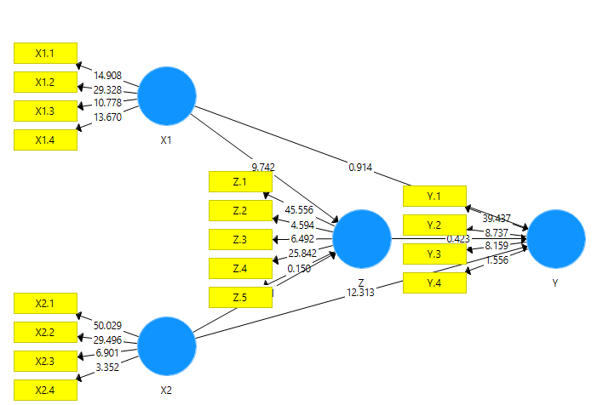

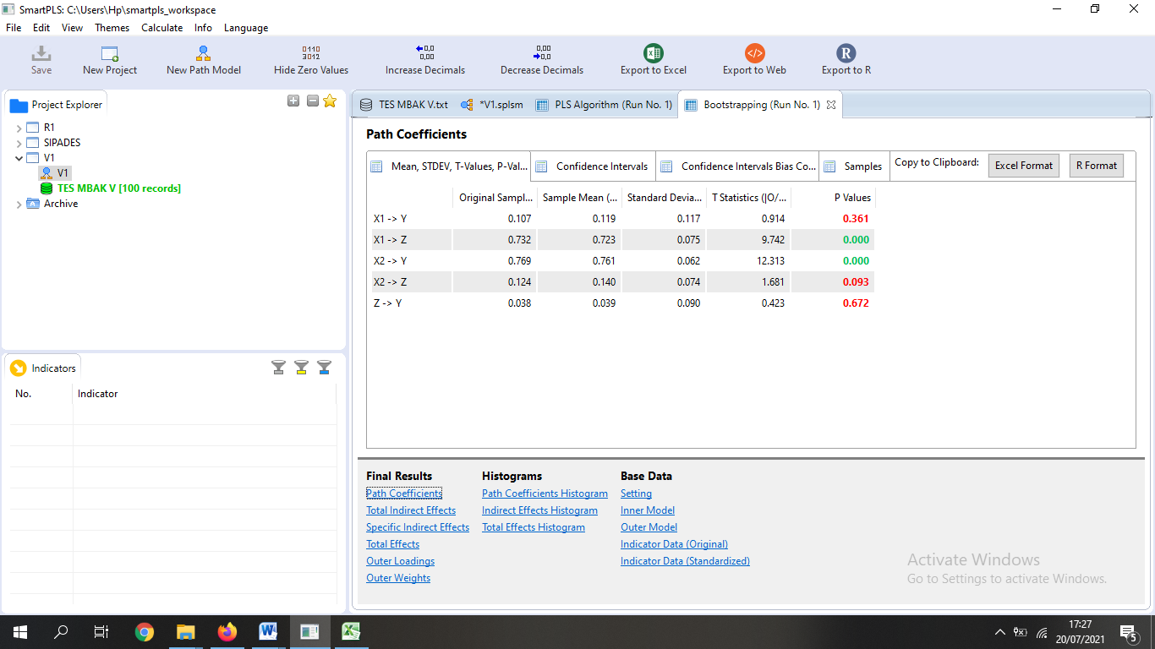

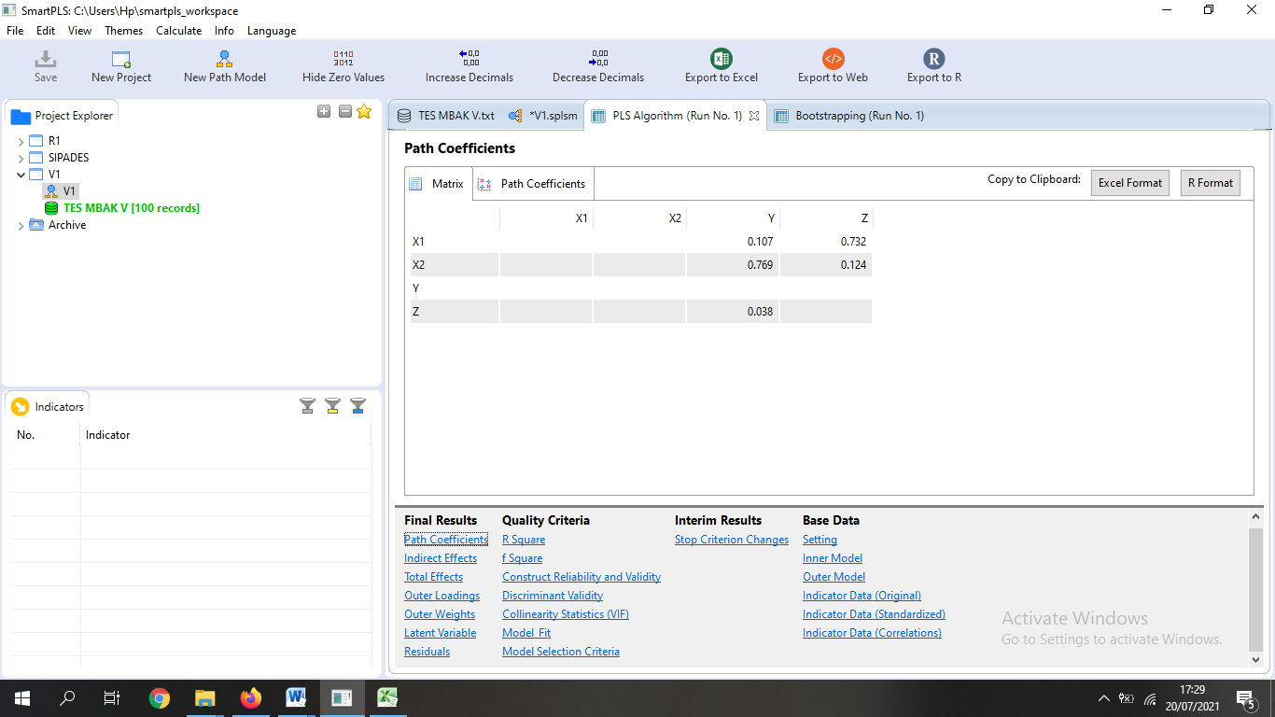

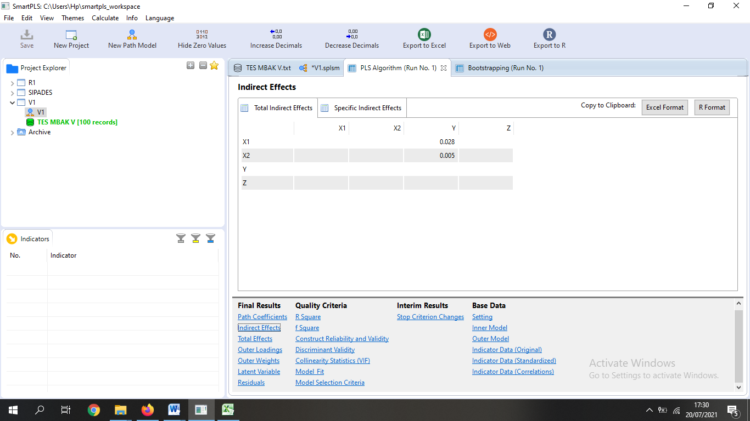

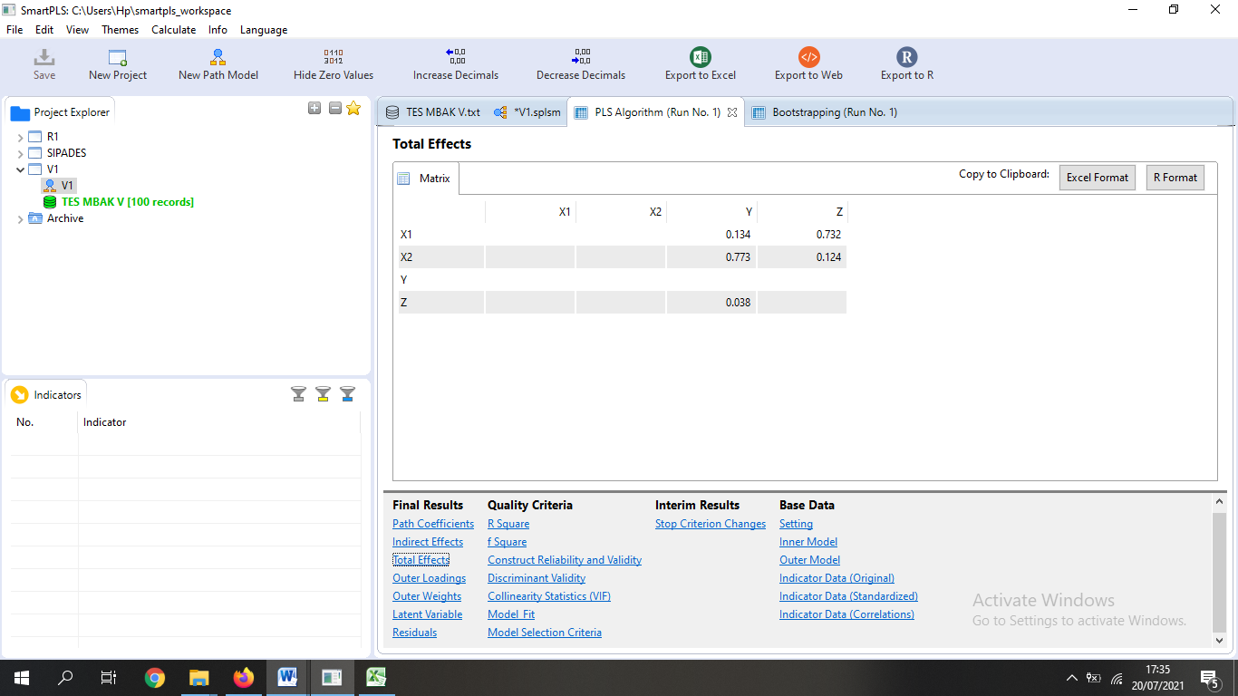

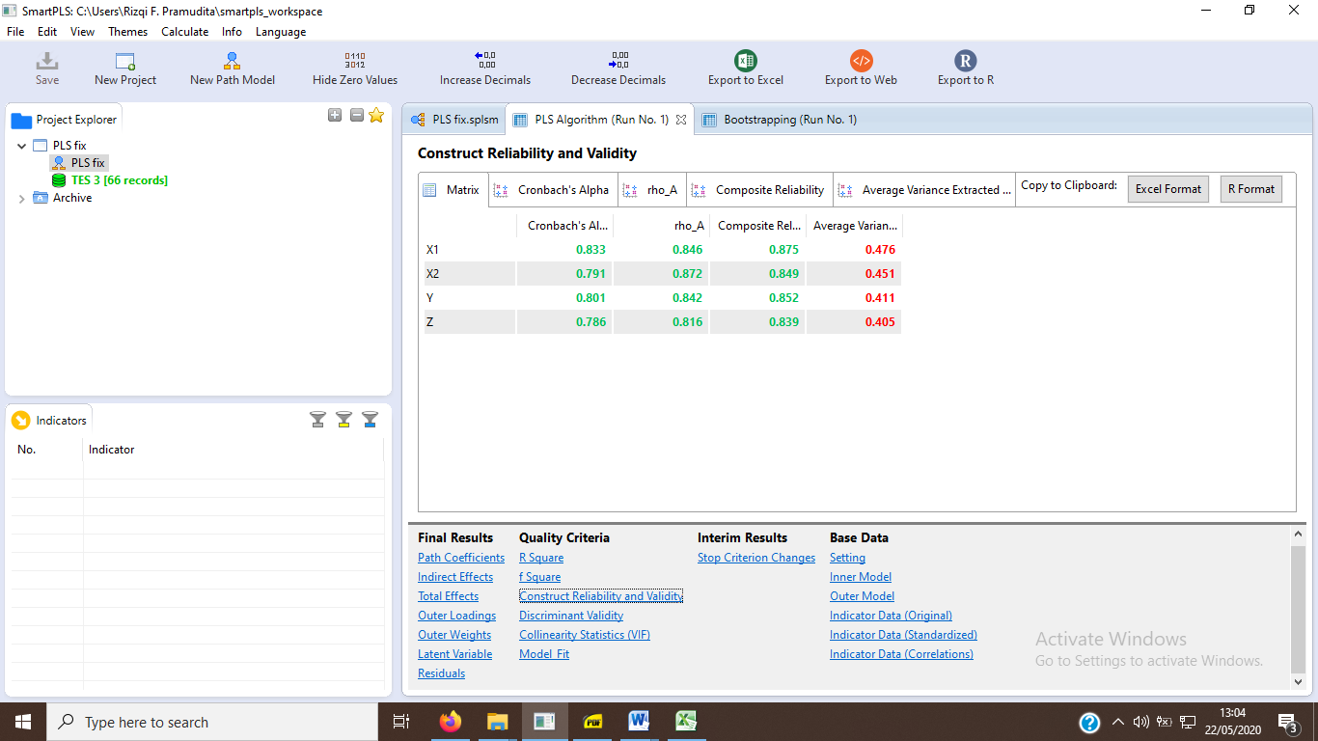

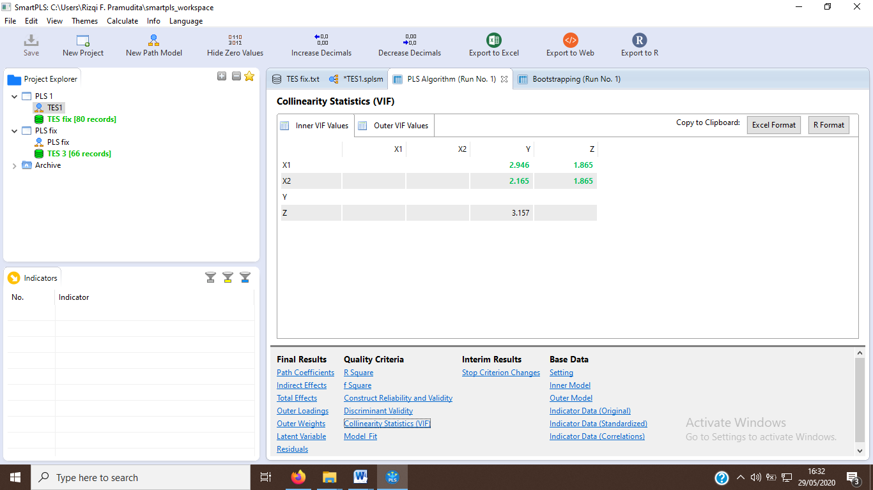

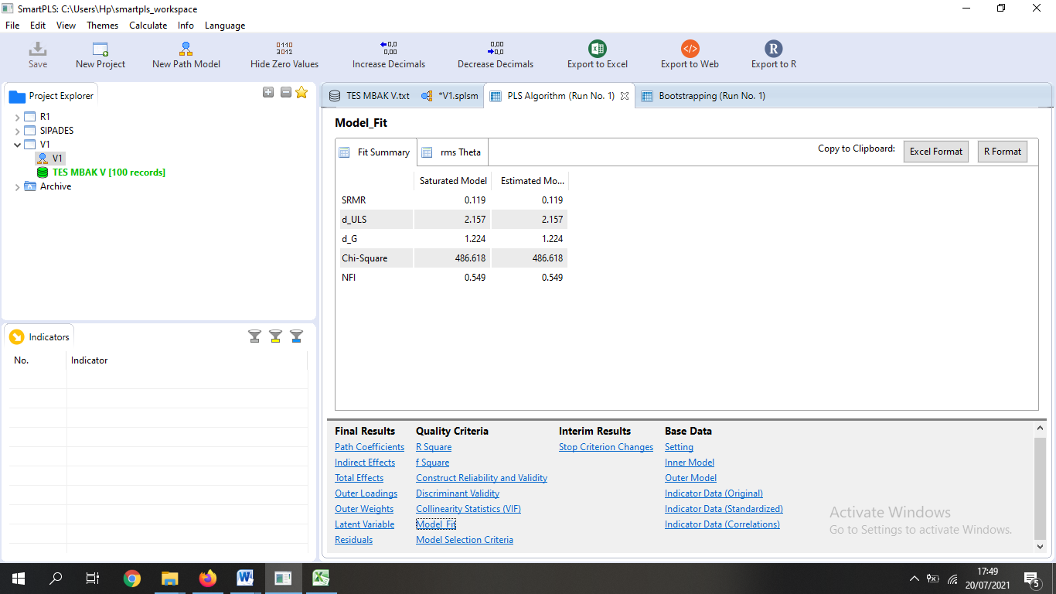

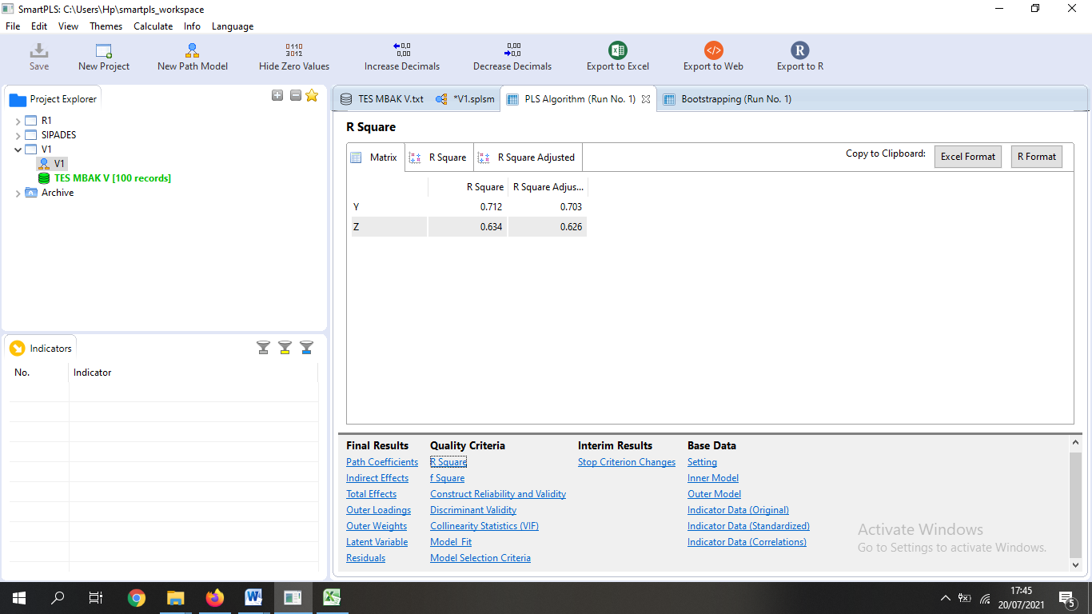

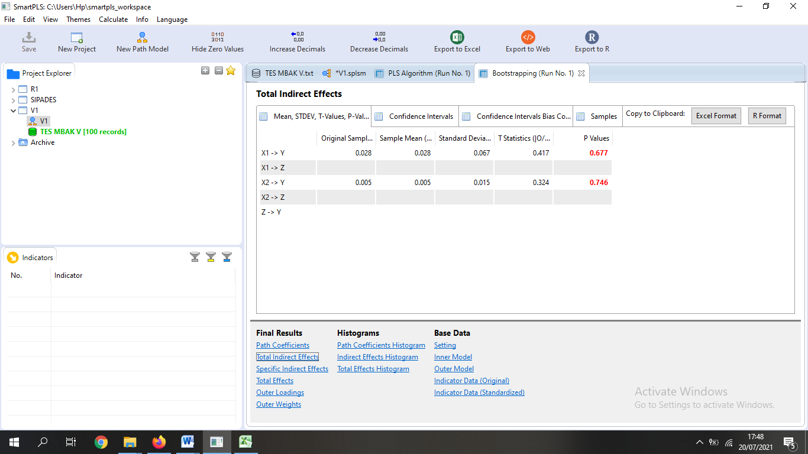

Outer Loading

|  |  |  |  |  |
| --- | --- | --- | --- | --- |
| **Variabel** | **X1** | **X2** | **Z** | **Y** |
| X1.1 | 0.754 |  |  |  |
| X1.2 | 0.812 |  |  |  |
| X1.3 | 0.818 |  |  |  |
| X1.4 | 0.764 |  |  |  |
| X1.5 | 0.770 |  |  |  |
| X2.1 |  | 0.884 |  |  |
| X2.2 |  | 0.787 |  |  |
| X2.3 |  | 0.754 |  |  |
| Z.1 |  |  | 0.734 |  |
| Z.2 |  |  | 0.822 |  |
| Z.3 |  |  | 0.727 |  |
| Z.4 |  |  | 0.701 |  |
| Z.5 |  |  | 0.732 |  |
| Y.1 |  |  |  | 0.840 |
| Y.2 |  |  |  | 0.731 |
| Y.3 |  |  |  | 0.762 |
| Y.4 |  |  |  | 0.776 |
| Y.5 |  |  |  | 0.801 |