**THE IMPACT OF RELIGIOSITY AND SERVICE QUALITY ON THE SAVING DECISIONS OF TABARU’ ACCOUNT HOLDERS AT KSPPS BMT PETA MALANG BRANCH WITH INTEREST AS A MEDIATING VARIABLE**

**Siti Masriyah1*,** **Achmad Sani Supriyanto 2,** **Vivin Maharani Ekowati3**

1 Postgraduate Program in Islamic Economics, UIN Maulana Malik Ibrahim Malang, Indonesia.

2,3Lecturer in the Postgraduate Program in Islamic Economics, UIN Maulana Malik Ibrahim Malang, Indonesia

Email Korespondensi: [220504210009@student.uin-malang.ac.id](mailto:220504210009@student.uin-malang.ac.id)

***Abstract***

*This study aims to determine the impact of religiosity and service quality on the saving decisions of tabaru' account holders at KSPPS BMT PETA Malang Branch, with interest serving as a mediating variable. The research employs a quantitative approach. The population in this study comprises tabaru' account holders. Sampling was conducted using purposive sampling. Data for this study were collected using primary data from questionnaires. The analysis method employed is path analysis using SmartPLS 4. The results of this study indicate that religiosity and service quality variables have a significant impact on saving decisions. Additionally, religiosity and service quality have a significant impact on interest, and interest has a significant impact on saving decisions. Furthermore, interest can mediate the relationship between religiosity and service quality with saving decisions. This study demonstrates that religiosity and service quality significantly affect saving decisions through interest as a mediating variable.*

***Keywords :*** *Saving decisions, religiosity, service quality, interest.*

***Abstrak***

*Studi ini bertujuan untuk menentukan dampak religiositas dan kualitas layanan terhadap keputusan menabung pemegang rekening tabaru' di KSPPS BMT PETA Cabang Malang, dengan bunga sebagai variabel mediasi. Penelitian ini menggunakan pendekatan kuantitatif. Populasi dalam studi ini adalah pemegang rekening tabaru'. Pengambilan sampel dilakukan dengan teknik purposive sampling. Data untuk penelitian ini dikumpulkan menggunakan data primer dari kuesioner. Metode analisis yang digunakan adalah analisis jalur dengan menggunakan SmartPLS 4. Hasil studi ini menunjukkan bahwa variabel religiositas dan kualitas layanan memiliki dampak yang signifikan terhadap keputusan menabung. Selain itu, religiositas dan kualitas layanan juga memiliki dampak signifikan terhadap bunga, dan bunga memiliki dampak signifikan terhadap keputusan menabung. Lebih lanjut, bunga dapat memediasi hubungan antara religiositas dan kualitas layanan dengan keputusan menabung. Studi ini menunjukkan bahwa religiositas dan kualitas layanan mempengaruhi keputusan menabung secara signifikan melalui bunga sebagai variabel mediasi.*

***Kata Kunci****: Keputusan Menabung, Religiusitas, Kualitas Layanan, Minat.*

***JEL Clasification : Religiosity, Service Quality, Saving Decisions***

**Introduction**

Indonesia is a country with a majority Muslim population. There should be a greater interest in using Islamic financial institutions and possessing knowledge about Islamic finance. However, in reality, many Muslims in Indonesia still prefer traditional financial institutions over Islamic ones, whose operations are prohibited due to involvement in interest (riba). One of the financial institutions in Indonesia that adheres to Islamic law is Islamic banks (Fauzi and Murniawaty, 2020). In addition to banks, Baitul Maal wa Tamwil (BMT) is a type of non-banking institution that is directly involved in poverty alleviation programs, focusing on both social and commercial objectives. Similar to this, BMTs are institutions that distribute funds fairly and equitably, rather than exploiting the majority to benefit a small group of investors (founders). They are organizations formed to assist mainly small and microbusiness owners. BMTs are directly related to acquiring and allocating business funding. In this context, official Islamic institutions are established to support local economic efforts and enhance local economies through micro and small enterprises that adhere to Islamic law (Fadeli, 2022).

The positive economic development in East Java has been accompanied by the growth of Islamic business and industries in several regions of East Java, including Islamic banking, halal food, and Islamic tourism. East Java has significant potential for the Islamic finance sector and halal industry, including institutions like BMT, of which there are currently 626 formally registered Islamic microfinance institutions in East Java (Khofifah, 2022). The Cooperative of Islamic Saving and Financing KSPPS BMT Perekonomian Tasyrikah Agung (KSPPS BMT PETA) Malang Branch, established in early 2020, is one of the BMTs in East Java. However, it did not commence operations immediately due to the COVID-19 pandemic. It resumed operations in 2021 and continues to operate to this day. KSPPS BMT PETA offers several products, one of which is the Tabaru’ saving product, which is popular among many members (Saiful, 2023).

The phenomenon observed at KSPPS BMT PETA Malang Branch is the lack of public interest in saving at KSPPS BMT PETA, despite the fact that the quality of the products offered aligns with Islamic principles and is free from harmful elements. Members choose to save at KSPPS BMT PETA due to the high quality of service provided, where members are not required to visit the office directly; instead, there are staff who pick up and deliver deposits for each member. However, KSPPS BMT PETA still faces some shortcomings, such as the low trust of the local community in the performance and quality of service due to its relatively new status. Therefore, it is necessary to conduct a more comprehensive and systematic study to address these issues.

Service quality is one of the factors influencing people's decisions to save, and a key aspect of excellent service provided by bank employees is the service they offer to the public. If a member is still inexperienced, employees should provide guidance on any relevant information. Customer satisfaction and decision-making can be significantly influenced by prompt, courteous, and friendly service (Pramudani and Fithria, 2021). As demonstrated in the study conducted by Rio Aprian, et al (2021), the results show that at Bank BRI Manna Branch, service quality has a significant impact on the decision to save (Aprian et al, 2021). Similarly, the research conducted by (Lina, 2020; Alwahidin & Afni, 2022; Qomariah, 2021; Pratamasyari, 2022) indicates that service quality affects the decision to save. On the other hand, another study conducted by Yusuf & Rangkuti (2023) found that the service quality variable does not have a partial effect on the decision to save at Bank Aceh Syariah in Langsa City (Yusuf and Rangkuti, 2023). Similarly, the research conducted by (Sutrisno, 2016; Robyani et al., 2023; Carolina, 2023) indicates that service quality does not affect the decision to save.

People's decision to save is influenced not only by service quality but also by religiosity. Religiosity also has a significant impact on their decision to save at BMT or not, and since each person is different, their desire to save varies as well. The strong historical and textual impetus of religious beliefs, which address not only the afterlife but also all aspects of life on earth, including banking transactions, is a reason behind the existence of BMTs in Indonesia. The study conducted by Pabbajah, et al (2019) shows that religiosity affects the decision to save (Pabbajah et al, 2019). Similarly, the research conducted by (Yusuf and Rangkuti; Faha et al., 2022; Hasibuan, 2020; Robyani et al., 2023) indicates that religiosity affects customers' decisions to save. On the other hand, in the study conducted by (Ramadhan, 2019; Murniati et al., 2020; Maghfiroh, 2018) indicates that religiosity does not affect customers' decisions to save.

The decision to save at KSPPS BMT PETA will be influenced by the relationship between interest as a mediating variable and the independent variables, which are religiosity and service quality. Choosing to save at KSPPS BMT PETA is an example of how interest (intention) can link fundamental elements with behavior. According to the Theory of Planned Behavior (TPB) (Ajzen, 2005) the higher the public's interest in saving, the more they will consider saving at KSPPS BMT PETA, and the better the service quality offered there. However, if the level of service is poor and the desire to save is low, people are likely to avoid choosing KSPPS BMT PETA as a place to save. A similar situation occurs with religiosity, assuming a strong desire to save aligns with religiosity. This will increase the number of people choosing to save at KSPPS BMT PETA. Several previous studies conducted by (Mardiana et al., 2021; Hakim, 2020; Muzammil, 2021) show that religiosity affects the interest in saving.

There are also several studies conducted by (Aziz & Hendrastyo, 2020 ; Aisya & Riyadi, 2020) indicating that the service quality variable has a significant impact on the interest in saving. In the study conducted by (Retnosari, 2022; Munir, A, 2024; Salsabila, 2021)) states that interest can significantly influence the decision to save. The study conducted by Parastika, et al. (2021) shows that the decision to save at Islamic banks is positively and significantly influenced by religiosity, mediated by interest (Parastika et al, 2021). The study conducted by (Layli, 2022; Anas & Abidin, 20244; Zahra et al., 2024) states that religiosity and service quality are the factors that most influence members' interest in making saving decisions at Islamic financial institutions.

Considering the previously explained gap and research findings, the researcher is interested in understanding how religiosity and service quality affect consumers' decisions to save at KSPPS BMT PETA.

**Literature Review**

A decision is defined as an action chosen from two or more options. In other words, an individual faced with a decision must choose one option from various possibilities. When confronted with two choices, such as whether to buy or not, a person can take action accordingly (Prasetijo dan Ihalauw, 2005). Both basic needs and new needs will drive an individual's decision to purchase or use a service. Kotler (2002) in (Suprapto et al, 2022), The steps in the decision-making process include problem identification, information gathering, evaluating several options, deciding what to purchase, and post-purchase actions taken by the customer. Indicators of saving decisions According to Kotler and Armstrong (2008) in (Pradana et al, 2017), there are several indicators influencing the decision to purchase or use a service, including: a) Commitment to using the service (saving) b) Decision based on the brand c) Alignment with desires and needs d) Receiving recommendations from others.

Religion, according to Harun Nasution's analysis in Jalaludin (2010) in (Zakaria et al, 2020), comes from three words: al-Din, religi (relegere, religare), and religious. Al-Din is a Hebrew word for law or statute. Therefore, in Arabic, this term means mastery, conquest, obedience, debt, retribution, and custom. On the other hand, the Latin terms for religion, relegare, refers to reading and gathering, while religare means to bind.

According to Jalaluddin and Ramayulis (2015) in (Alwahidin and Afni, 2022), Religiosity or faithfulness is an internal state that motivates a person to act according to their religious belief. The consistency of religious belief as a cognitive component and religion as a conative component forms existence. A person's approach to life, shaped by the principles they uphold, reflects their level of religiosity. Therefore, the extent to which a person values and believes in the existence of God, demonstrated by their sincere obedience to commands and prohibitions with their whole heart and soul, can be interpreted as their religiosity. Indicators of religiosity according to Glock and Stark (1996) in (Fielnanda and Wahyuningsih, 2021) identify five categories of religiosity, as follows: a) Belief dimension b) Religious practice dimension c) Experience dimension d) Religious knowledge dimension e) Consequence dimension.

According to Lovelock (2010), service quality refers to performance standards and the ability to maintain them in order to satisfy clients. Customers perceive a service as good and satisfactory if they feel that the service they receive meets their expectations. However, if clients receive service that falls below standard and is inadequate, their experience will not align with their expectations (Heni Purwaningsih, 2020). According to Rusydi (2017) in (Aco and Natasya, 2022) defined as an effort to assist in preparing (maintaining) what is needed by someone or others from us, thereby creating a bond with each party's rights and obligations. Conversely, service is defined by Barata (2011) in (Aco and Natasya, 2022) as an action or series of actions that results in direct communication between a person and another person or a physical machine, and meets the client's needs. Indicators of service quality according to Zeithaml, Parasuraman, and Berry in (Sunyoto, 2012) using the concept of service quality gaps, such as: a) Assurance b) Tangibles c) Reliability d) Responsiveness e) Empathy.

Interest is the tendency within a person to be attracted to something or an object. According to Crow and Crow (1984) in (Suprihati et al, 2021) refers to a drive that causes a person to pay attention to others, to something, and also to certain activities. Interest according to Winkel (1993) in (Purwaningsih, 2020) is a tendency and enduring condition to find happiness in participating in certain activities and feeling attracted to specific areas or things. It is difficult to determine definitively which comes first, but feelings of pleasure can also generate curiosity, which is further supported by the same optimistic attitude. Indicators of interest according to Ferdinand (2002) in (Oktaviani, 2018) explains that purchase interest can be identified through the following indicators: a) Transactional interest b) Referential interest c) Preference interest d) Exploratory interest.

Research Model:

**Picture 1.1**

**Hypothesis Model**

H1

H6

H6

H3

H7

H5

H7

H4

H2

Descriptions : Direct Test

: Indirect Test

Research Hypotheses:

H1: The effect of religiosity on the decision to save

H2: The effect of service quality on the decision to save

H3: The effect of religiosity on interest

H4: The effect of service quality on interest

H5: The effect of interest on the decision to save

H6: The effect of religiosity on the decision to save mediated by interest

H7: The effect of service quality on the decision to save mediated by interest

**Methodology**

This research uses a quantitative methodology. The research approach employed here is explanatory research with a quantitative approach, as it is capable of explaining the relationships between hypotheses and the influence of independent variables both individually and collectively on the dependent variable.

The data collection method in this study is a questionnaire. The measurement instrument consists of closed-ended statements and is measured using an ordinal scale from 1 to 5. Respondents provide their opinions on each statement, ranging from strongly disagree to strongly agree.

Additionally, the next data collection technique is documentation, aimed at obtaining data directly from the research site. This includes relevant books, photographs, and any data pertinent to the research. The data source used in this study is primary data from the questionnaire. The population in this study consists of members of the Tabaru' saving group of KSPPS BMT PETA Malang Branch, whose size is unknown. The sample represents a portion of the population's size and composition. This study employs a purposive sampling method, despite the unknown population size. The determination of the minimum sample size is calculated based on the formula by Hair et al (Hair, et al, 2010), Where the representative sample size is dependent on the number of indicators multiplied by 5 to 10. The sample size for this study is 180 samples. The definitions and indicators for each variable in this study are explained in Table 1.1, as follows:

**Table 1.1: Operational Definitions of Research Variables**

|  |  |  |
| --- | --- | --- |
| No. | Operational Definitions of Variables | Indicators |
| 1 | Religiosity (X1) is the level of an individual's religious awareness and belief in the existence of God, measured by their degree of religiosity, which is achieved by following religious guidelines and avoiding forbidden actions with wholehearted commitment (Alwahidin and Afni, 2022). | 1. 1. Belief, 2. 2. Religious Practice, 3. 3. Experience, 4. 4. Religious Knowledge, 5. 5. Consequences   (Fielnanda and Wahyuningsih, 2021; Sayyidah et al, 2022) |
| 2 | Service Quality (X2) is defined by Barata (2011) as an action or series of actions that result in direct interaction between an individual and a physical machine or another person, and meets customer needs (Aco and Natasya, 2022). | 1. 1. Assurance, 2. 2. Physical Appearance, 3. 3. Responsiveness, 4. 4. Reliability, 5. 5. Empathy. 6. (Sunyoto, 2012; Syahrial, 2018) |
| No. | *Operational Definitions of Variables* | *Indicators* |
| 3 | Saving Decision (Y) involves making a choice from a set of available options. An individual can make a decision when presented with two alternatives, such as buying or not buying, and decides to buy (Prasetijo dan Ihalauw, 2005). | 1. 1. Confidence in Using Service Products (Saving) 2. 2. Deciding Based on The Brand 3. 3. Aligned With Desires and Needs 4. 4. Receiving Recommendations from Others 5. (Pradana et al, 2017); (Muflif, 2006) |
| 4 | Interest (Z), according to Crow and Crow (1984), refers to a motivating factor that compels an individual to focus on something, another person, or specific activities (Suprihati et al, 2021). | 1. 1. Transactional Interest, 2. 2. Referential Interest, 3. 3. Preference Interest, 4. 4. Exploratory Interest.   (Novi Oktaviani, 2018; Burhan, 2012) |

*Source: Data processed by theresearcher, 2024*

**Results And Discussion**

The application used in this study is SmartPLS 4. The following are the steps for analyzing the data:

**Evaluation of the Measurement Model (Outer Model)**

* 1. **Validity**

This analysis is conducted to test the validity and reliability of the constructs for each indicator, ensuring that the data used is suitable for measurement in the model. There are four latent variables in the measurement model: religiosity (X1), service quality (X2), interest (Z), and saving decision (Y). The measurement model in this study includes latent variables that do not meet the required loading factor criterion, which is having a value less than 0.5. This led to the exclusion of those latent variables that did not meet the criteria from the data set (the results of the initial data processing can be found in the appendix). Therefore, the researcher performed a second round of data processing, as follows:

**Picture 1.2 Outler Loading**

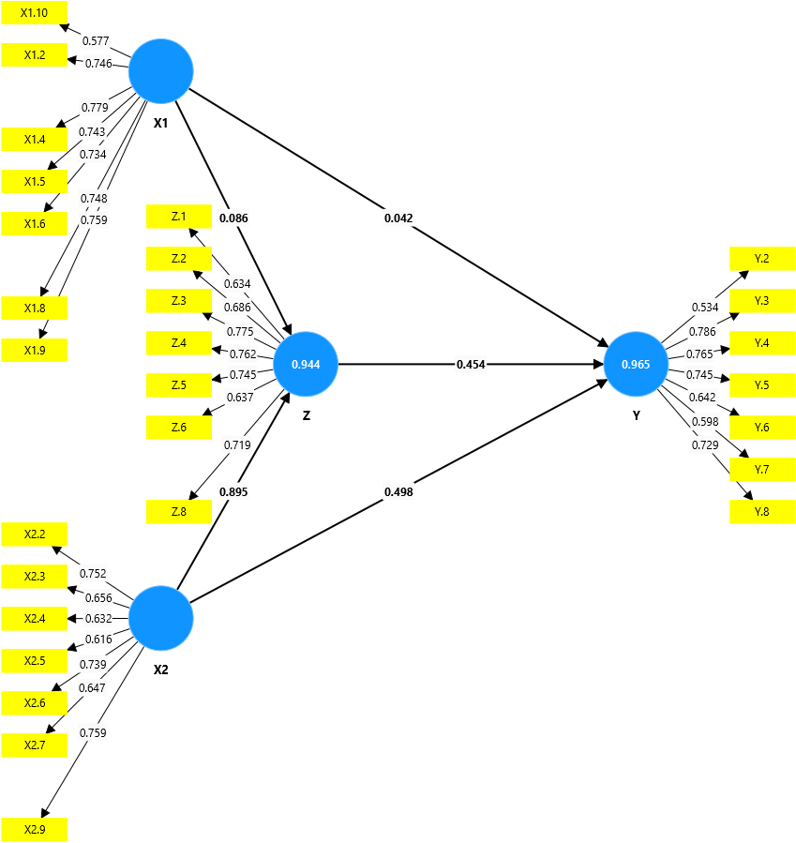

*Source: Data processed by theresearcher, 2024*

Based on the results of the analysis of the outer model, further analysis is then conducted. The subsequent analysis includes testing for convergent validity and the Average Variance Extracted (AVE), as follows:

1. Convergent Validity

The convergent validity test shows the relationships between the items in the latent variables within the questionnaire distributed to respondents. An indicator is considered to meet the validity test if its loading factor value is greater than 0.5. The loading factor value indicates the weight of each item as a measure of the respective variable. The following are the values of convergent validity after removing data that did not meet the criteria and conducting the second round of data processing:

**Table 1.2 Loading Factor**

|  |  |  |  |
| --- | --- | --- | --- |
| **Variable** | **Items** | ***Loading Factor*** | **Information** |
| Religiosity | X1.2 | *0.746* | Valid |
| X1.4 | *0.779* | Valid |
| X1.5 | *0.743* | Valid |
| X1.6 | *0.734* | Valid |
| X1.8 | *0.748* | Valid |
| X1.9 | *0.759* | Valid |
| X1.10 | *0.577* | Valid |
| Quality of Service | X2.2 | *0.752* | Valid |
| X2.3 | *0.656* | Valid |
| X2.4 | *0.632* | Valid |
| X2.5 | *0.616* | Valid |
| X2.6 | *0.739* | Valid |
| X2.7 | *0.647* | Valid |
| X2.9 | *0.759* | Valid |
| Saving Decisions | Y.2 | *0.534* | Valid |
| Y.3 | *0.786* | Valid |
| Y.4 | *0.765* | Valid |
| Y.5 | *0.745* | Valid |
| Y.6 | *0.642* | Valid |
| Y.7 | *0.598* | Valid |
| Y.8 | *0.729* | Valid |
| Interest | Z.1 | *0.634* | Valid |
| Z.2 | *0.686* | Valid |
| Z.3 | *0.775* | Valid |
| Z.4 | *0.762* | Valid |
| Z.5 | *0.745* | Valid |
| Z.6 | 0.637 | Valid |
| Z.8 | 0.719 | Valid |

*Source: Data processed by theresearcher, 2024*

Based on the analysis results, the outer loading values for each latent variable vary, but all values are greater than 0. Thus, they are considered valid.

1. Average Variance Extracted

In addition to outer loading, validity testing also examines the Average Variance Extracted (AVE). The AVE value is considered good if it is greater than 0.5, which means that the indicators can explain and reflect each variable. The AVE values for each variable are as follows:

**Table 1.3 Average Variance Extracted Value**

|  |  |  |
| --- | --- | --- |
|  | AVE | Description |
| Religiosity | 0.649 | Valid |
| Quality of Service | 0.679 | Valid |
| Saving Decisions | 0.626 | Valid |
| Interest | 0.622 | Valid |

*Source: Data processed by theresearcher, 2024*

* 1. **Reliability**

A dataset is considered reliable by examining the Cronbach's alpha and Composite Reliability values for each variable. A variable is deemed reliable if both Cronbach's alpha and Composite Reliability values are greater than 0.7. The following are the values for Cronbach's Alpha and Composite Reliability:

**Table 1.4 Nilai Cronbach alpha dan composite reliability**

|  |  |  |  |
| --- | --- | --- | --- |
|  | Cronbach Alpha | Composite Reliability | Information |
| Religiosity | 0.820 | 0.837 | Reliable |
| Quality of Service | 0.762 | 0.768 | Reliable |
| Saving Decisions | 0.800 | 0.805 | Reliable |
| Interest | 0.796 | 0.804 | Reliable |

*Source: Data processed by theresearcher, 2024*

The results in Table 1.3 show that all variables have Cronbach's alpha and Composite Reliability values greater than 0.7, indicating that all variables in this study have good composite reliability. Therefore, further analysis can be conducted by examining the *inner model*.

**Evaluation of the Structural Model (Inner Model)**

* + - * 1. **R-Square**

**Table 1.5 R-Square test result**

|  |  |
| --- | --- |
|  | R-Square |
| Saving Decisions | 0.989 |
| Interest | 0.949 |

*Source: Data processed by theresearcher, 2024*

In Table 1.4, it is shown that the R-squared value for the saving decision variable is 0.989, which means that simultaneously, the saving decision variable can explain 98% of the variance in the independent variables of religiosity and service quality. The remaining 2% is explained by other variables not included in this research model.

The R-squared value for the interest variable is 0.949, which means that simultaneously, the interest variable can explain 94% of the variance in the independent variables. The remaining 6% is explained by other variables not included in this research model.

* + - * 1. **Results of Hypothesis Testing**

**Table 1.6 Result of Hypothesis Testing**

|  |  |  |  |  |  |  |  |
| --- | --- | --- | --- | --- | --- | --- | --- |
|  | Variable | Original Sample (O) | Sample Mean (M) | Standard Deviation (STDEV) | T-Statistics  (O/STDEV) | P-Value | Hypothesis |
| Direct Effect | X1🡪Y | 0.227 | 0.249 | 0.080 | 2.820 | 0.003 | H1  Accepted |
| X2🡪Y | 0.773 | 0.751 | 0.077 | 10.024 | 0.000 | H2  Accepted |
| X1🡪Z | 0.254 | 0.275 | 0.088 | 2.891 | 0.002 | H3  Accepted |
| X2🡪Z | 0.744 | 0.724 | 0.085 | 8.793 | 0.000 | H4  Accepted |
| Z🡪Y | 0.802 | 0.823 | 0.113 | 7.116 | 0.000 | H5  Accepted |
| Mediation | X1🡪Z🡪Y | 0.204 | 0.226 | 0.078 | 2.627 | 0.005 | H6  Accepted |
| X2🡪Z🡪Y | 0.597 | 0.597 | 0.113 | 5.293 | 0.000 | H7  Accepted |

*Source: Data processed by theresearcher, 2024*

**Picture 1.3 X1 Comparison test involving mediating variables**

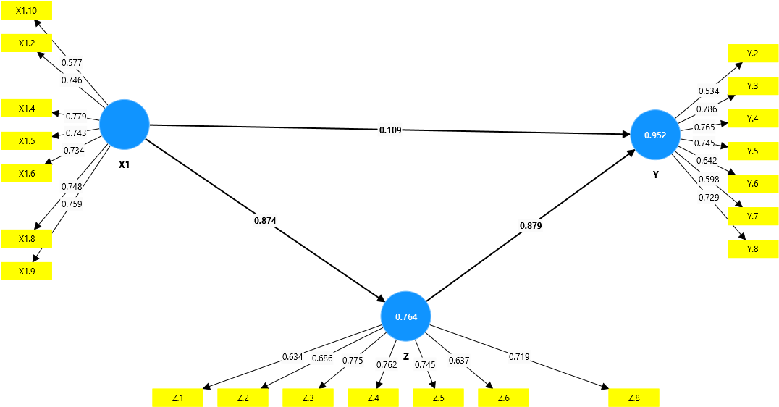

**Picture 1.4 X1 Comparison test without involving mediating variables**

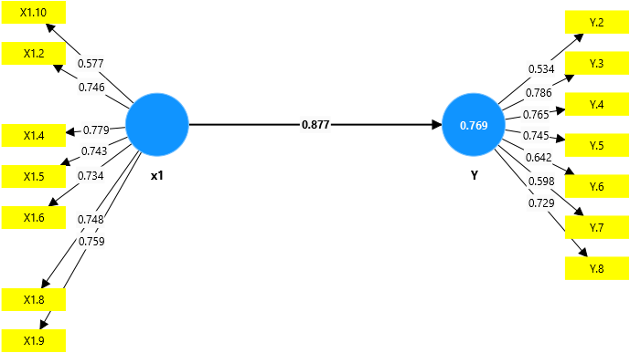

**Picture 1.5 X2 Comparison test involving mediating variables**

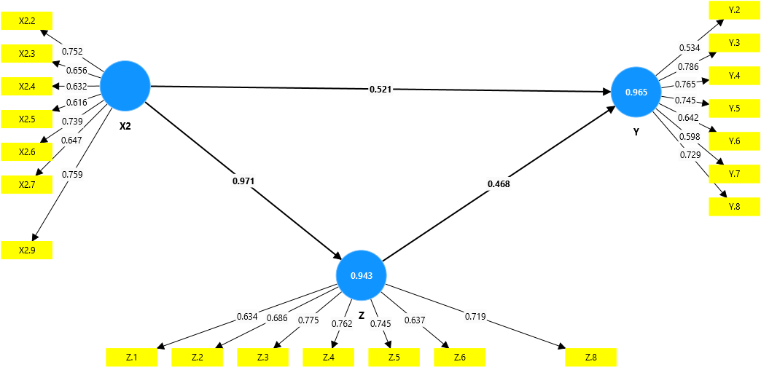

**Picture 1.6 X2 Comparison test without involving mediating variables**

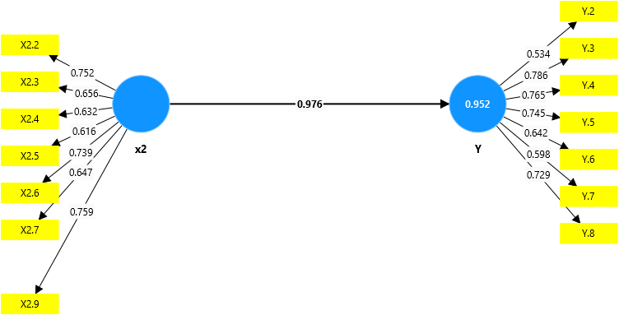

Statistical testing in PLS involves using simulations for each hypothesized relationship. In Smart PLS, a tool for performing statistical tests, the comparison test and bootstrapping analysis methods are employed on samples. From Figures 1.3, 1.4, 1.5, 1.6, and Table 1.6, several conclusions regarding the research hypotheses can be drawn and will be elaborated as follows:

In the first hypothesis, the original sample value is 0.227, indicating a positive relationship. The t-statistic value is 2.820, which suggests a significant effect because the t-statistic is greater than the t-table value (1.97), and the p-value is 0.003 < 0.050. Therefore, Hypothesis H1, which states that religiosity has a significant effect on saving decisions, **is accepted.**

In the second hypothesis, the original sample value is 0.773, indicating a positive relationship. The t-statistic value is 10.024, which shows a significant effect because the t-statistic is greater than the t-table value (1.97), and the p-value is 0.000 < 0.050. Therefore, Hypothesis H2, which states that service quality has a significant effect on saving decisions, **is accepted.**

In the third hypothesis, the original sample value is 0.254, indicating a positive relationship. The t-statistic value is 2.891, which demonstrates a significant effect because the t-statistic is greater than the t-table value (1.97), and the p-value is 0.002 < 0.050. Therefore, Hypothesis H3, which states that religiosity has a significant effect on interest, **is accepted.**

In the fourth hypothesis, the original sample value is 0.254, indicating a positive relationship. The t-statistic value is 2.891, which shows a significant effect because the t-statistic is greater than the t-table value (1.97), and the p-value is 0.000 < 0.050. Therefore, Hypothesis H4, which states that service quality has a significant effect on interest, **is accepted.**

In the fifth hypothesis, the original sample value is 0.802, indicating a positive relationship. The t-statistic value is 7.116, which demonstrates a significant effect because the t-statistic is greater than the t-table value (1.97), and the p-value is 0.000 < 0.050. Therefore, Hypothesis H5, which states that interest has a significant effect on saving decisions, **is accepted.**

In the sixth hypothesis, based on Table 1.6, Figure 1.3, and Figure 1.4, it can be explained that interest as a mediator effectively mediates the relationship between religiosity and saving decisions. This is indicated by the original sample value of 0.204, which shows a positive relationship. The t-statistic value is 2.627, demonstrating a significant effect because the t-statistic is greater than the t-table value (1.97), and the p-value is 0.005, which is less than 0.050 (0.005 < 0.05). Additionally, the comparison test shown in Figures 1.3 and 1.4 indicates that values c (0.874) and d (0.879) are significant, and value a (0.109) is also significant, with the coefficient of a being smaller than b (0.877), confirming that mediation is occurring. Therefore, Hypothesis H6, which states that religiosity has a significant effect on saving decisions mediated by interest, **is accepted.**

In the seventh hypothesis, based on Table 1.6, Figure 1.5, and Figure 1.6, it can be explained that interest as a mediating variable effectively mediates the relationship between service quality and saving decisions. This is indicated by the original sample value of 0.597, which shows a positive relationship. The t-statistic value is 5.293, demonstrating a significant effect because the t-statistic is greater than the t-table value (1.97), and the p-value is 0.000, which is less than 0.050 (0.000 < 0.05). Additionally, the comparison test shown in Figures 1.5 and 1.6 indicates that values c (0.971) and d (0.468) are significant, and value a (0.521) is also significant, with the coefficient of a being smaller than b (0.976), confirming that mediation is occurring. Therefore, Hypothesis H7, which states that service quality has a significant effect on saving decisions mediated by interest, **is accepted.**

**DISCUSSION**

**The Influence of Religiosity on Saving Decisions**

Based on the results of Hypothesis 1, religiosity has a direct effect on saving decisions, so Hypothesis 1 in this study is accepted and supported by the data. This study is also consistent with previous research conducted by (Hasanah, 2019(Hasanah, 2019; Aulia, 2022Aulia, 2022; Aco & Natasya, 2022)Aco & Natasya, 2022) which explains that religiosity has a significant impact on customers' saving decisions. This finding is also supported by research conducted by (Rachmatullah and Puradi)(Rachmatullah and Puradi) This explains that good knowledge and understanding of religiosity can influence an individual's ability to make sound saving decisions. In this study, the variable of religiosity can be interpreted as the impact of respondents' level of understanding of religiosity, which can affect their saving decisions.

* + - 1. **The Influence of Service Quality on Saving Decisions**

The results of Hypothesis 2 indicate that service quality affects saving decisions, so Hypothesis 2 in this study is accepted and supported by the data. This finding aligns with previous research conducted by (Alwahidin & Afni, 2022(Alwahidin & Afni, 2022; Pramudani & Fithria, 2021Pramudani & Fithria, 2021;Yusuf & Rangkuti, 2023Yusuf & Rangkuti, 2023; Aprian et al., 2021); Aprian et al., 2021) which states that the variable of service quality has a significant impact on saving decisions. Thus, this demonstrates that service quality has a considerable influence on respondents' decisions to save at KSPPS BMT PETA.

* + - 1. **The Influence of Religiosity on Interest**

The results of Hypothesis 3 indicate that religiosity affects saving interest, so Hypothesis 3 in this study is accepted and supported by the data. This finding is consistent with previous research conducted by (Hakim, 2020(Hakim, 2020; Muzammil, 2021Muzammil, 2021; Mardiana et al., 2021)Mardiana et al., 2021) indicating that religiosity has a significant effect on saving interest. This explains that in this study, the variable of religiosity can be interpreted as follows: the higher the level of religiosity among respondents, the greater their interest in becoming a member of KSPPS BMT PETA.

* + - 1. **The Influence of Service Quality on Interest**

The results of Hypothesis 4 indicate that service quality affects saving interest, so Hypothesis 4 in this study is accepted and supported by the data. This finding is consistent with previous research which states that service quality can influence consumer interest in saving with Islamic financial institutions, as demonstrated by (Aziz & Hendrastyo, 2020(Aziz & Hendrastyo, 2020; Sofyan, A Syathir, 2021Sofyan, A Syathir, 2021; Aisya & Riyadi, 2020)Aisya & Riyadi, 2020). This indicates that consumers highly consider the quality of service provided by BMT when making their saving decisions.

* + - 1. **The Influence of Interest on Saving Decisions**

The results of the hypothesis testing indicate that Hypothesis 5 (H5) shows that saving interest affects consumer saving decisions at BMT PETA. Therefore, this hypothesis is accepted and supported by the data in this study. The findings are consistent with previous research conducted by (Salsabila, 2021(Salsabila, 2021; Abdau, 2021Abdau, 2021; Retnosari, 2022)Retnosari, 2022) which states that interest significantly influences saving decisions. Therefore, the higher the saving interest among consumers, the more it will enhance the intensity of saving decisions at BMT PETA.

* + - 1. **The Influence of Religiosity on Saving Decisions is Mediated by Interest**

Based on the test results presented in Table 1.5, Figure 1.2, and Figure 1.3, it can be explained that the results of Hypothesis 6 show that interest, as a mediating variable, influences the relationship between religiosity and saving decisions at KSPPS BMT PETA. Therefore, H6 is accepted and supported by the data in this study. Additionally, consistent with the findings of Parastika et al. (2021), which revealed a significant effect of religiosity on saving decisions in Islamic banks with interest as an intervening variable, it can be concluded that as the level of religiosity increases, the interest in saving in Islamic financial institutions also increases, thereby strengthening the decision to save at BMT PETA.

* + - 1. **The Influence of Service Quality on Saving Decisions is Mediated by Interest**

Based on the test results presented in Table 4.13, Figure 4.5, and Figure 4.6, it can be explained that the results of H7 show that interest, as a mediating variable, effectively influences the relationship between service quality and saving decisions at KSPPS BMT PETA. This is consistent with the study conducted by Zahra et al. (2024), which revealed that interest can mediate the effect of service quality on saving decisions in Islamic financial institutions. Therefore, it can be concluded that as the quality of service provided by BMT PETA increases, consumer interest in using the products and services of the Islamic institution is likely to grow.

**Conclusion**

Based on the research findings and discussion, both religiosity and service quality have a significant effect on saving decisions. Additionally, religiosity and service quality significantly influence interest. Interest, in turn, has a significant effect on saving decisions. As a mediating variable, interest effectively mediates the relationship between religiosity and service quality and saving decisions.

It is hoped that KSPPS BMT PETA Malang Branch will continue to enhance its company performance by improving its ability to provide the best services and facilities to its members.

For future researchers, it is recommended to build upon this study by adding additional variables or expanding the sample size to refine and enhance the research. Additionally, it is hoped that future researchers will use this study as a reference for similar research topics.

**Acknowledgements**

First of all, I would like to express my gratitude to the State Islamic University (UIN) Maulana Malik Ibrahim Malang and the Institution of Islamic Cooperative (KSPPS) BMT PETA Branch Malang for providing me with the opportunity to complete this research. Secondly, I extend my thanks to Prof. Dr. H. Achmad Sani Supriyanto, SE., M. Si and Dr. Vivin Maharani Ekowati, SE., M. Si as lecturers of the Master's Program in Islamic Economics at UIN Maulana Malik Ibrahim Malang, who have always given me encouragement and assistance in completing this research. Finally, I would like to thank my parents for their prayers and support.**Top of FormBottom of Form**

**References**

Aco, Nur Asia, and Natasya, ‘Pengaruh Religiusitas, Promosi, Dan Pelayanan Dalam Pengambilan Keputusan Menjadi Nasabah Tabungan Haji Pada PT. Bank Muamalat Cabang Mamuju’, *Forecasting: Jurnal Ilmiah Ilmu Manajemen*, 1.2 (2022), 1–10

Alwahidin, and Nur Afni, ‘Pengaruh Kualitas Pelayanan Dan Religiusitas Terhadap Minat Menabung Di Bank Syariah Indonesia’, *Journal of Economics and Accounting*, 3.1 (2022), 57–71 <https://doi.org/10.47065/arbitrase.v3i1.445

Aprian, Rio, Karona Cahya Susena, and Tito Irwanto, ‘The Influence of Mobile Banking and Service Quality Toward Customers ’ Saving Decision in Bank BRI Branch of Manna Pengaruh Mobile Banking Dan Kualitas Pelayanan Terhadap Keputusan Nasabah Menabung Di Bank BRI Cabang Manna’, *Jurnal of Indonesia Management*, 2021, 174–79

Aziz, Nazzarudin, and Vito Shiga Hendrastyo, ‘Pengaruh Kualitas Layanan, Kepercayaan Dan Promosi Terhadap Minat Nasabah Menabung Pada Bank Syariah Cabang Ulak Karang Kota Padang’, *Jurnal Pundi*, 3.3 (2020), 227 <https://doi.org/10.31575/jp.v3i3.183>

Carolina, Nadia Intan, ‘Pengaruh Kualitas Porudk, Kualitas Pelayanan, Dan promosi Terhadap Keputusan Menabung Pada Nasabah Bank Syariah Indonesia Di Kota Malang’ (UIN Maulana Malik Ibrahim Malang, 2023)

Dedhy Pradana, and Rahmawati Syarifah Hudayah, ‘Pengaruh Harga Kualitas Produk Dan Citra Merek BRAND IMAGE Terhadap Keputusan Pembelian Motor’, *Ekonomi Dan Manajeman*, 14.1 (2017)

Fadeli, M Nur, ‘Pengaruh Promosi Dan Religiusitas Terhadap Minat Masyarakat Menabung Di BMT NU Cabang Glenmore’, 2022

Fauzi, Ahmad, and Indri Murniawaty, ‘Pengaruh Religiusitas Dan Literasi Keuangan Syariah Mahasiswa Terhadap Minat Menjadi Nasabah Di Bank Syariah’, *EEAJ Economic Education Analysis Journal*, 9.2 (2020), 473–86 <https://doi.org/10.15294/eeaj.v9i2.39541>

Fielnanda, Refky, and Santi Wahyuningsih, ‘Pengaruh Tingkat Religiusitas, Tingkat Pendidikan Dan Tingkat Pendapatan Terhadap Minat Menabung Di Bank Syariah Pada Masyarakat Kelurahan Simpang IV Sipin’, *Jurnal Margin*, 1.1 (2021), 58–70

Hair, J. F., Black, W. C., Babin, B. J., & Anderson, R. E., ‘Multivariate Data Analysis’, 7th edn (Pearson, 2010)

Heni Purawningsih, ‘Pengaruh Religiusitas, Pengetahuan, Dan Kualitas Pelayanan Terhadap Minat Menabung Di Bank Syariah (Studi Empiris Pada Nasabah Bank Syariah Di Gunungkidul)’, *Skripsi*, 2020, 9

Khofifah, 2022 <https://kominfo.jatimprov.go.id/berita/jatim-borong-tiga-penghargaan-di-anugerah-adinata-syariah-2022>

Muhammad Muflif, *Perilaku Konsumen Dalam Perspektif Islam* (Jakarta: PT RajaGrafindo, 2006)

Oktaviani, Novi, ‘Pengaruh Religiusitas, Pengetahuan Dan Lokasi Terhadap Minat Menabung Pada Bank Syariah Dengan Kepercayaan Sebagai Variabel Intervening’, *Salatiga: IAIN Salatiga. SKRIPSI*, 2018, 29 <http://e-repository.perpus.iainsalatiga.ac.id/id/eprint/4789>

Pabbajah, Mustaqim, Ratri Nurina Widyanti, and Widi Fajar Widyatmoko, ‘The Factors of Service, Religiosity and Knowledge in the Decision of Customers To Save Funds in Sharia Banks in Yogyakarta City’, *International Journal of Business, Humanities, Education and Social Sciences (IJBHES)*, 1.2 (2019), 13–26 <https://doi.org/10.46923/ijbhes.v1i2.37>

Parastika, Parastika, Titin Hartini, and Ulil Amri, ‘Pengaruh Religiusitas Dan Pengetahuan Terhadap Keputusan Menabung Di Bank Syariah Dengan Minat Sebagai Variabel Intervening’, *Jurnal Intelektualita: Keislaman, Sosial Dan Sains*, 10.1 (2021), 177–87 <https://doi.org/10.19109/intelektualita.v10i1.8609>

Pramudani, Melita Puji, and Annisa Fithria, ‘Pengaruh Kualitas Produk, Religiusitas, Kualitas Pelayanan, Dan Promosi Terhadap Keputusan Mahasiswa Menabung Di Bank Syariah’, *Syi`ar Iqtishadi : Journal of Islamic Economics, Finance and Banking*, 5.2 (2021), 207 <https://doi.org/10.35448/jiec.v5i2.11614>

Ristiyani Prasetijo dan Jhon J.O.I Ihalauw, *Perilaku Konsumen* (Yogyakarta: Andi, 2005)

Saiful, ‘Wawancara Sejarah KSPPS BMT PETA’ (MALANG, 2023)

Sayyidah, Aisya Farah, Rifda Nafisa Mardhotillah, Nur Alfiana Sabila, and Sri Rejeki, ‘Peran Religiusitas Islam Dalam Meningkatkan Kesejahteraan Psikologis’, *Al-Qalb : Jurnal Psikologi Islam*, 13.2 (2022), 103–15 <https://doi.org/10.15548/alqalb.v13i2.4274

Sunyoto, Danang, *Dasar-Dasar Manajemen Pemasaran* (Yogyakarta: BPEE, 2012)

Suprapto, Ribut, Nawal Ika Susanti, and Zulfi Ferikha, ‘Pengaruh Faktor Sosial, Budaya Dan Religiusitas Terhadap Keputusan Anggota Menabung Di Bmt Ugt Sidogiri Capem Sempu’, *JPSDa: Jurnal Perbankan Syariah Darussalam*, 2.1 (2022), 28–39 <https://doi.org/10.30739/jpsda.v2i1.1280>

Syahrial, Murah, ‘Kualitas Pelayanan Dalam Islam’, *Jurnal IndraTech*, 8.4 (2018), 81–94

Yusuf, Rauzah, and Marah Sutan Rangkuti, ‘Pengaruh Kualitas Pelayanan , Bagi Hasil & Pengetahuan Produk Terhadap Keputusan Nasabah Menabung Pada Bank Aceh Syariah Kota Langsa’, *Jurnal Pendidikan, Sains, Dan Humaniora*, 11.1 (2023), 68–77

Zakaria, Livia Deni, Afifudin, and M. Cholid Mawardi, ‘Pengaruh Religiusitas, Fasilitas Layanan, Literasi Keuangan Dan Bagi Hasil Terhadap Minat Mahasiswa Untuk Menabung Di Bank Syariah’, *Jurnal Ekonomi Dan Bisnis*, 09.11 (2020), 25–26