**Hasil Penelitian**

**Tabel 1. Validitas *Pilot Test***

|  |  |  |  |
| --- | --- | --- | --- |
| Indikator | R hitung | R tabel | Ket |
| PK1 | 0,905 | 0,361 | Valid |
| PK2 | 0,817 | 0,361 | Valid |
| PK3 | 0,911 | 0,361 | Valid |
| KP1 | 0,664 | 0,361 | Valid |
| KP2 | 0,502 | 0,361 | Valid |
| KP3 | 0,870 | 0,361 | Valid |
| SKP1 | 0,737 | 0,361 | Valid |
| SKP2 | 0,864 | 0,361 | Valid |
| SKP3 | 0,855 | 0,361 | Valid |
| SKP4 | 0,775 | 0,361 | Valid |

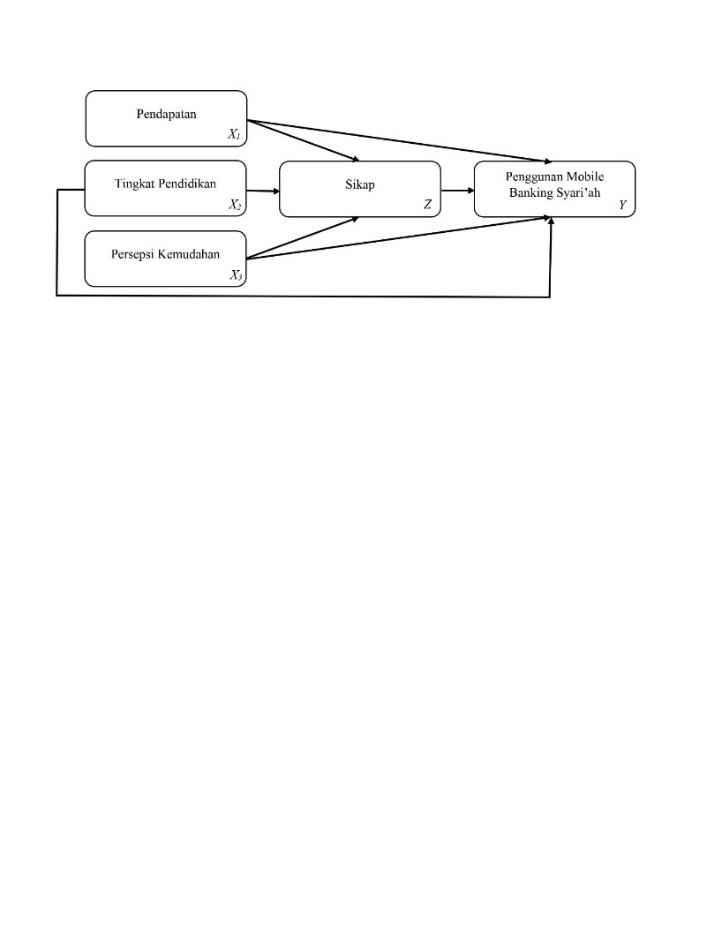  
**Gambar 1. Rancangan Penelitian**

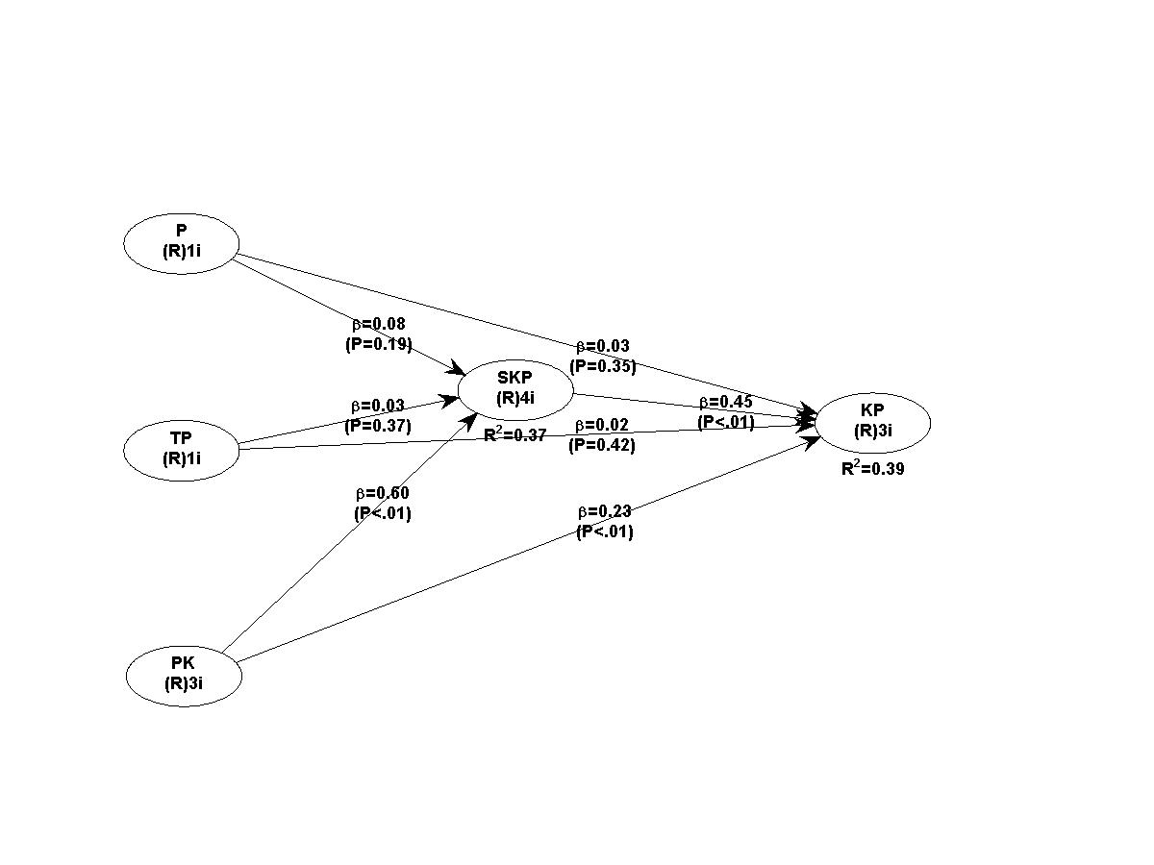

**Gambar 2. *Output* Model Pengukuran**

**Tabel 2. Nilai *Loading* Validitas Konvergen**

|  |  |  |
| --- | --- | --- |
| Indikator | Nilai *Loading* | *ρ-value* |
| P | 1,000 | <0,001 |
| TP | 1,000 | <0,001 |
| PK1 | 0,922 | <0,001 |
| PK2 | 0,852 | <0,001 |
| PK3 | 0,893 | <0,001 |
| KP1 | 0,701 | <0,001 |
| KP2 | 0,805 | <0,001 |
| KP3 | 0,655 | <0,001 |
| SKP1 | 0,776 | <0,001 |
| SKP2 | 0,844 | <0,001 |
| SKP3 | 0,843 | <0,001 |
| SKP4 | 0,768 | <0,001 |

**Tabel 3. Nilai AVE dan Koefisien Korelasi**

|  |  |  |  |  |  |
| --- | --- | --- | --- | --- | --- |
|  | P | TP | PK | SKP | KP |
| P | (1,000) | 0,002 | 0,127 | 0,100 | 0,089 |
| TP | 0,002 | (1,000) | 0,056 | 0,068 | 0,076 |
| PK | 0,127 | 0,056 | (0,889) | 0,504 | 0,592 |
| SKP | 0,100 | 0,068 | 0,504 | (0,723) | 0,589 |
| KP | 0,089 | 0,076 | 0,592 | 0,589 | (0,809) |

**Tabel 4. *Model Fit and Indices***

|  |  |  |
| --- | --- | --- |
| Indikator | Hasil | Ideal |
| *APC* | 0,206; *ρ*=0,005 | *ρ* <0,05 |
| *ARS* | 0,383; *ρ*<0,001 | *ρ*<0,05 |
| *AARS* | 0,364; *ρ*<0,001 | *Ρ*<0,05 |
| *AVIF* | 1,111 | ≤ 5 |
| *AFVIF* | 1,433 | ≤ 5 |
| *GoF* | 0,554 | Large |
| *SPR* | 1,000 | ≥ 0,7 |
| *RSCR* | 1,000 | ≥ 0,9 |
| *SSR* | 1,000 | ≥ 0,7 |
| *NLBCDR* | 0,786 | ≥ 0,7 |

**Tabel 5. Uji Hipotesis melalui *Inner Model***

|  |  |  |  |
| --- | --- | --- | --- |
| Variabel | Koefisien Jalur | *ρ-value* | Ket |
| P 🡪 SKP | 0,046 | *0,311* | Tidak |
| TP 🡪 SKP | 0,036 | 0,348 | Tidak |
| PK 🡪 SKP | 0,500 | <0,001 | Signifikan |
| P 🡪 KP | 0,043 | 0,319 | Tidak |
| TP 🡪 KP | 0,037 | 0,345 | Tidak |
| PK 🡪KP | 0,378 | <0,001 | Siginifikan |
| SKP 🡪 KP | 0,435 | <0,001 | Signifikan |