**EMPLOYEE’S PERFORMANCE IS REVIEWED FROM ORGANIZATIONAL CULTURE, MOTIVATION AND WORKLOAD OF THE SUKOHARJO DISTRICT NATIONAL LAND AGENCY OFFICE**

Desi Setyaningrum1), Eny Kustiyah2), Ratna Damayanti3)

*1-3(Prodi Manajemen, Fakultas Ekonomi, UNIBA Surakarta)*

1)[desisetyaningrum052@gmail.com](mailto:desisetyaningrum052@gmail.com), 2)[kustiyah_uniba@gmail.com](mailto:kustiyah_uniba@gmail.com), 3)[ratnadamayanti@gmail.com](mailto:ratnadamayanti@gmail.com)

***ABSTRACT***

*This research aim to identify how Organizational Culture, Motivation and Workload gives impact to Employee’s Performance at the Sukoharjo Regency National Land Agency Office. Civil Servants (PNS) at the Sukoharjo Regency National Land Agency Office is used as research’s population with total 70 employees. Researcher used saturated sample technique on research with 70 sample. There are 3 methods being used in this research, such as the classical assumption test, multiple linear regression test, hypothesis test, coefficient of determination test with SPSS 21 program. This research categorized as quantitative descriptive research that used primary data and secondary data obtained by observation, documentation, questionnaires, interviews and literature study. Final results of this research higlights positive and significant impact from Organizational Culture and Motivation variable on Employee’s Performance, while there is a positive and insignificant effect on Workload variable to Employee’s Performance. The coefficient of determination (R2) of all variables has a contribution of 41.4% and the remaining 58.6% is explained by variables outside this research model.*

**Keywords: *Employee’s Performance, Organizational Culture, Motivation, Workload***

1. **Introduction**

The increasing development of science and technology as well as the world economy in the era of technological progress shows that global competition is getting tougher. Each company and other agency is required to have consistent performance to remain able to survive in competition in today's global market. The speed of an organization is determined by many key aspects, one of the keys to a company's success comes from its employees. Employee performance includes various standards set as a basis for assessment in a company. According to (Rosmaini & Tanjung, 2019) one of the keys to successfully achieving the goals of an organization lies in the presence of employees within it, whose role really determines the success of government administration and its development.

Organizational culture greatly influences the performance of an employee in continuing to carry out their duties. Organizational culture itself is defined as a unity of systems, meanings, values ​​and beliefs that serve as guidelines for behavior, are adhered to by all elements, and differentiate one organization from another. The application of a certain culture to an organization or agency can directly shape the character of workers, especially in completing their responsibilities and helping the company achieve its goals. This indicates that whether or not the performance of an organization's employees or human resources is better is determined by how strongly the organizational culture is rooted, so that this culture then becomes the main identity of the organization which continues to be maintained periodically (Emil & Sari, 2020). Apart from organizational culture, motivation also plays an important role in encouraging increased contribution from employees. Each individual in the organization has their own needs, so their motivations are not the same as each other. If the employee needs in question are already available in an agency, then the organization is responsible for meeting the needs of its human resources. Maintaining the motivation level of organizational workers at an ideal level is very important in order to achieve the work achievement targets set by their place of work (Christian & Kurniawan, 2021).

Apart from organizational culture and motivation, employee performance is also influenced by workload, which is understood as a unit of activity that must be completed. Excessive workload tends to cause negative impacts for employees, such as physical and psychological fatigue and causes a number of emotional reactions, while too little workload also results in symptoms of "lack of movement" and leads to boredom. Boredom or lack of workload can increase the potential for reduced attention to work which can lead to a decrease in employee performance (Yandri & Aziz, 2021). There are also conditions where the workload requires organizational members to complete more work responsibilities than before, while the work resilience of each individual is not entirely the same.

The Sukoharjo Office (BPN) is an Indonesian non-ministerial public body which is responsible for carrying out state land duties in accordance with statutory regulations. In carrying out its functions, the Sukoharjo Office (BPN) continues to encourage its members to continue to improve their performance. In an effort to improve performance, employees are needed who understand organizational culture, supportive motivation, and match the workload with the portion of each employee's work.

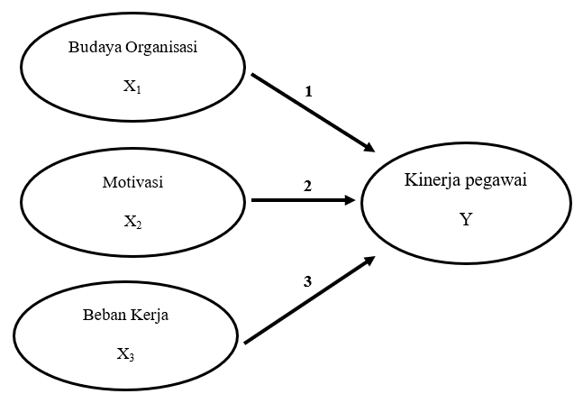

**Methodology**

This research was conducted at the Sukoharjo BPN Office using quantitative methods. The research was conducted in October-December 2023. The research involved all BPN Sukoharjo civil servants, totaling 70 employees. Saturated sampling technique was chosen in this research.

In terms of data collection techniques, researchers used several techniques such as observation, documentation, questionnaires, interviews and literature studies with employees of the Sukoharjo Regency National Land Agency Office.

**Operational definition**

The research definition of a variable in this research is a statement that is clearly related to the reality of the variable to be observed which is given by the researcher to the respondent for the purpose of testing the research hypothesis.

**Employee Performance**

Performance is an assessment of employee work which is assessed in terms of quantity and quality, accompanied by the implementation of tasks achieved by employees of the Sukoharjo Regency BPN Office.

**Organizational culture**

Organizational culture is understood as a unit of systems, meanings, values ​​and beliefs that are adhered to by employees and become guidelines for behavior and character in the company which are maintained and preserved at the National Land Agency of Sukoharjo Regency.

**Motivation**

Motivation itself is the encouragement that employees have to carry out activities or activities with the aim of achieving the goals of the Sukoharjo Regency BPN Office.

**Workload**

Workload is defined as the employee's capacity to complete the tasks that must be completed by employees of the Sukoharjo Regency National Land Agency**.**

**RESULTS AND DISCUSSION**

**Instrument Test**

1. **Validity test**

***Table 1***

***Employee Performance Test Results (Y)***

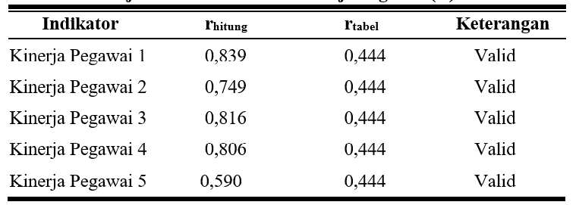

***Table 2***

***Organizational Culture Test Results (X1)***

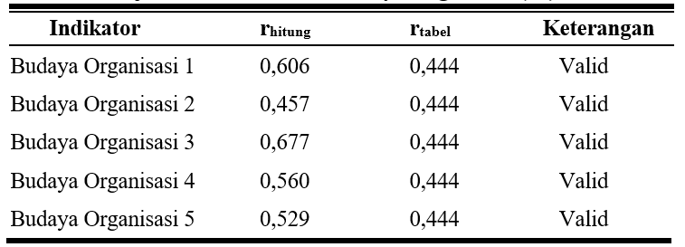

***Table 3***

***Motivation Test Results (X2)***

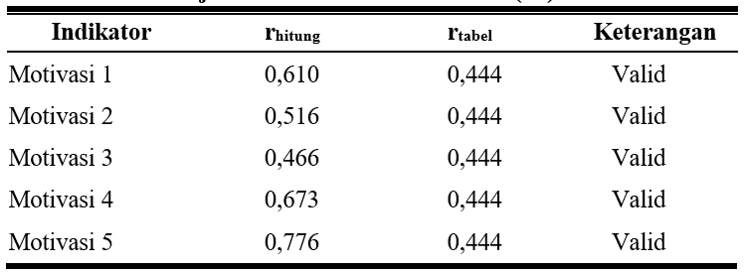

***Table 4***

***Workload Test Results (X3)***

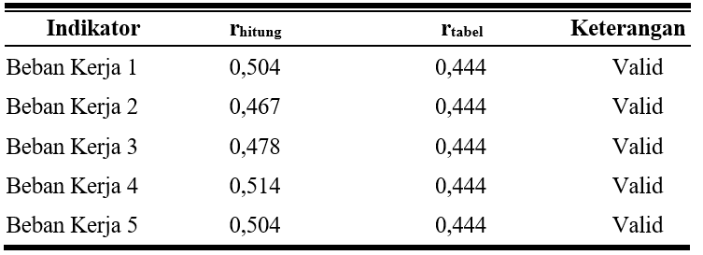

The results of the validity calculation above show that the 5 statement items submitted to respondents regarding Employee Performance (Y), Organizational Culture (X1), Motivation (X2) and Workload (X3) have a value of rcount > rtable which is declared valid.

1. **Reliability Test**

Ghozali (2020:26) states that the Reliability Test is a questionnaire measurement method that contains indicators of a change or construct. A questionnaire is considered reliable if a particular respondent's answer to a particular statement submitted is stable or consistent from time to time Ghozali (2016: 47-48)

Reflecting on the results of the validity test, the level of reliability of all statements will be measured, where below are the test results.

***Table 5***

**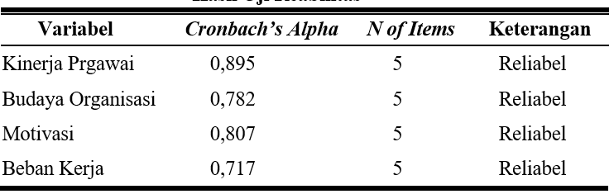*Reliability Test Results***

The results of reliability calculations as shown in Table 5 show that all variables are consideredreliable as proven by the Cronbatch's Alpha calculated value for each variable > 0.060.

**Classic assumption test**

1. **Normality test**

***Tabel 6***

***Normality Test Results***

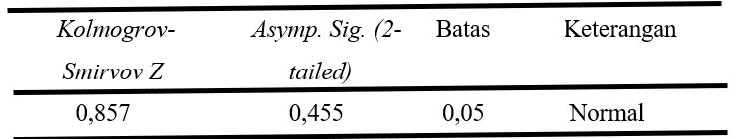

Based on table 6 above, it shows that the value of Asymp. Sig of the regression model with a result of 0.455. Thus, these results mean that in terms of data distribution, the regression equation for the model is classified as (Normal).

1. **Multicollinearity Test**

***Tabel 7***

***Multicollinearity Test Results***

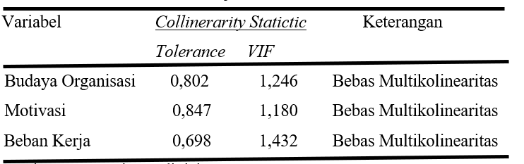

Looking at table 7 above, there is no multicollinearity, because all independent variables have a tolerance greater than.

1. **Heteroscedasticity Test**

***Table 8***

***Heteroscedasticity Test Results***

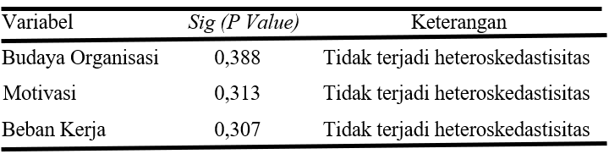

The results of the heteroscedasticity test in Table 8 show that all independent variables have a value of Sig.

**Multiple Linear Regression Analysis**

***Table 9***

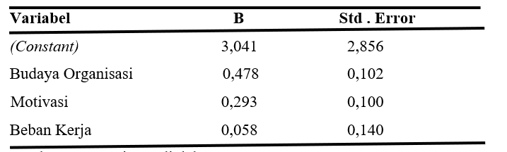 ***Multiple Linear Regression and Standard Error of Research Variables***

**Hypothesis Test (t Test)**

The results above are detailed in the explanation below.

1. Organizational culture has a positive and significant impact because the tcount value with a result of 4.692 is greater than the ttable with a value of 1.996 and a significant value of 0.000
2. Motivation has a positive and significant influence because the tcount value with a result of 2.925 is greater than the ttable with a value of 1.996 and a significant value of 0.005.
3. Workload has a positive and insignificant effect because the t-count value is 0.410 and the significant value is 0.683

**R Square Test (R2)**

***Table 11***

***R Square Test Results***

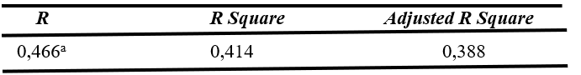

The results of the test above are as follows:

The calculation results show that the coefficient of determination (R2) is 0.414 (41.4%), which means that the contribution of the Organizational Culture, Motivation and Workload variables is 41.4%, while the remaining 58.6% is explained by other variables.

**CONCLUSION**

The results of the acquisition and analysis of data during this research gave rise to the final conclusions as explained below.

According to test results, organizational culture and motivation have a positive and significant impact on the performance of BPN Sukoharjo Office employees. Meanwhile, the workload according to the test results has no impact on the performance of BPN Sukoharjo Office employees. Calculations show that the coefficient of determination (R2) is 0.414 (41.4%), which means that the contribution of the Organizational Culture, Motivation and Workload variables is 41.4%, while the remaining 58.6% is explained by other variables, such as discipline, work environment , experience and so on.

**SUGGESTION**

Considering the conclusions drawn from the results of previous data analysis, then :

1. In this case, the company must continue to maintain the comfort of organizational culture so that employees feel that they enjoy the cultural conditions that exist in the company more in carrying out their work. It is hoped that the Sukoharjo Regency BPN Office can maintain a good organizational culture. By making employees feel comfortable, orderly, disciplined so that they are able to make a full contribution to the work they do.
2. To increase enthusiasm and motivation, leaders must provide encouragement to their employees in carrying out their work such as giving direction and advice, apart from that they need sensitivity in carrying out work which can support the implementation of work to be even better so that it can motivate employees in carrying out work, in addition to carrying out office duties. , the workforce also interacts with fellow members.
3. If there is further similar research, it is hoped that the scope of the research will be expanded by using independent variables in this research, for example work environment, discipline, career development, compensation, leadership style, and other aspects, so that it can complete the problems and perfect this research.

**BIBLIOGRAPHY**

Christian, D., & Kurniawan, M. (2021). Pengaruh Disiplin Kerja dan Motivasi Kerja terhadap Kinerja Karyawan PT Yala Kharisma Shipping Cabang Palembang. *Jurnal Nasional Manajemen Pemasaran & SDM*, *2*(2). https://doi.org/10.47747/jnmpsdm.v2i2.283

Emil, M., & Sari, S. P. (2020). Pengaruh Budaya Organisasi terhadap Kinerja Karyawan Bagian Penjualan pada PT. Agung Automall Paal 10 Jambi. *J-MAS (Jurnal Manajemen Dan Sains)*, 125. https://doi.org/10.33087/jmas.v5i1.159

Rosmaini, R., & Tanjung, H. (2019). Pengaruh Kompetensi, Motivasi Dan Kepuasan Kerja Terhadap Kinerja Pegawai. *Maneggio: Jurnal Ilmiah Magister Manajemen*, *2*(1), 1–15. https://doi.org/10.30596/maneggio.v2i1.3366

Yandri, A., & Aziz, N. (2021). Pengaruh Budaya Organisasi Dan Beban Kerja Terhadap Kinerja Pegawai Pada Bpkad Kota Padang. *Jurnal Manajemen Universitas Bung Hatta*, *16*(2). https://doi.org/10.37301/jmubh.v16i2.19036